

**D.Y.Patil International University, Akurdi, Pune**

**School of Computer Science Engineering and Applications (SCSEA)**

**Final Year Engineering (B.Tech)**

**Cloud Computing for Artificial Intelligence CSE 4001**

Lab Manual







Cloud Computing for Artificial Intelligence

## Course Objectives:

1. To understand the fundamental concepts of AI/ML and their application in cloud environments.  
2. To learn how to build, train, and deploy machine learning models using cloud platforms.  
3. To gain practical experience in using cloud services for natural language processing, speech  
processing, and image/video analysis.  
4. To develop skills in designing and implementing intelligent serverless workflows using cloud  
AI services.  
5. To understand the security and ethical considerations in deploying AI/ML applications on  
the cloud.

## Course Outcomes:

On completion of the course, learner will be able to–

| **CO1** | **(Understanding)** Explain the differences between AI, Machine Learning, and Deep Learning and describe their various applications across different domains. |
| --- | --- |
| **CO2** | **(Applying)** Build, train, and deploy machine learning models using Amazon SageMaker, including data preprocessing, hyperparameter tuning, and model evaluation. |
| **CO3** | **(Analyzing)** Analyze and compare the performance of different cloud-based NLP, speech processing, and image/video analysis services for specific tasks. |
| **CO4** | **(Creating)** Design and implement intelligent serverless workflows integrating various AWS services like Lambda, S3, DynamoDB, and API Gateway for an AI application. |
| **CO5** | **(Evaluating)** Critically evaluate the security, ethical, and scalability aspects of deploying AI/ML applications on cloud platform |

# Rules and Regulations for Laboratory:

* Students should be regular and punctual to all the Lab practical
* Lab assignments and practical should be submitted within given time.
* Mobile phones are strictly prohibited in the Lab.
* Please shut down the Computers before leaving the Lab.
* Please switch off the fans and lights and keep the chair in proper position before leaving the Lab
* Maintain proper discipline in Lab

**D.Y.Patil International University, Akurdi, Pune**

**School of Computer Science Engineering and Applications**

Index

| **Sr.**  **No.** | **Name of the Practical** | **Date of Conduction** | **Page No.** | | **Sign**  **of Teacher** | **Remarks\*** |
| --- | --- | --- | --- | --- | --- | --- |
| **From** | **To** |
| **1.** | **Setting up AWS Account and IAM Roles :** To configure an AWS account and create IAM roles with appropriate permissions for accessing AI/ML services. | 1/09/2025 |  |  |  |  |
| **2.** | **Exploring SageMaker Notebook Instances:** To familiarize oneself with the SageMaker environment and create a notebook instance for developing and running ML code. | 8/09/2025 |  |  |  |  |
| **3.** | **Building a Simple Linear Regression Model with SageMaker:** To train and deploy a linear regression model using built-in algorithms in SageMaker | 15/09/2025 |  |  |  |  |
| **4.** | **Implementing Data Preprocessing using SageMaker Notebooks:** To perform data cleaning, transformation, and feature engineering using SageMaker notebooks | 22/09/25 |  |  |  |  |
| **5.** | **Hyperparameter Tuning for a Classification Model:** To optimize the performance of a classification model by tuning its hyperparameters using SageMaker | 29/09/25 |  |  |  |  |
| **6.** | **Sentiment Analysis using Amazon Comprehend:** To use Amazon Comprehend to perform sentiment analysis on text data. | 06/10/25 |  |  |  |  |
| **7** | **Building a Simple Conversational Bot with Amazon Lex:** To design and implement a simple conversational bot using Amazon Lex. | 13/10/25 |  |  |  |  |
| **8** | **Object Detection using Amazon Rekognition:** To use Amazon Rekognition to perform object detection in images. | 27/10/2025 |  |  |  |  |

**\*Absent/Attended/Late/Partially Completed/Completed**

### CERTIFICATE

This is to certify that Mr. /Miss _ _ _ _ _ _ _ _ _ _ _ _ _ _ _ _ _ _ _ _ _ _ _ _ _ _ _ _ _ _ __ _ _ __ _

PRN: _ _ _ _ _ _ _ _ __ _ _ _ of class: _ _ _ _ _ _ _ _ __ _ _ _ has completed practical/term work in

the course of Advanced Artificial Intelligence of Final Year Engineering (B.Tech) within SCSEA, as prescribed by D.Y.Patil International University, Pune during the academic year 2023 - 2024.

**Date: Teaching Assistant Faculty I/C Director**

(SCSEA)

# Practical 01

| **Student Name: Roshan Samuel** |
| --- |
| **Date of Experiment: 1/09/2025** |
| **Date of Submission:** |
| **PRN No: 20220802088** |

**1. Title of lab:** To configure an AWS account and create IAM roles with appropriate permissions for accessing AI/ML services.

**2. Objective:** To learn how to create and configure an AWS account, manage Identity and Access Management (IAM) users, groups, and roles, and assign permissions required to access AI/ML services such as Amazon SageMaker, Comprehend, or Rekognition.

**3. Tools:** Web Browser (Google Chrome, Firefox, or Edge), Internet Connection, AWS Free Tier Account

**4. Software Used:** AWS Management Console, AWS Identity and Access Management (IAM)

**5. Theory / Concept:** **Amazon Web Services (AWS)** is a cloud computing platform offering services such as computing power, database storage, and machine learning tools.  
 To securely manage access, AWS uses **Identity and Access Management (IAM)**, which lets you control who can access which services.

**Key Concepts:**

1. **Root User:** The main account owner with unrestricted access.
2. **IAM User:** An identity created for individuals or applications needing specific access.
3. **IAM Group:** A collection of users with common permissions.
4. **IAM Role:** A temporary set of permissions that can be assumed by users, services, or applications.
5. **Policies:** JSON documents defining permissions (e.g., full access to Amazon S3 or SageMaker).

Using IAM, we can provide **least privilege access**, meaning only the minimum permissions needed for a task.

**6. Output:**

AWS Free Tier Account Setup:

1. Visit the AWS Free Tier Page: Go to the AWS Free Tier page.

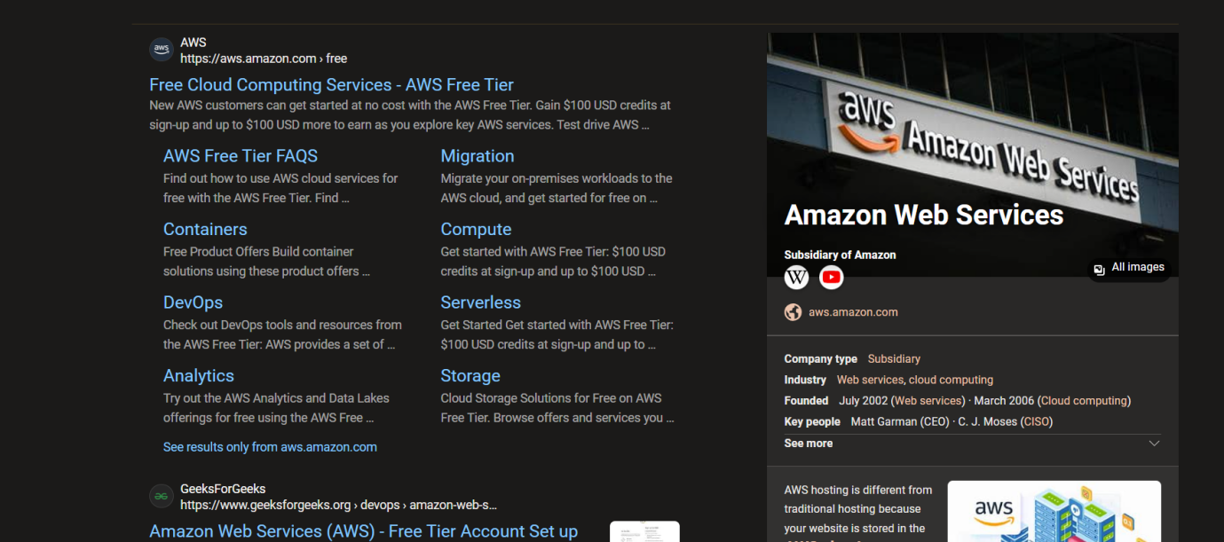

2. Create a New AWS Account:

Click on “**Create a Free Account**”

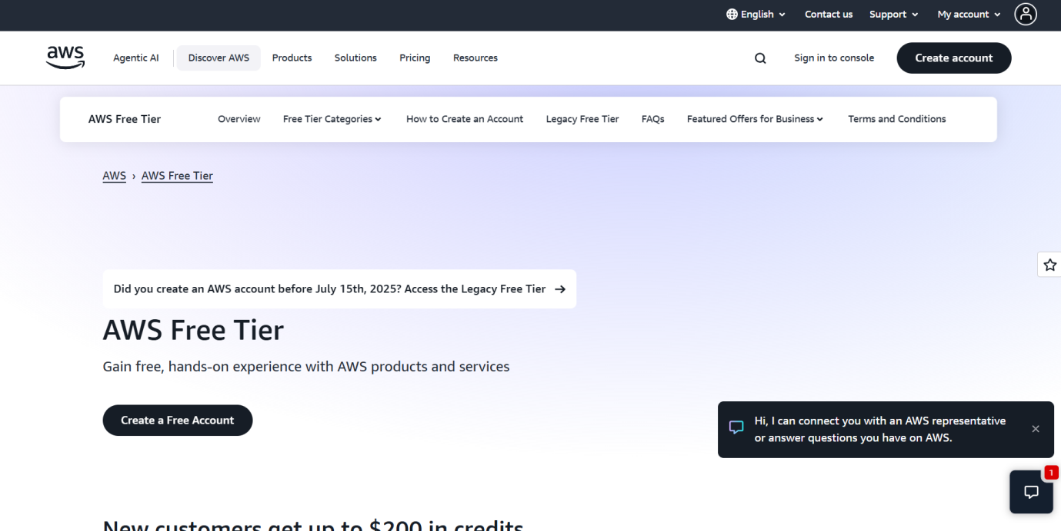

Enter your address and account name.

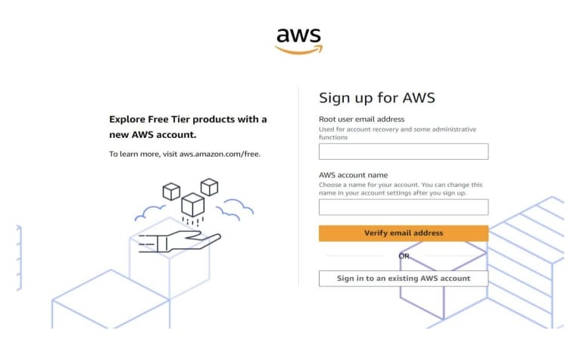

* Enter the verification code received on your provided email address.

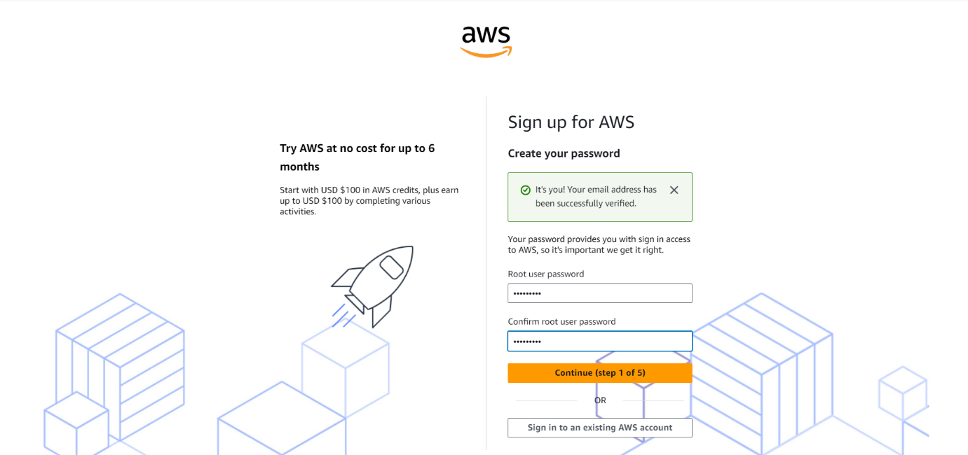

* Create password for root user and click on continue.
* Choose Free Plan.

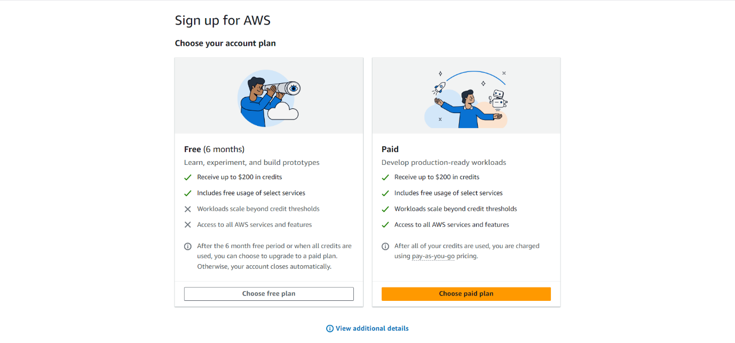

3. Provide Contact Information:

* Enter your contact details, including phone number and address.
* Verify your phone number via a text message or voice call.

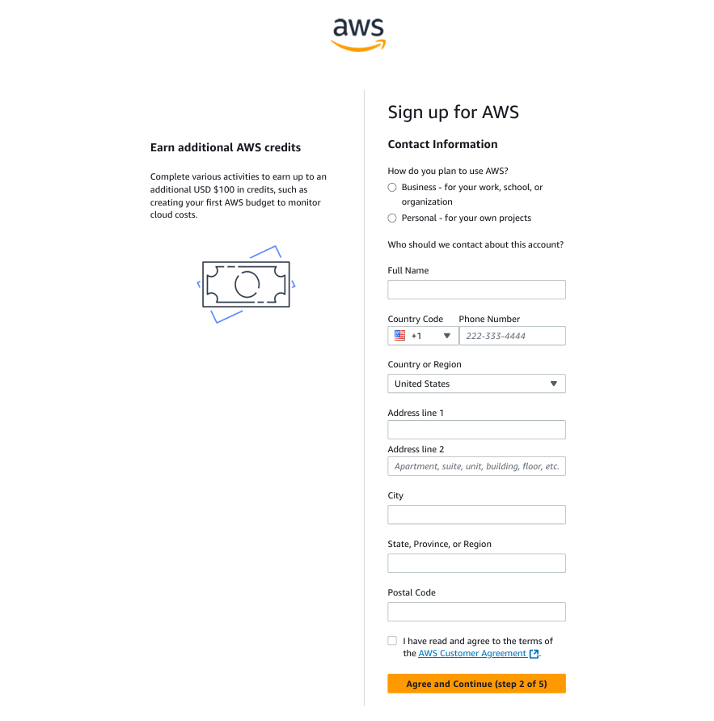

4. Enter Payment Info

* Enter payment info for debit card. AWS requires a payment method for verification purposes.

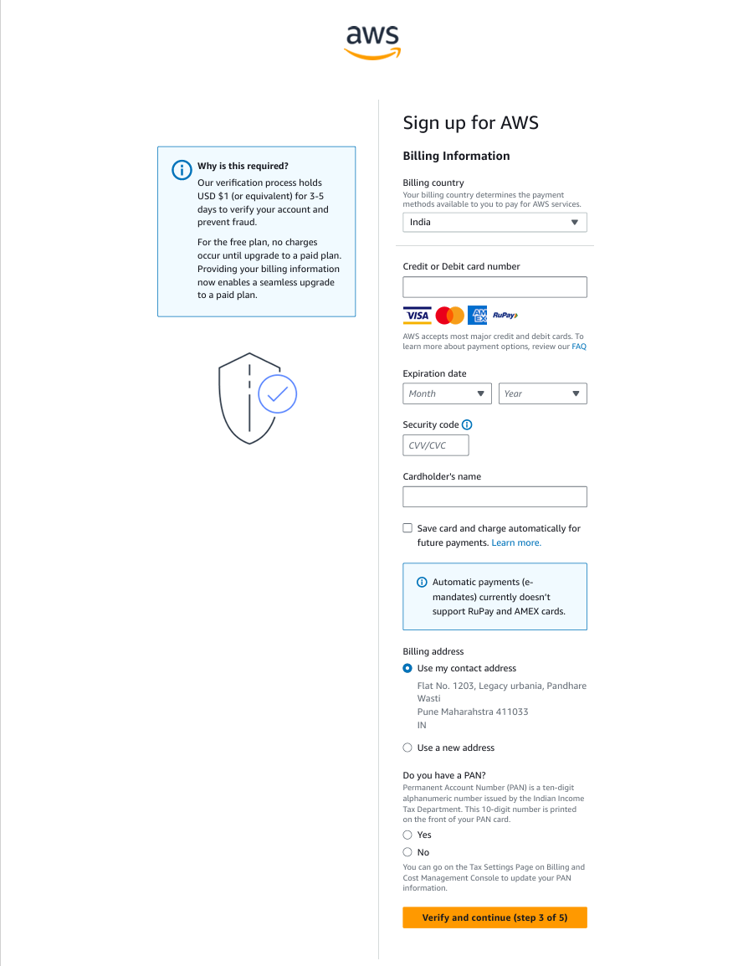

5. Choose a Plan.

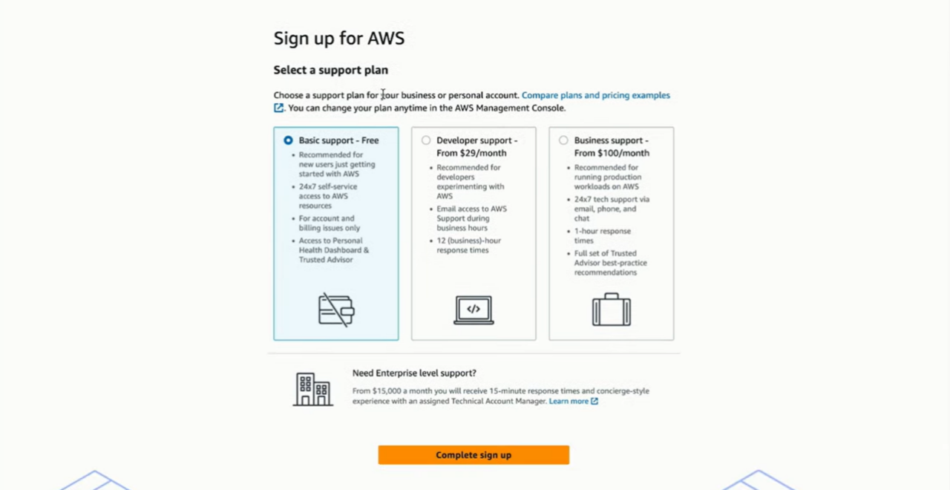

6. Identity verification

* Verify your identity using verification code sent to your mail or phone.

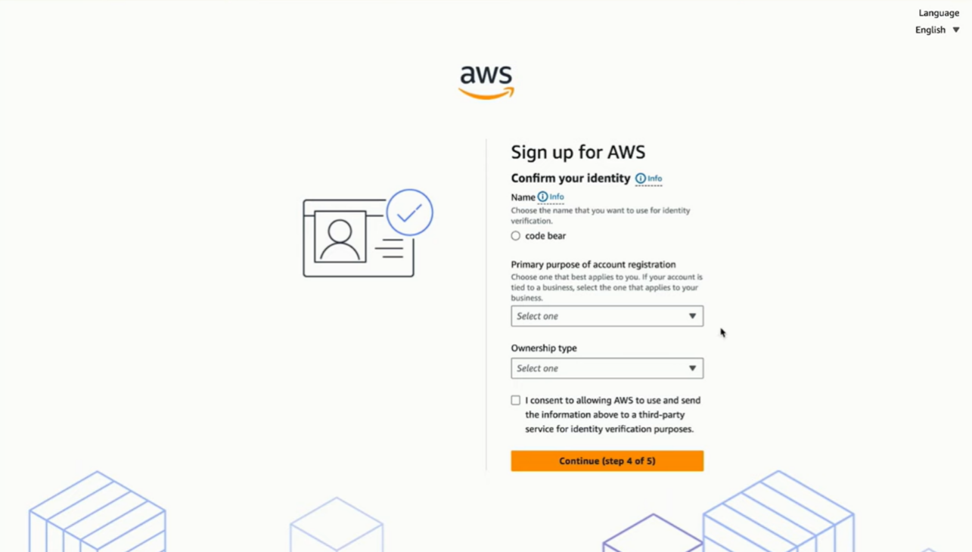

7. Complete Registration

* After verification, you can log in to the AWS management console.

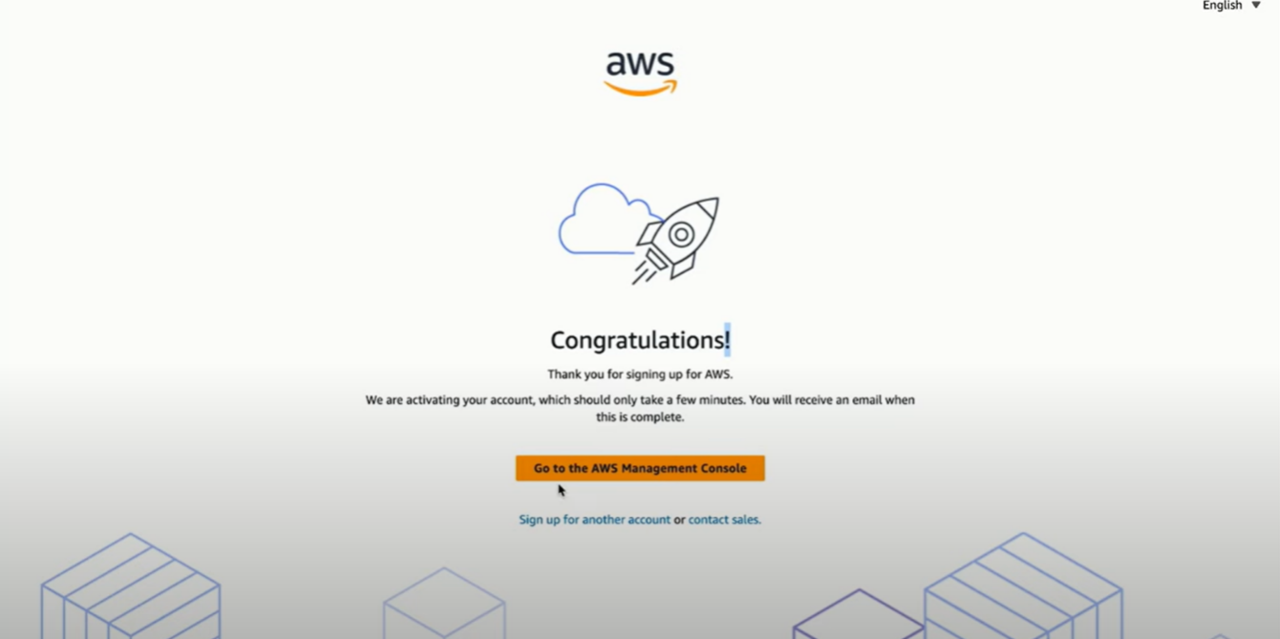

* The AWS Free Tier offers 6 months of free access to many services (like EC2, S3 and Lambda) with limited usage.

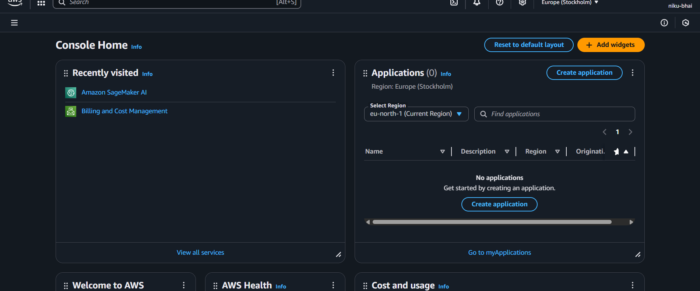

Aim: Creating and Managing IAM Groups and User Permissions

Step 1: Sign in to AWS console and open IAM.

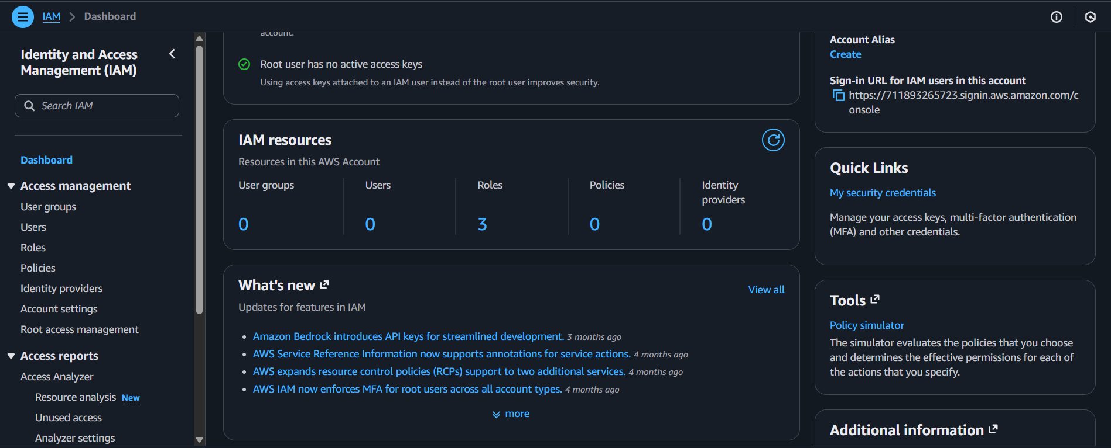

Step 2: Go to user in Access Management Panel in IAM.

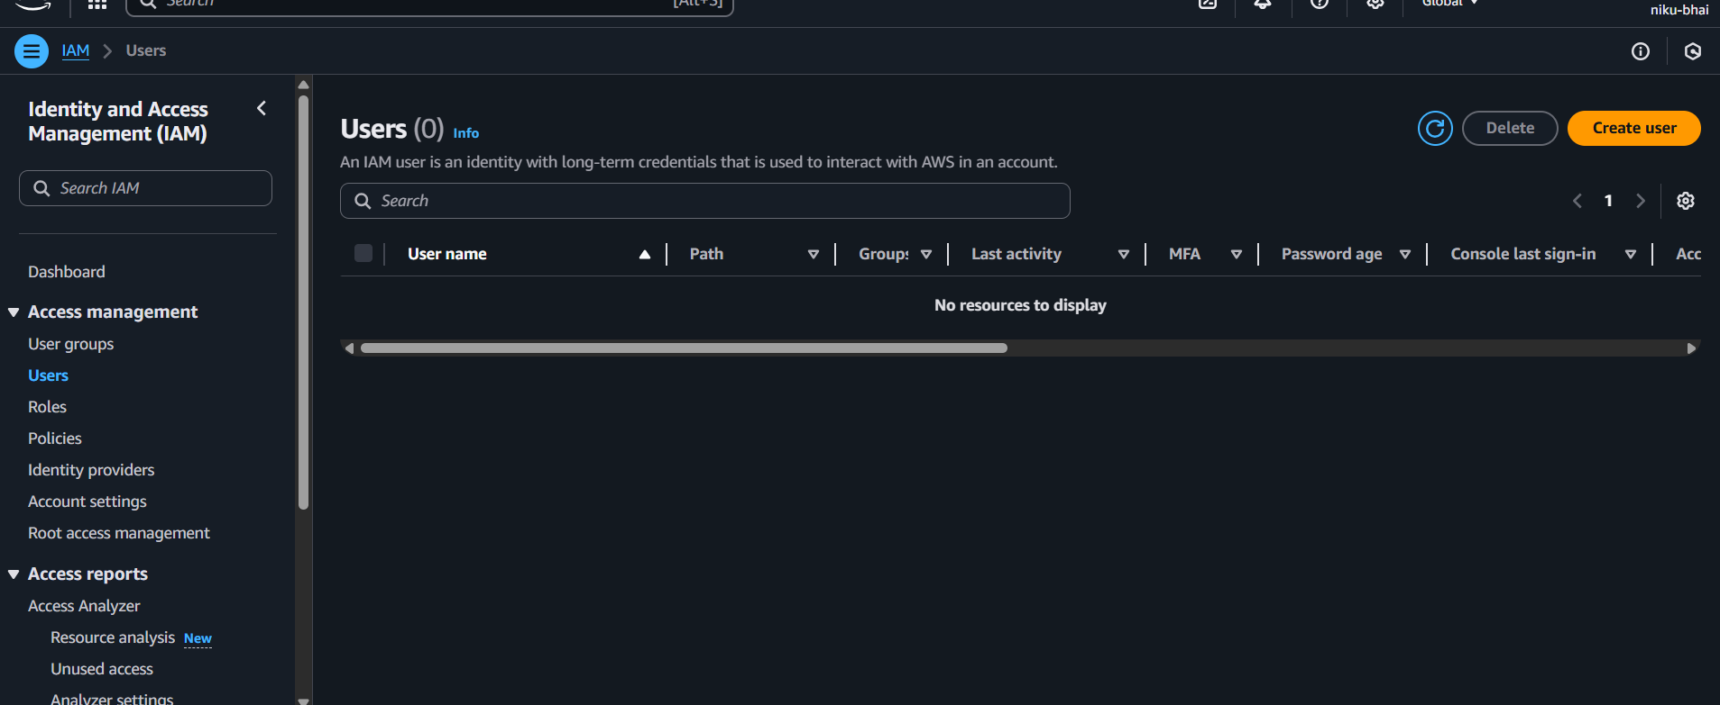

Step 3: Select Create User.

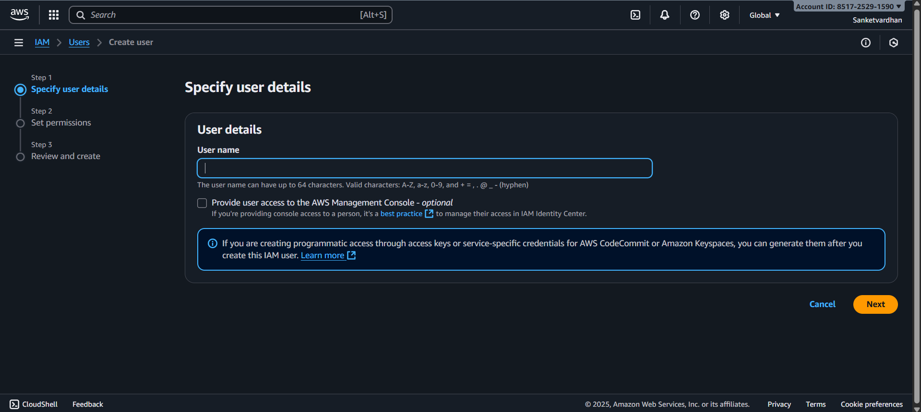

Step 4: Enter User Details.

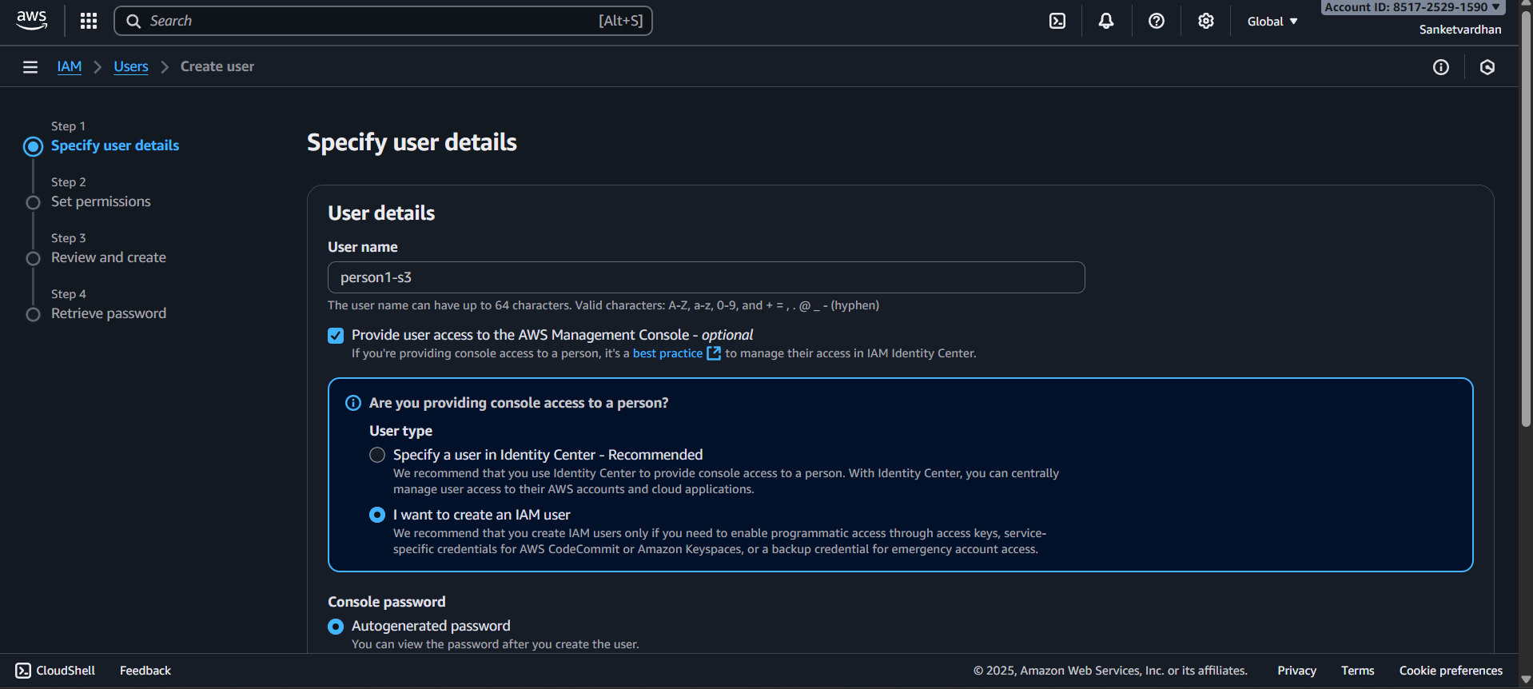

Step 5: On Permission Page, choose attach Policies directly. Search and select the policy “S3 Full Access”. Review and create the User.

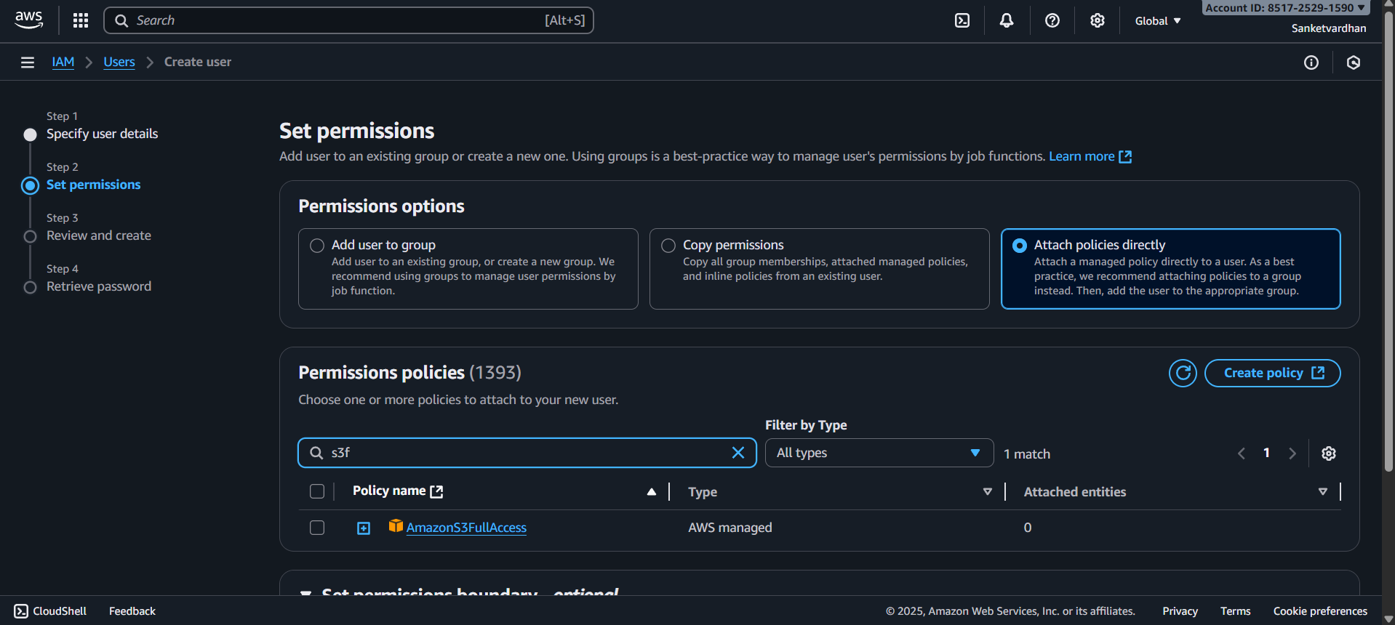

Step 6: Review and Confirm

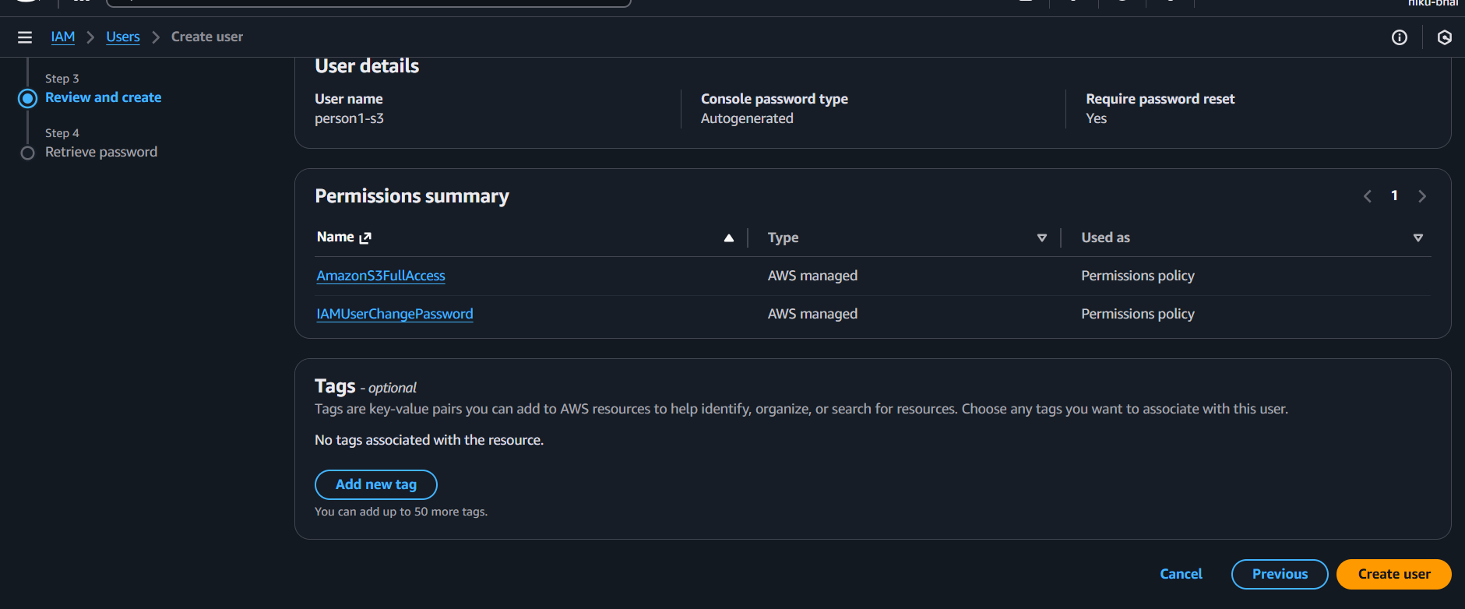

Step 7: Download CSV Page

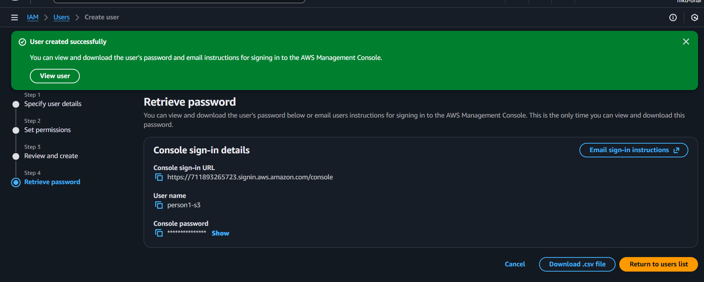

Step 8: Repeat Same steps for other 2 users (person1-ec2 And person-sage) and give them permissions of EC2 (Full Access) and SageMaker (Full Access) respectively.

Step 9: Test Cross user Permissions. Login As ‘person1-s3’.

Step 10: Try to Access EC2 Resource via EC2 Console. Since person1-s3 has only S3 access, so he is not able to access or manage EC2 resource.

Step 11: Navigate to IAM

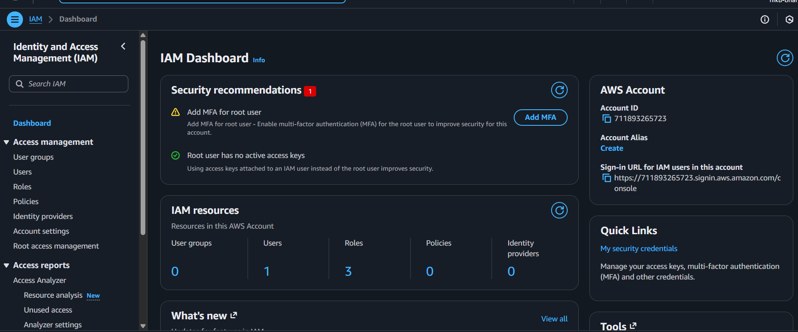

Step 12: Click on User Groups on the sidebar.

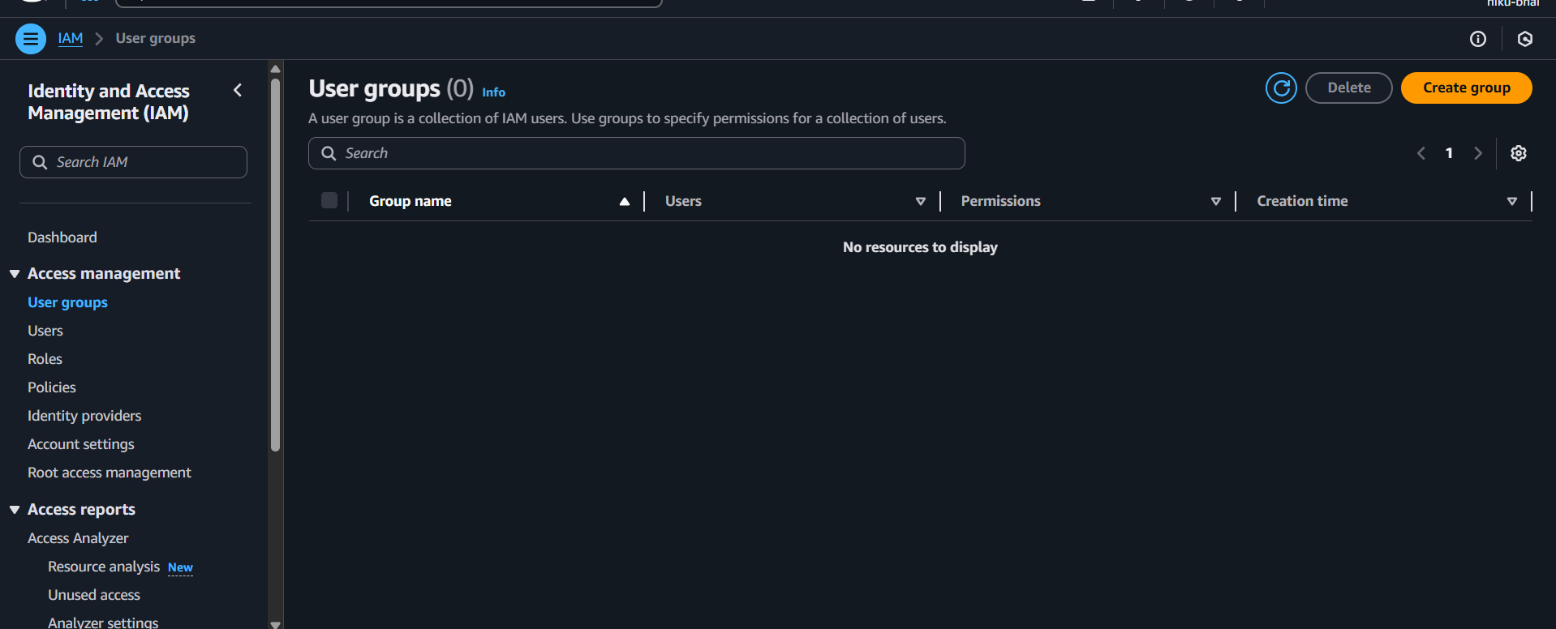

Step 13: Click on Create New Group Button.

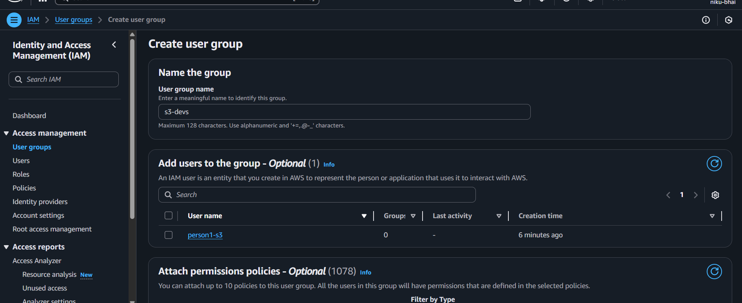

Step 14: Fill in the Group Name. Select User for the group. Attach specific permissions. Press create group button.

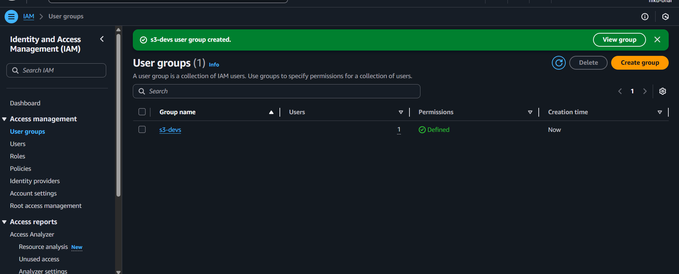

7. Conclusion:  
We created Multiple users using the IAM Service on AWS Console, and saw that users with no permissions are unable to access features not given to them. We also saw how to create groups and gave permissions to user in specific groups.

# Practical 02

| **Student Name: Roshan Samuel** |
| --- |
| **Date of Experiment: 08/09/2025** |
| **Date of Submission:** |
| **PRN No: 20220802088** |

**1. Title of lab:** Exploring SageMaker Notebook Instances — To familiarize oneself with the SageMaker environment and create a notebook instance for developing and running ML code.  
 **2. Objective:**

* To understand the Amazon SageMaker environment.
* To create and configure a SageMaker Notebook Instance.
* To open Jupyter Notebook in SageMaker and run sample ML code.

**3. Tools:**

* AWS Management Console
* Amazon SageMaker
* Jupyter Notebook interface (within SageMaker)

**4. Software Used:**

* Python 3 (built-in SageMaker environment)
* Pre-installed ML libraries (NumPy, Pandas, Scikit-learn, Matplotlib)

**5. Theory / Concept:**  
Amazon **SageMaker** is a fully managed service provided by AWS that enables developers and data scientists to quickly build, train, and deploy machine learning models at scale.  
 It provides **Notebook Instances**, which are managed Jupyter notebook servers preloaded with popular data science libraries and integrated with AWS storage and compute resources.

**Key concepts:**

1. **Notebook Instance:** A managed EC2 instance pre-configured with Jupyter Notebook.
2. **IAM Role:** Grants SageMaker permissions to access AWS services like S3.
3. **S3 Bucket:** Used to store data and model artifacts.
4. **Lifecycle Configuration:** Scripts that automate setup tasks on startup.

**6. Output:**

**Step 1**: In the AWS Management Console, search for SageMaker and Select Amazon SageMaker from the results to open the service dashboard.

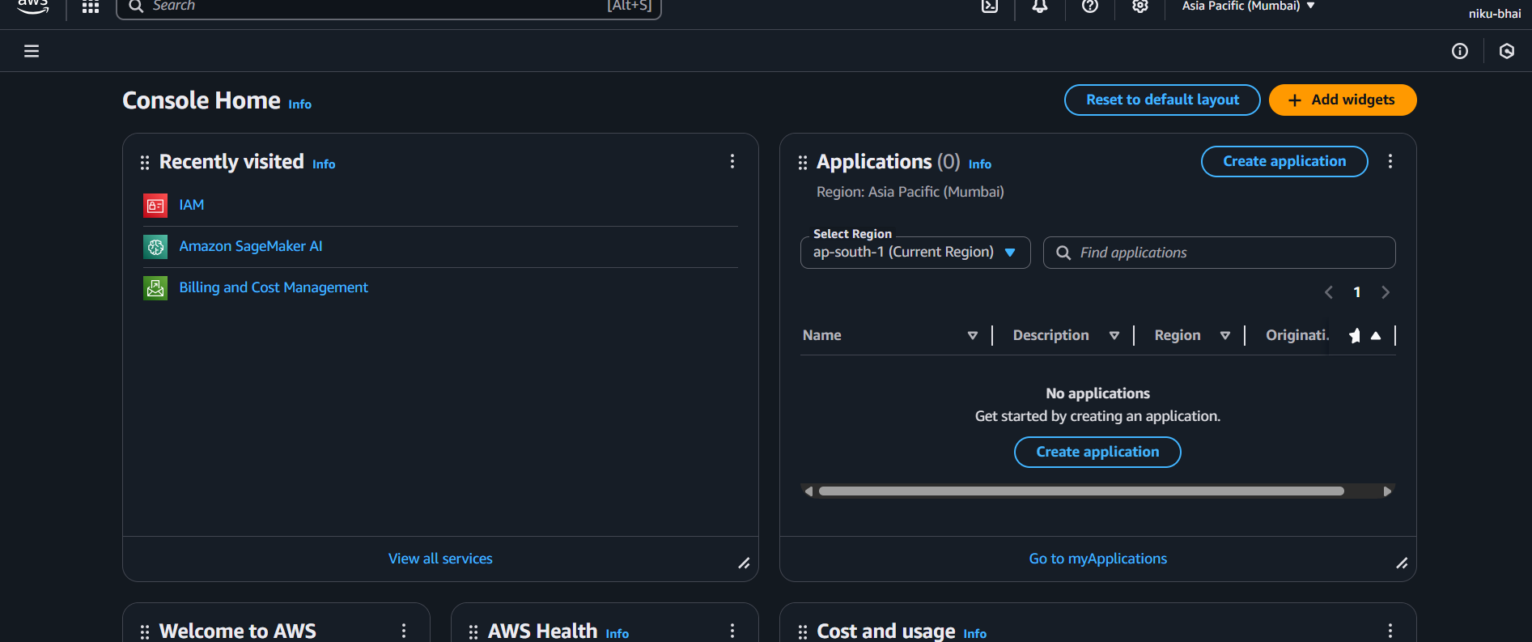

**Step 2:** From the Sidebar select Notebook.

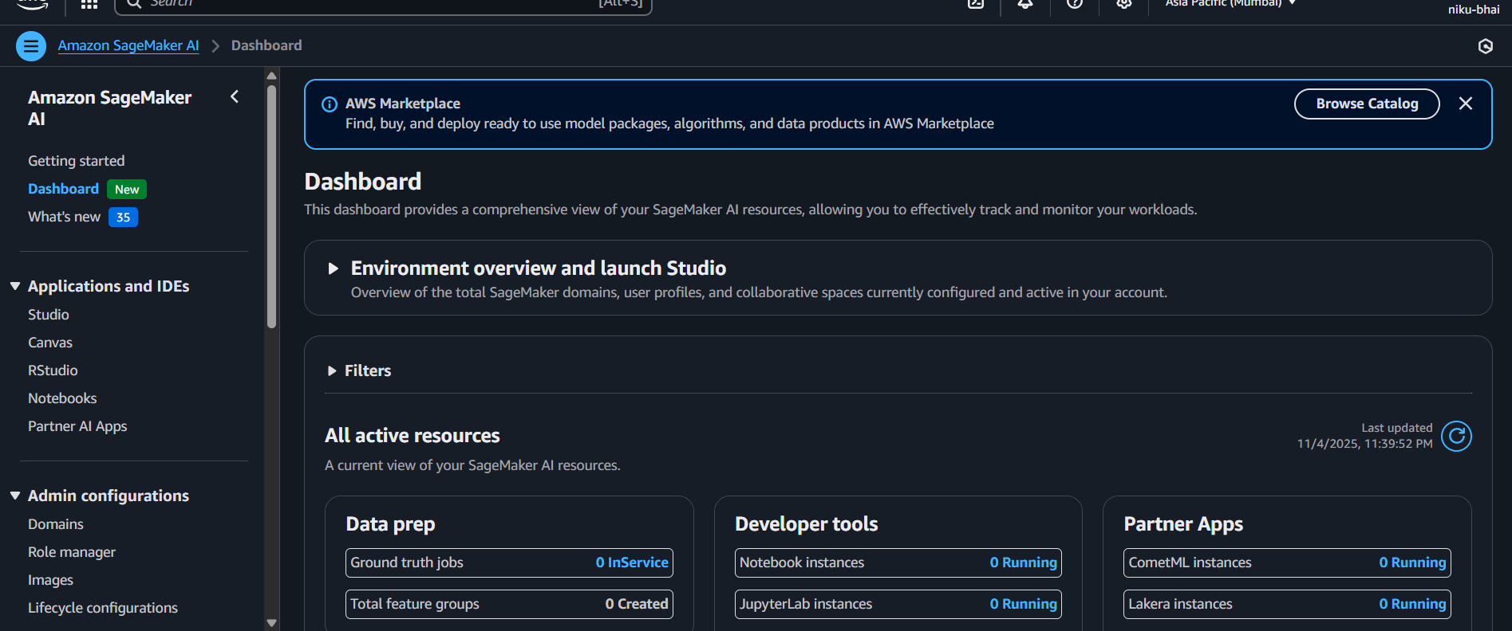

**Step 3:** Click ok the Create notebook instance

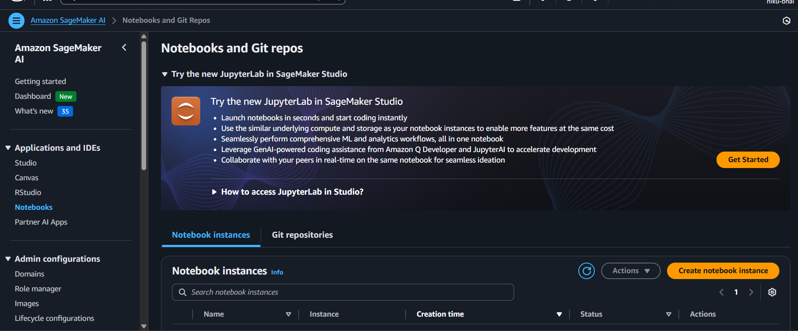

**Step 4:** Give the Notebook instance name

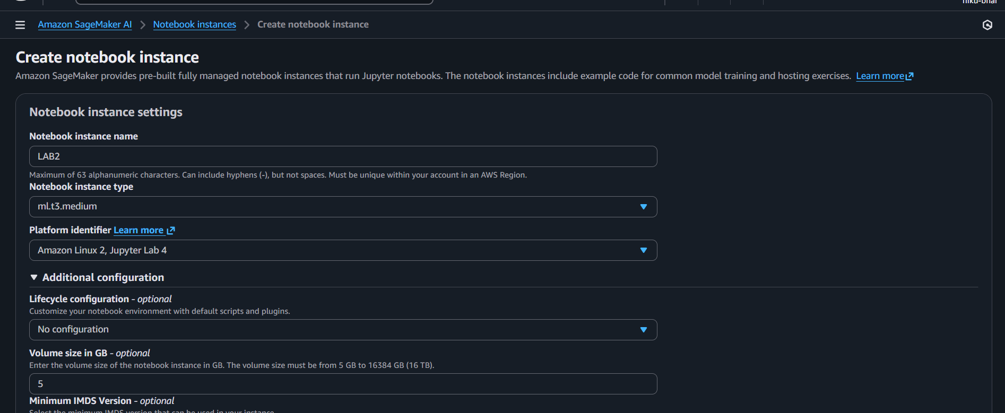

**Step 5:** Click on Create notebook instance at the bottom of the page

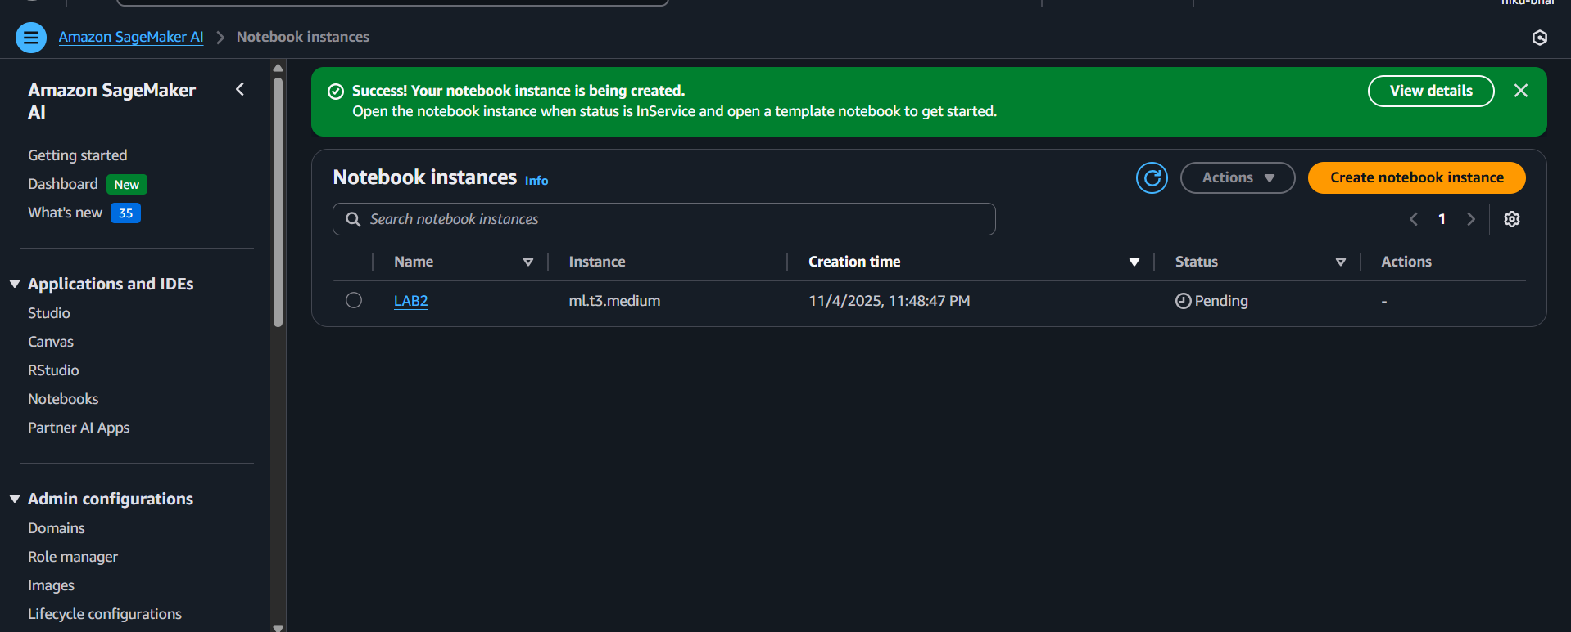

**Step 6:** Wait for the Notebook Status to be turned to InService

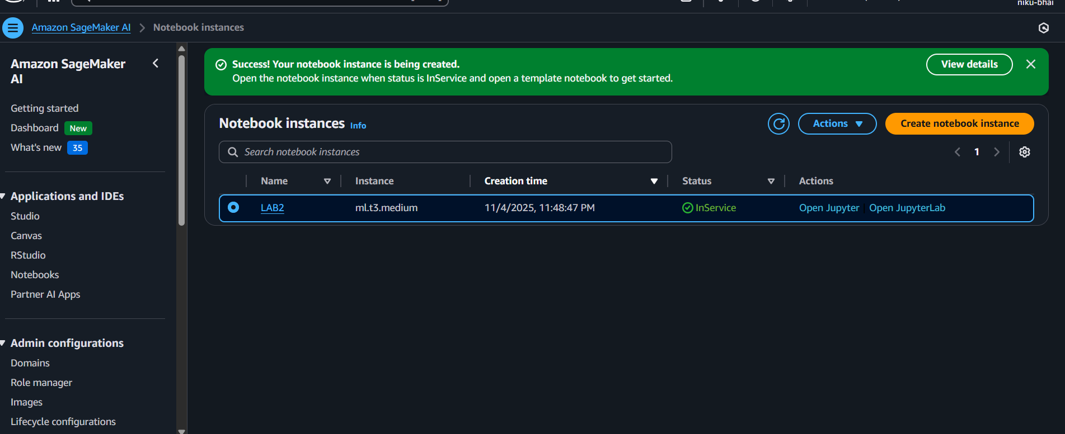

**Step 7:** Click on **“Open Jupyter”** to open the notebook in the web

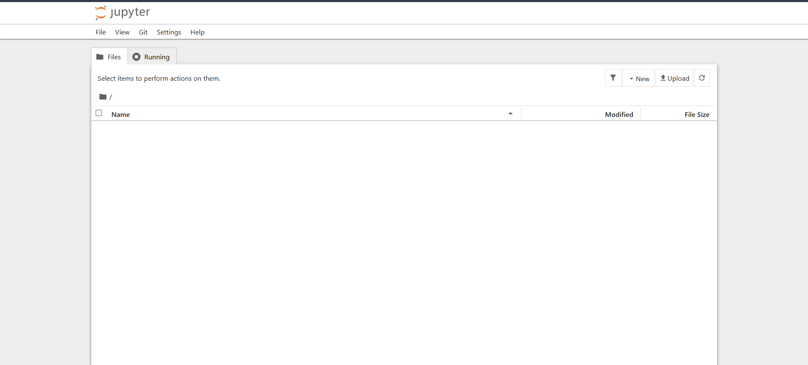

**Step 8:** Click on the New Dropdown and select the “conda_python3” notebook

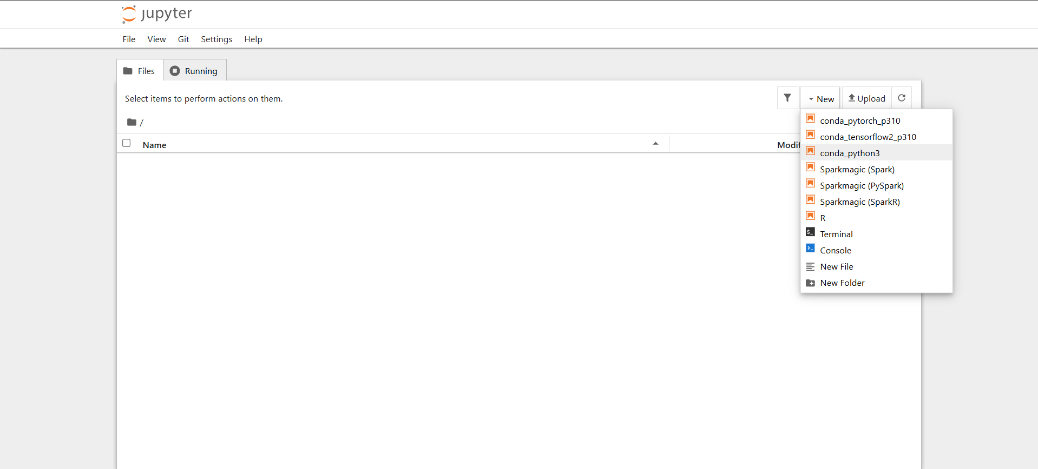

**Step 9:** The notebook is created, and we can enter code to run it.

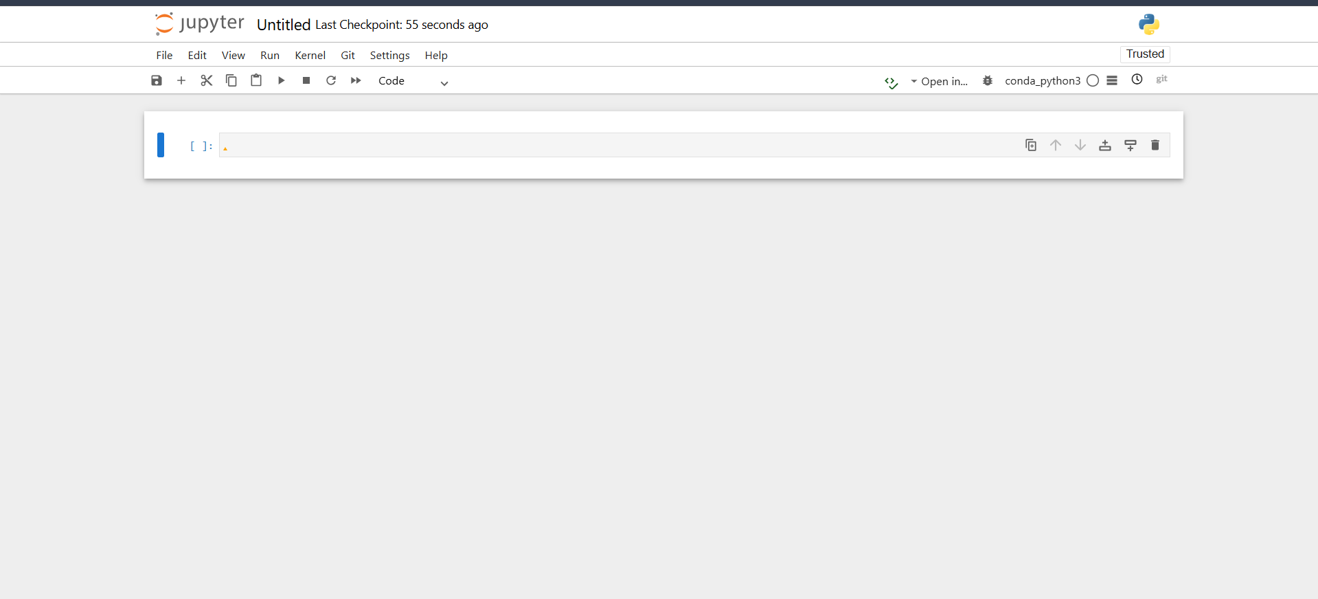

**Step 10:** Apply the code and run it.

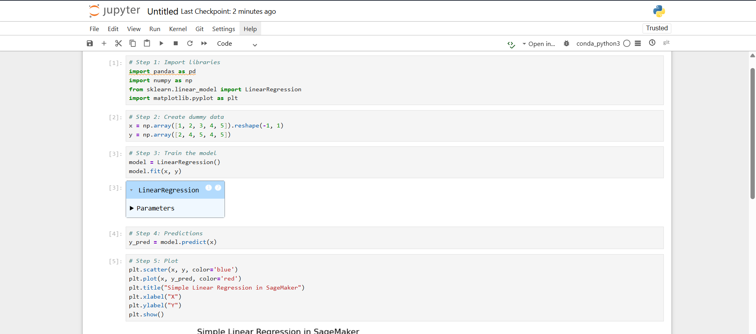

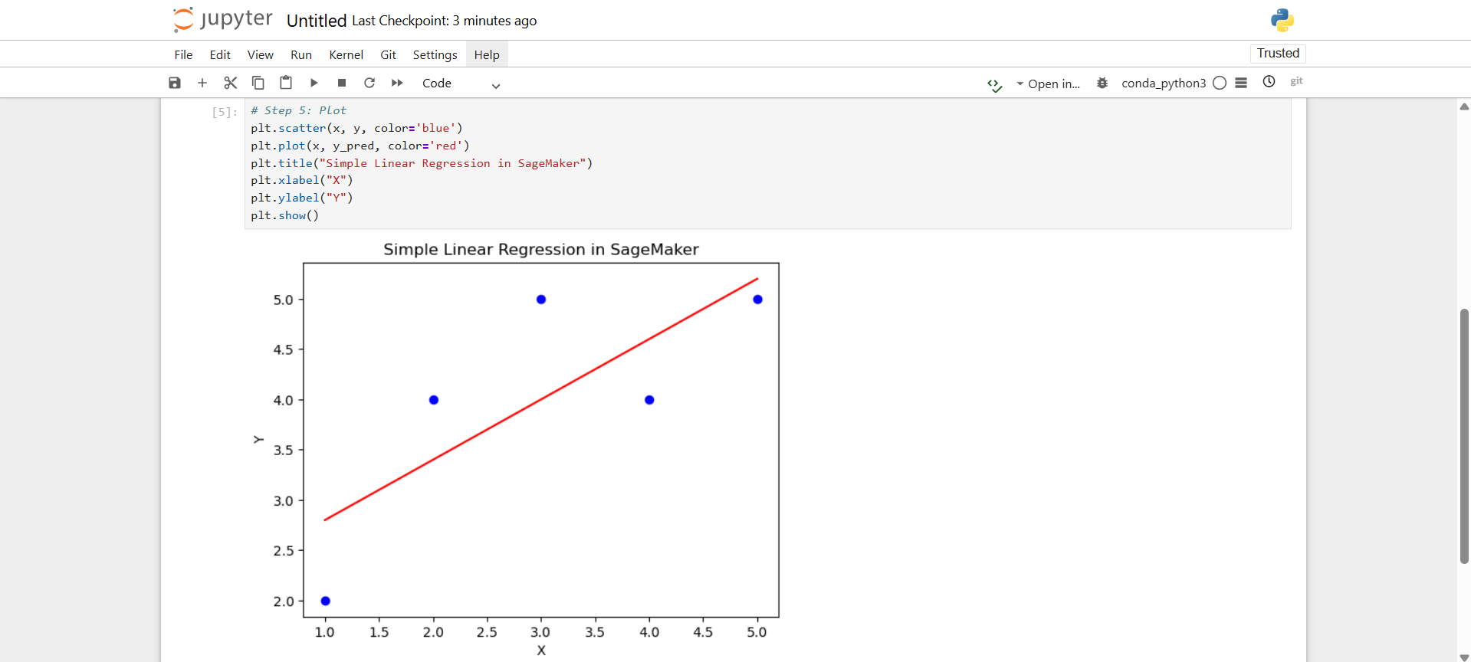

**7. Conclusion:**

The lab demonstrated the process of exploring the Amazon SageMaker environment by creating and accessing a SageMaker Notebook Instance. It provided an understanding of how Jupyter notebooks within SageMaker can be used to develop and execute machine learning code.

The exercise also emphasized the importance of effective resource management on AWS, including the proper steps to stop and delete instances, IAM roles, and S3 storage to prevent unnecessary billing.

Overall, the lab enabled practical familiarity with setting up, using, and cleaning up SageMaker resources, forming a strong foundation for future machine learning projects on AWS

# Practical 03

| **Student Name: Roshan Samuel** |
| --- |
| **Date of Experiment: 15/09/2025** |
| **Date of Submission:** |
| **PRN No: 20220802062** |

**1. Title of lab:** Building a Simple Linear Regression Model with SageMaker — To train and deploy a linear regression model using built-in algorithms in Amazon SageMaker for predictive analysis**.**

**2. Objective:**

* To understand how to build, and train a linear regression model using Amazon SageMaker’s built-in Linear Learner algorithm.
* To create and configure a SageMaker Notebook Instance for model development.
* To upload and manage datasets using Amazon S3.

**3. Tools:**

* Amazon SageMaker
* Amazon S3
* Amazon IAM (for creating and assigning execution roles)

**4. Software Used:**

* Python 3 (in the SageMaker environment)
* Built-in Amazon SageMaker Linear Learner algorithm
* Pre-installed ML libraries (NumPy, Pandas, Scikit-learn, Matplotlib)
* Jupyter Notebook interface within SageMaker

**5. Theory / Concept:**

**Linear Regression** is a supervised learning algorithm used to model the relationship between a dependent variable (target) and one or more independent variables (features).  
 It finds the best-fit line by minimizing the sum of squared differences between observed and predicted values.

In **Amazon SageMaker**, the **Linear Learner** algorithm provides a highly scalable implementation of linear regression and classification.  
 The process involves:

1. Uploading the dataset to an **S3 bucket**.
2. Creating and assigning a **SageMaker Execution Role**.
3. Opening a **Jupyter Notebook** in SageMaker Studio or Notebook Instance.
4. Writing code to:
   * Load data from S3.
   * Train the model using the Linear Learner algorithm.
   * Deploy the model to an endpoint.
   * Test the model with sample inputs

**6. Output:**

**Step 1:** Set Up Environment

1. Go to AWS Management Console > Amazon SageMaker.
2. Click Notebook instances > Create notebook instance.
3. Enter:

* Name: LAB3
* IAM role: Choose Create a new role > “S3 buckets: Any”.

1. Click Create notebook instance.
2. Once status = InService, click Open Jupyter.

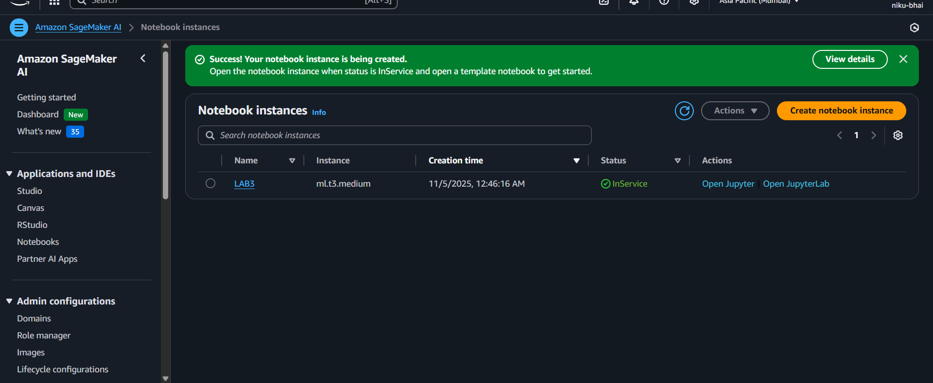

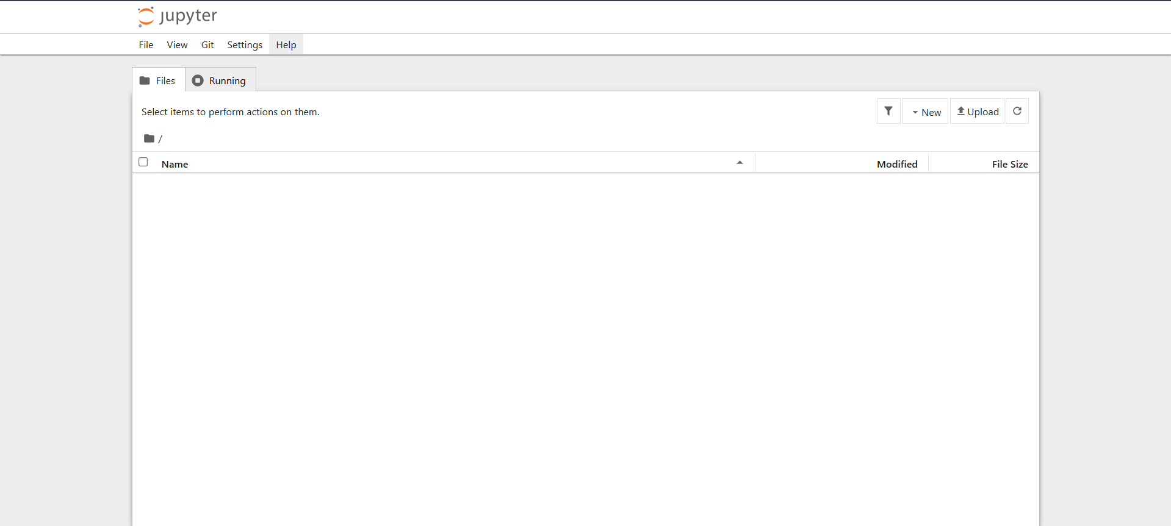

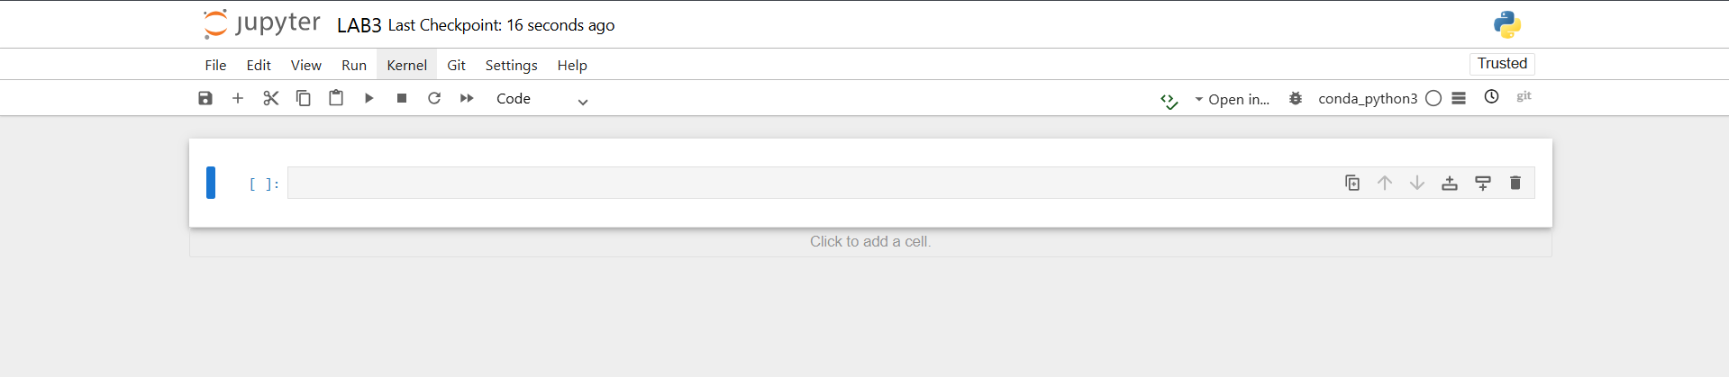

**Step 2:** Upload Data to S3

1. Prepare a simple csv file (for example, housing.csv) with columns like: size and prize
2. Go to Amazon S3 > Create bucket > name it lab3-data-nikunj
3. Upload the LAB3_data.csv file into it.

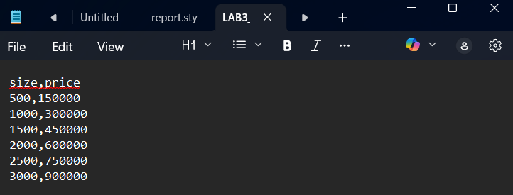

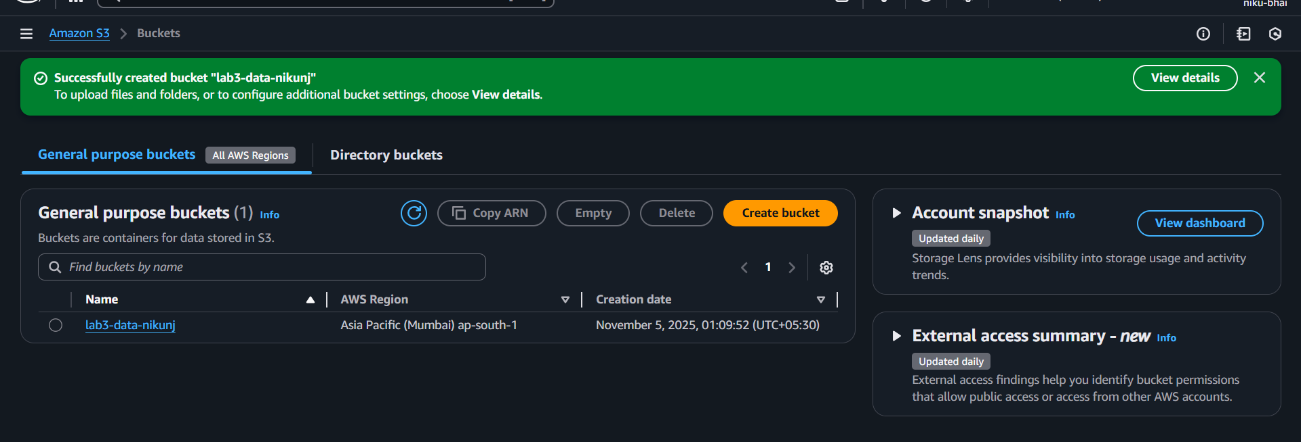

Upload lab3 data:

1. Click your bucket’s **name** (e.g., lab3-data-nikunj).

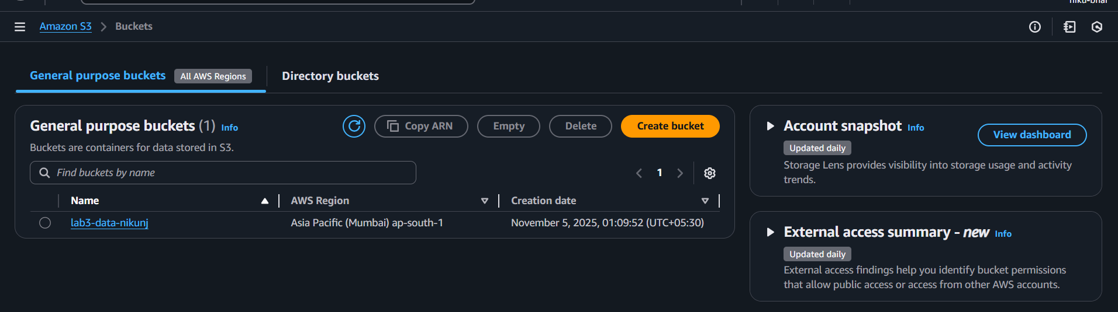

1. Click the **Upload** button (top-right).

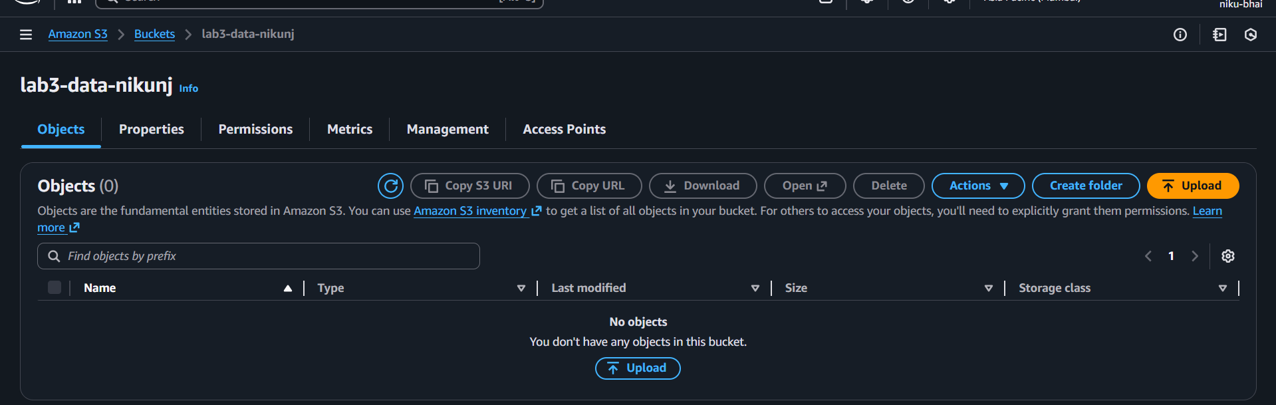

1. Click Add files > browse your computer > select your LAB3_data.csv

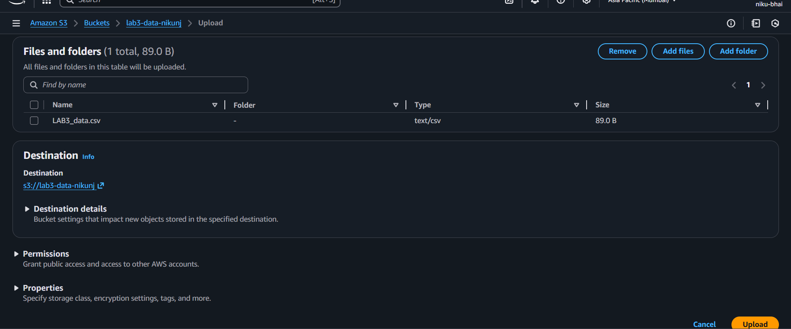

1. Leave all options **as default** (no need to change permissions or encryption).
2. Scroll down and click **Upload**.

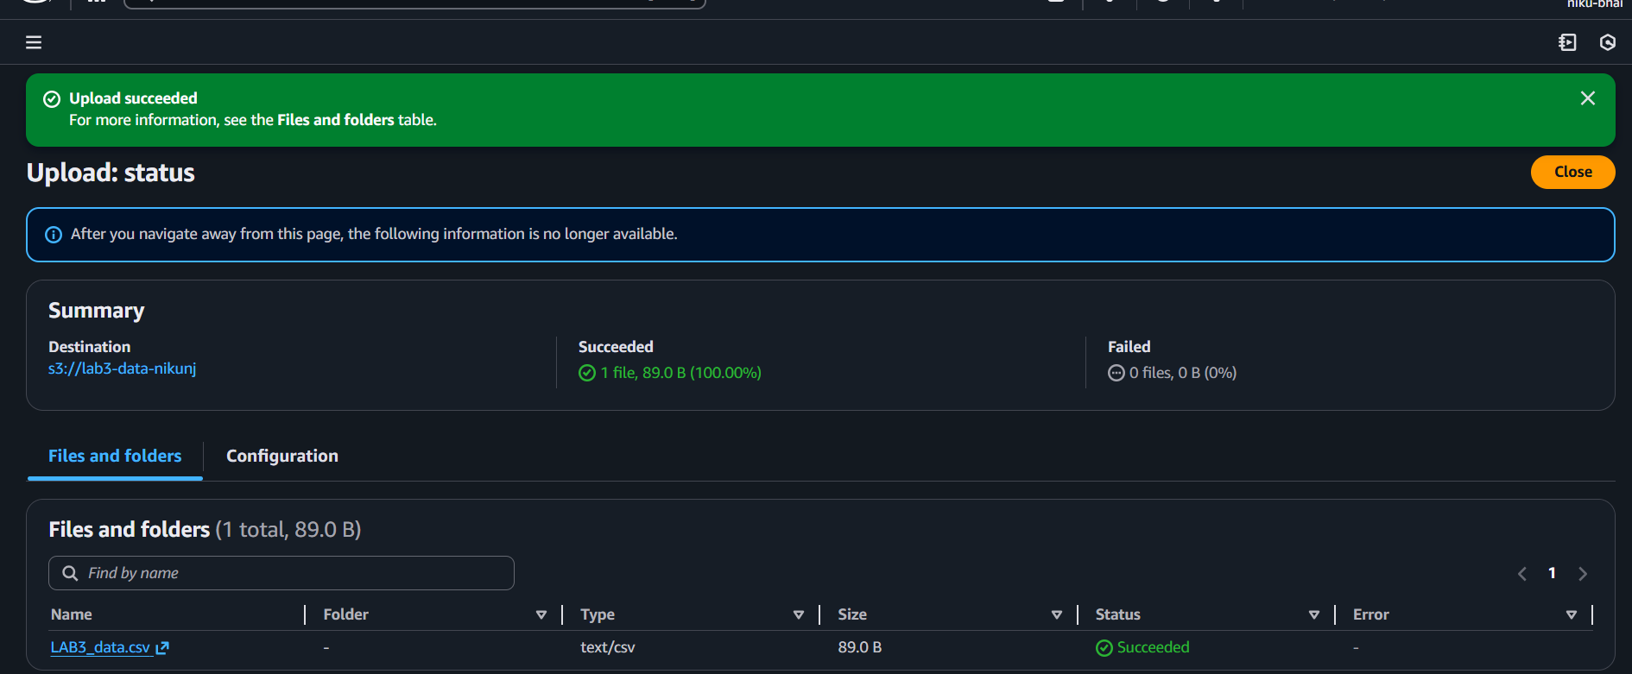

**Step 3:** Importing the data and running algorithm

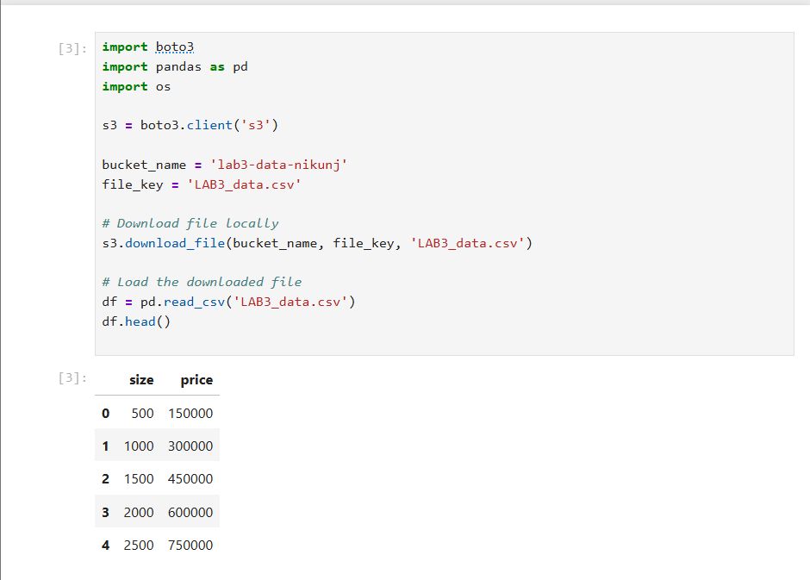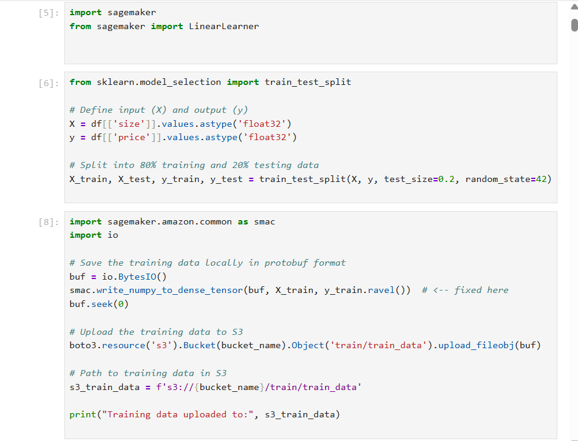

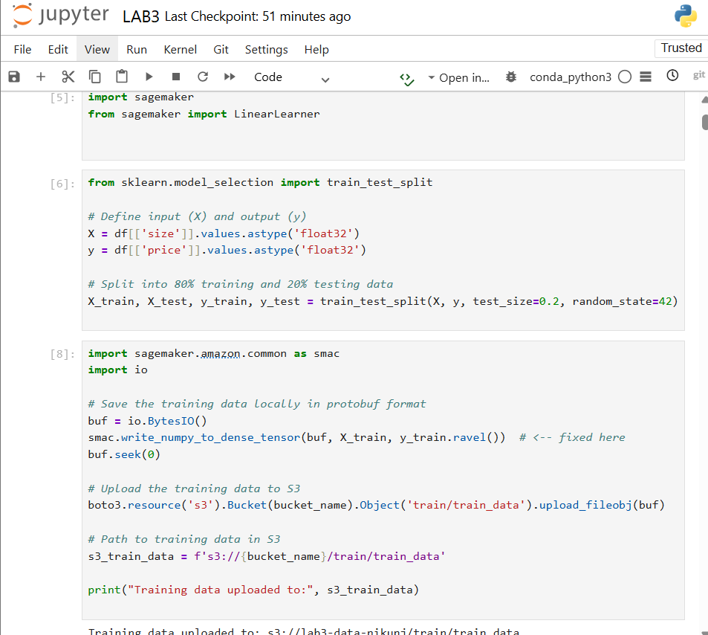

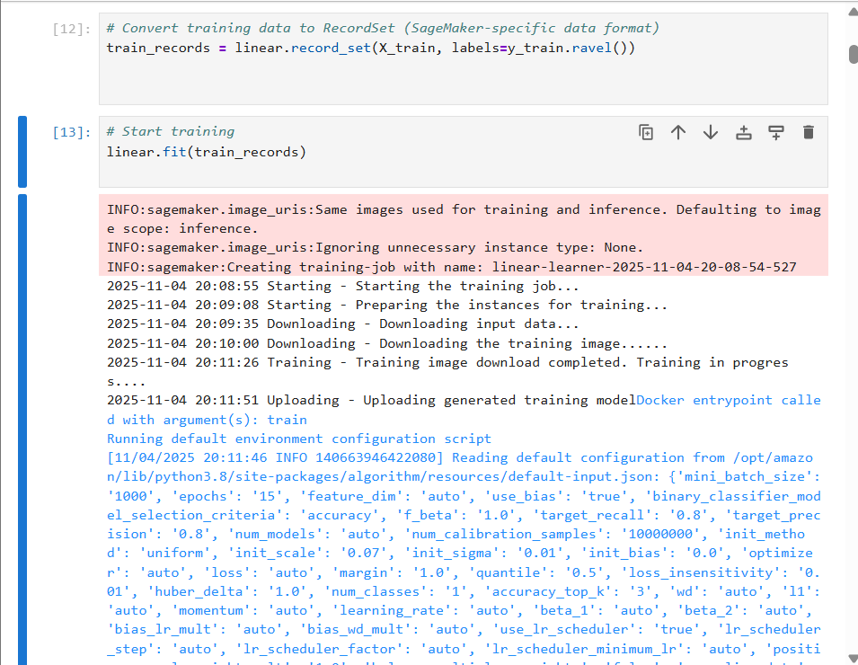

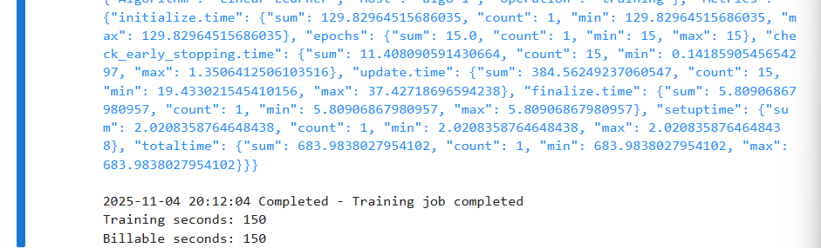

**7. Conclusion:**

The lab was successfully completed by creating and training a Linear Learner model in Amazon SageMaker using data stored in an S3 bucket. The entire workflow—from uploading the dataset, configuring the training job, and running the model training—was performed smoothly. After training, all resources such as the notebook instance and S3 buckets were properly stopped and deleted to prevent any additional charges. This concludes the lab with all AWS resources safely cleaned up.

# Practical 04

| **Student Name: Roshan Samuel** |
| --- |
| **Date of Experiment: 22/09/2025** |
| **Date of Submission:** |
| **PRN No: 20220802088** |

**1. Title of lab**: Implementing Data Preprocessing using SageMaker Notebooks

**2. Objective:** To perform data cleaning, transformation, and feature engineering on a dataset using Amazon SageMaker notebooks and store the processed data back in Amazon S3.

**3. Tools:** Python (for coding)

Pandas & NumPy (for data manipulation)

Scikit-learn (for feature engineering and transformation)

**4. Software Used**: AWS Management Console

Jupyter Notebook (inside SageMaker)

Python 3 kernel

**5. Theory / Concept:** Data preprocessing is a crucial step in any Machine Learning workflow. It involves cleaning the data, handling missing values, encoding categorical variables, scaling features, and preparing the dataset for training.

AWS SageMaker provides a fully managed environment for developing and running preprocessing code without local setup, and Amazon S3 is used for data storage and retrieval.

We’ll perform the following:

1. **Create an S3 bucket** to store raw and processed data.
2. **Upload the Titanic dataset** (titanic.csv) to the S3 bucket.
3. **Create and open a SageMaker Notebook instance**.
4. **Load the dataset from S3** into the notebook.
5. **Perform preprocessing** (handle missing values, encode categorical data, scale numerical columns).
6. **Save the cleaned dataset back to S3**.

**6. Output:**

**Step 1: Create an S3 Bucket:**

**Open AWS Console:** Go to → https://console.aws.amazon.com/s3

**Click “Create bucket”** (orange button on the top right).

**Bucket name:** Type a unique, simple name — e.g. data-preprocess-nikunj

**AWS Region:** Choose the same region you’ll use for SageMaker (for example: **Asia Pacific (Mumbai) ap-south-1**).

**Bucket settings:**

* **Block all public access:** **Keep this checked** (very important — avoids public access & billing risks).
* **Versioning:** Leave **Disabled**.
* **Encryption:** Leave **Default (None)** — no extra cost.
* **Object Ownership:** Keep default (ACLs disabled).

**Click “Create bucket”.**

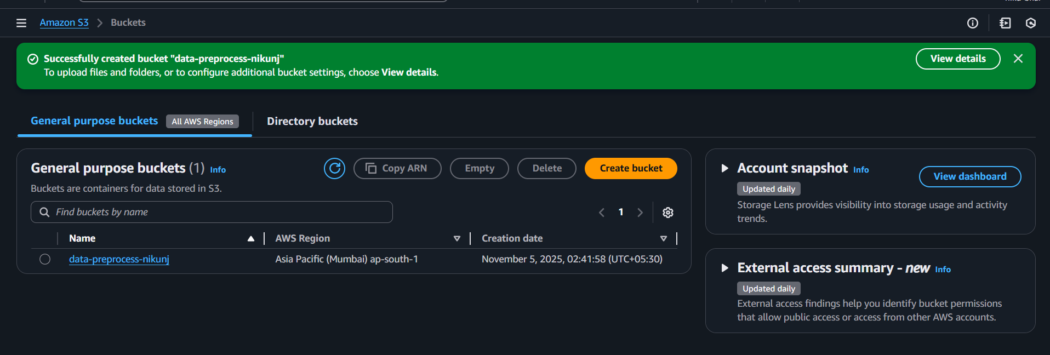

**Step 2 – Upload the Titanic Dataset to Your S3 Bucket**

**Open your bucket**

* Click on the name of your bucket (example: data-preprocess-nikunj).

**Click “Upload”** (orange button at the top).

**In the Upload page:**

* Click **Add files** → Browse and select your local titanic.csv file (from your Downloads folder).
* You’ll see it listed under Files to upload*.*

**Scroll down to “Permissions” section:**

* Keep **“Grant public read access”** **unchecked**  
   (We’re keeping this file private to avoid any charges or exposure.)

**Scroll further down and click “Upload”.**

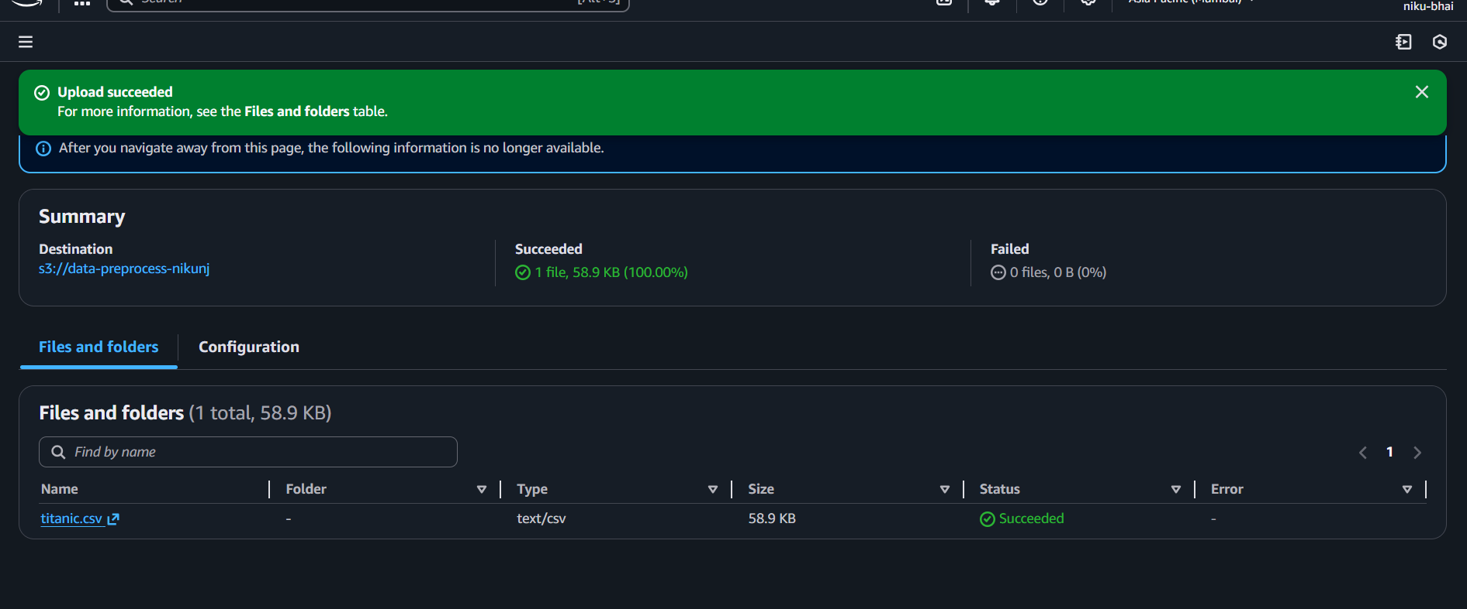

**Step 3 – Create a SageMaker Notebook Instance**

1. **Open AWS Console → SageMaker** https://console.aws.amazon.com/sagemaker
2. **Click “Notebook instances”** (left sidebar)
3. **Click “Create notebook instance”** (orange button)

**3.a. Configure Notebook Instance:**

Notebook instance name- data-preprocess-lab

Notebook instance type- ml.t3.medium

Volume size- 5GB

IAM Role- Create a new role

**3.b. Configure IAM Role for S3 access**

* In the create a new role popup:

Choose: ‘Any S3 bucket’

Or ‘Specific S3 buckets’ > select date-prerocess-nikunj if least privilege

* Create role

**3.c. Additional Settings**

* Keep default settings for Network, Encryption, Git repositories.
* No need to enable Lifecycle configuration or Git for this lab.

**3.d. Create Notebook**

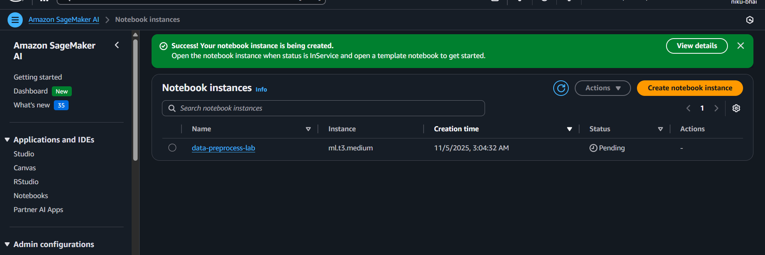

**Step 4:** Load the Titanic Dataset from S3

Read the titanic.csv file from the S3 bucket data-preprocess-nikunj into a Pandas DataFrame for preprocessing.

Open your **SageMaker Notebook** > data-preprocess-lab > click New > conda_python3.

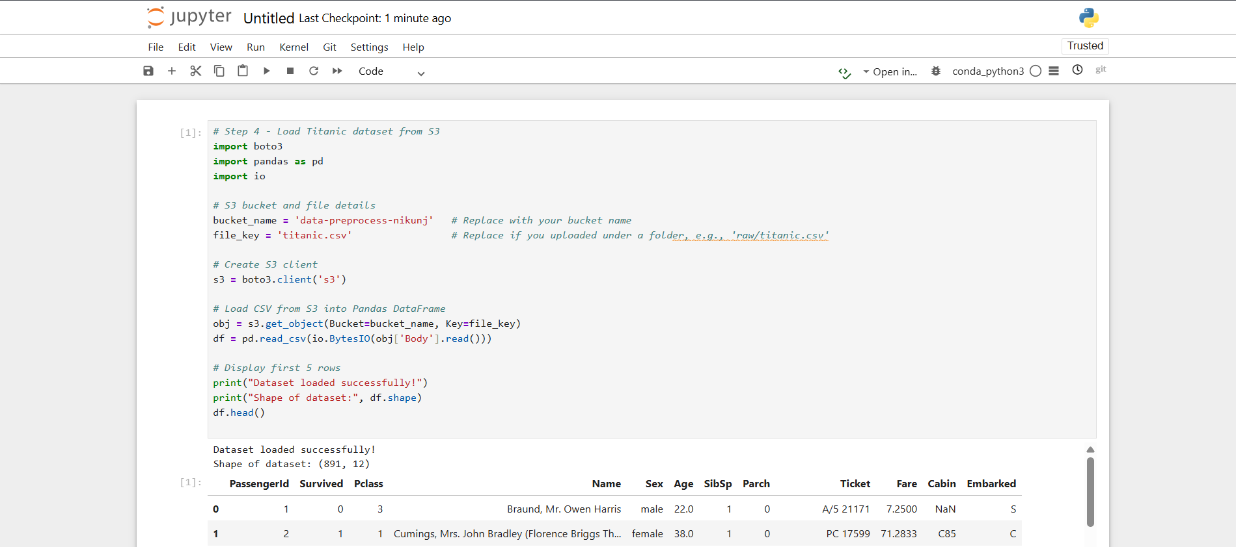

**Step 5:** Data Cleaning:

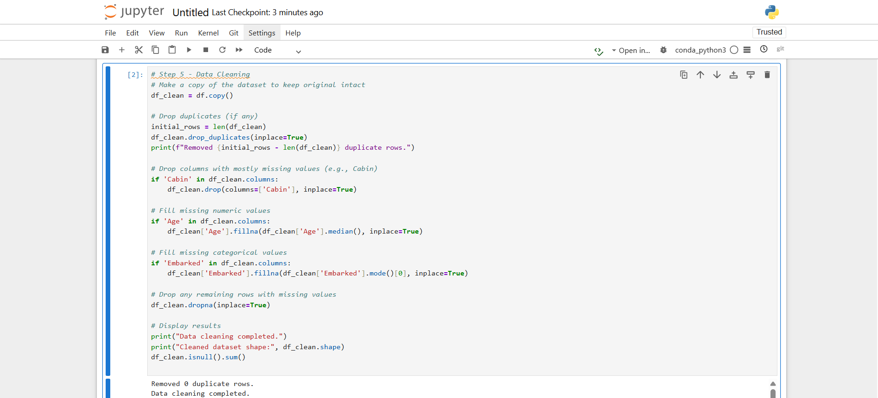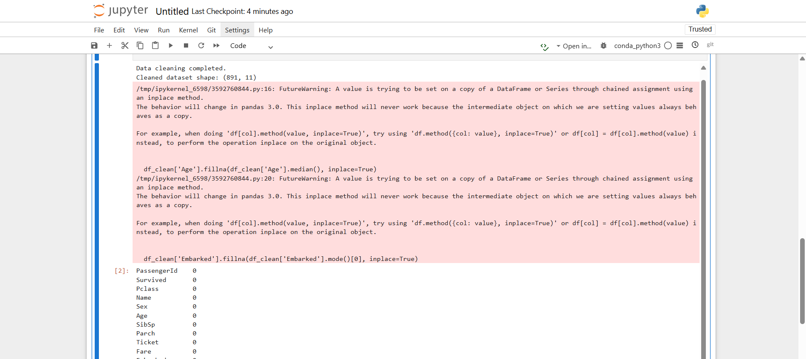

**Step 6:** Data Transformation  
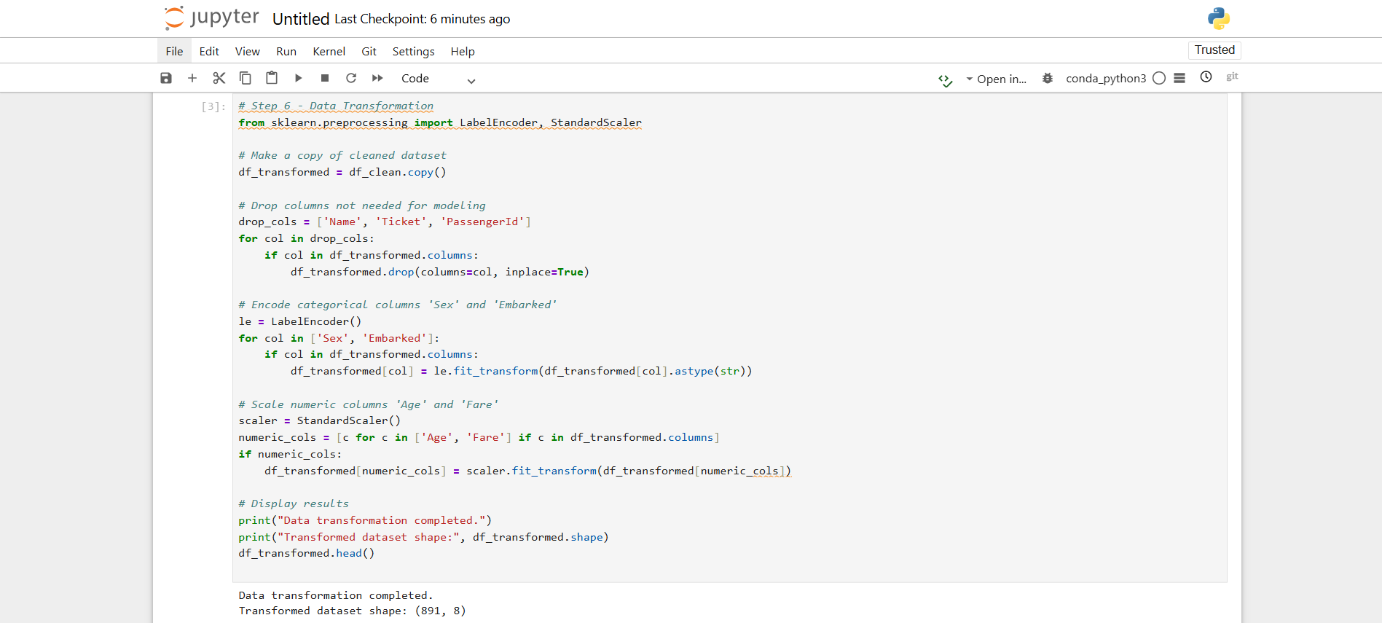

**Step 7:** Feature Engineering

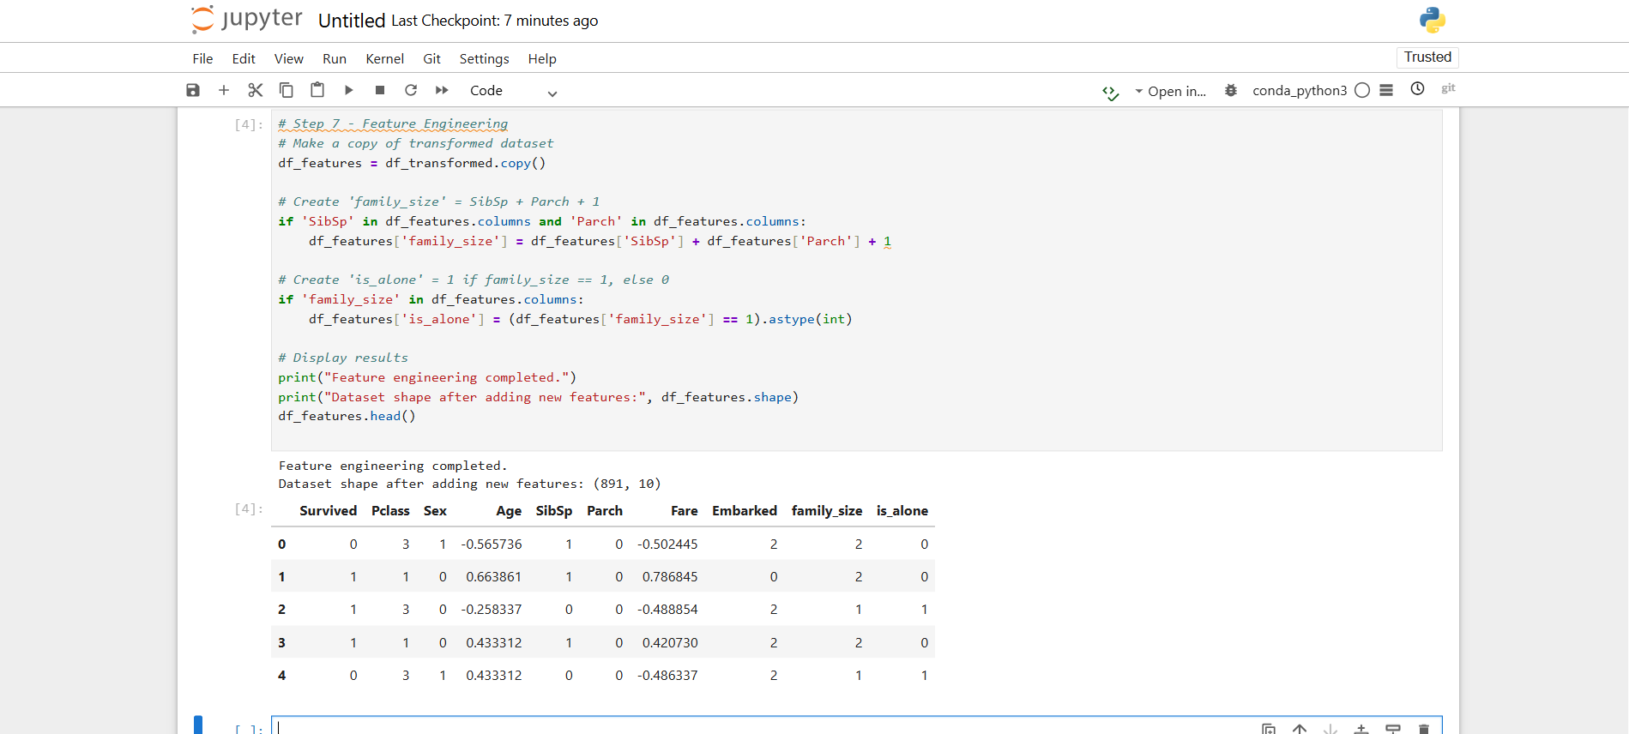

**Step 8:** Save Processed Dataset and Upload to S3

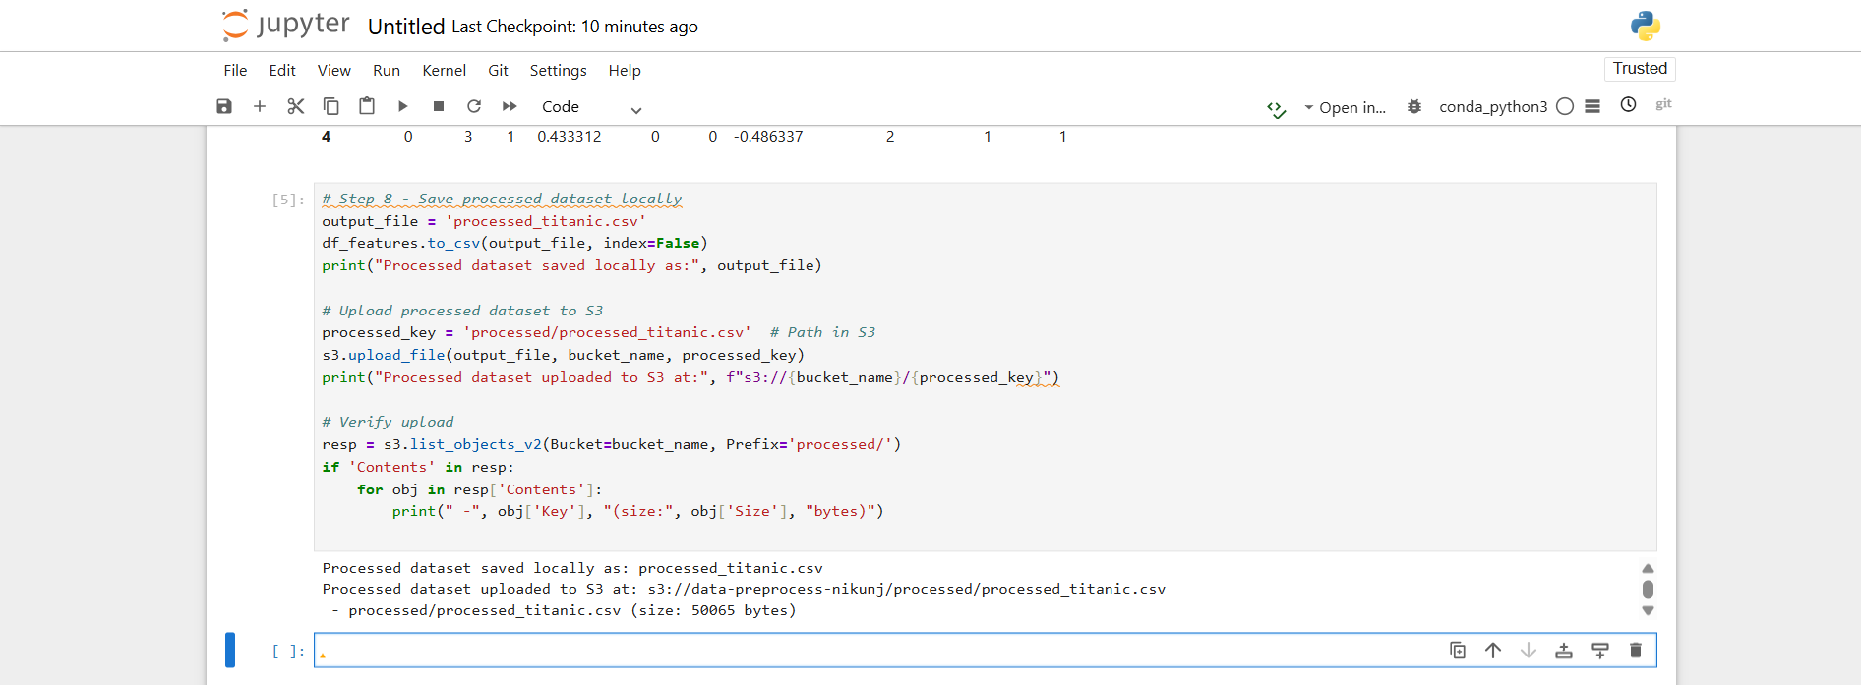

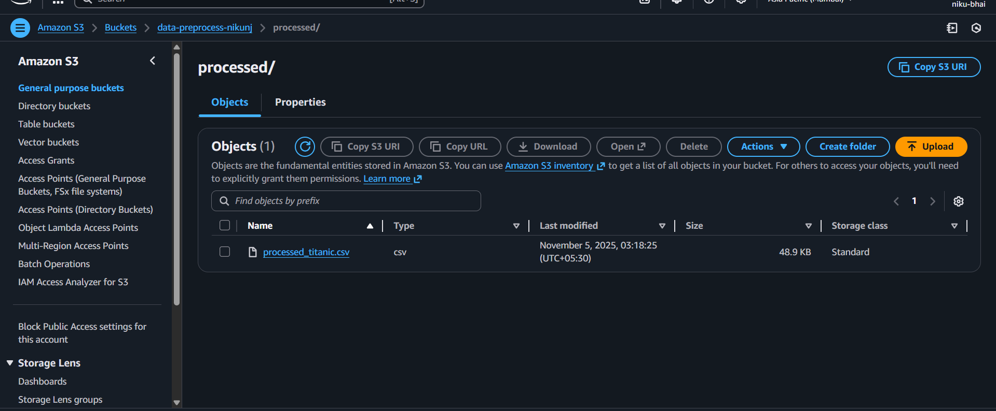

**7. Conclusion:**

In this lab, a dataset was successfully preprocessed using Amazon SageMaker notebooks and Amazon S3 storage. The Titanic dataset was loaded from S3, cleaned by handling missing values, and transformed by encoding categorical variables and scaling numeric features. Additional features, such as family_size and is_alone, were created to enhance the dataset.

The processed dataset was then saved back to the S3 bucket, demonstrating seamless integration between SageMaker and S3 for data handling. This lab highlights how cloud-based notebooks enable efficient, scalable, and cost-effective data preprocessing without requiring local computational resources.

# Practical 05

| **Student Name: Roshan Samuel** |
| --- |
| **Date of Experiment: 29/09/2025** |
| **Date of Submission:** |
| **PRN No: 20220802088** |

**1. Title of lab:** Hyperparameter Tuning for a Classification Model: To optimize the performance of a classification model by tuning its hyperparameters using SageMaker.

**2.Objective:**

The objective of this practical is to learn the process of **hyperparameter optimization (HPO)** for a machine learning model using **Amazon SageMaker**. We will:

* Prepare a dataset for training a binary classification model.
* Use a built-in SageMaker algorithm (XGBoost) to train the model.
* Define a range of hyperparameters to explore.
* Use SageMaker's automated **HyperparameterTuningJob** to find the best combination of hyperparameters that maximizes model performance (as measured by the AUC metric).

**3. Tools:**

**Amazon Web Services (AWS):** The cloud platform providing all the services.

**Amazon S3 (Simple Storage Service):** Used to store the training dataset and model artifacts.

**Amazon SageMaker:** The primary AWS service for building, training, and deploying machine learning models.

**SageMaker HyperparameterTuningJob:** The specific SageMaker feature that automates the tuning process.

**4. Software Used**:

**Python 3:** The programming language used for the entire practical.

**Jupyter Notebook:** The interactive environment (provided by SageMaker Studio) used to write and execute code.

**SageMaker Python SDK:** A high-level Python library for working with Amazon SageMaker.

**Pandas & NumPy:** Python libraries used for data manipulation and preparation.

**Scikit-learn:** Used to split the data into training and validation sets.

**5. Theory / Concept:**

**What is a Classification Model?** A classification model is a type of supervised machine learning model that predicts a categorical label. In our case, it's a **binary classification** problem, where the model learns to predict one of two outcomes (e.g., "Yes" or "No," "1" or "0").

**What are Hyperparameters?** Hyperparameters are the "settings" of a machine learning algorithm that are set *before* the training process begins. They are not learned from the data itself. Examples for an XGBoost (a popular algorithm for classification) include:

* max_depth: The maximum depth of a decision tree.
* eta (learning rate): How much to shrink the feature weights at each step.
* subsample: The fraction of training data to use for each tree.

**What is Hyperparameter Tuning?** Hyperparameter tuning (or optimization) is the process of finding the optimal combination of hyperparameter values that results in the best model performance.

* **Manual Tuning:** The data scientist guesses settings, trains a model, checks the result, and repeats. This is slow and often ineffective.
* **Grid Search:** Tries every possible combination from a predefined grid. This is very slow and expensive.
* **Random Search:** Tries random combinations. It's more efficient than Grid Search.
* **Bayesian Optimization (What SageMaker uses):** This is a "smart" search. It uses the results from previous training jobs to make intelligent guesses about which new combination of hyperparameters is likely to perform best. This is far more efficient than other methods.

**How SageMaker HPO Works:** We don't just train one model. We tell SageMaker:

1. **The Algorithm:** "Use XGBoost."
2. **The Data:** "Here is the training/validation data in S3."
3. **The Hyperparameter Ranges:** "Try max_depth between 2 and 8, and eta between 0.1 and 0.5."
4. **The Objective:** "Find the settings that give the highest validation:auc (Area Under the Curve)."
5. **The Budget:** "Run a total of 20 training jobs to find the best one."

SageMaker then automatically launches 20 (or whatever number you set) separate training jobs, often in parallel, and keeps track of which one performed best.

**6. Output:**

#### **Step 1:** Go to the SageMaker Console

#### In the AWS search bar, type "SageMaker" and go to the service page.

#### On the left-hand menu, scroll down until you find the section named "Notebook".

#### Click on "Notebook instances".

#### **Step 2:** Create Your Notebook Instance

#### Click the big orange button that says "Create notebook instance".

#### Notebook instance name: Give it a simple name, like my-tuning-lab.

#### Notebook instance type: This is for billing.

#### Click the dropdown and select ml.t3.medium. (This is eligible for the AWS Free Tier and is perfectly fine for our lab).

#### Permissions and encryption: This is the most important part.

#### Under "IAM role", click the dropdown and select "Create a new role".

#### A pop-up will appear. Select "Any S3 bucket".

#### Click the "Create role" button.

#### Leave everything else as default. Scroll to the bottom and click the orange "Create notebook instance" button.

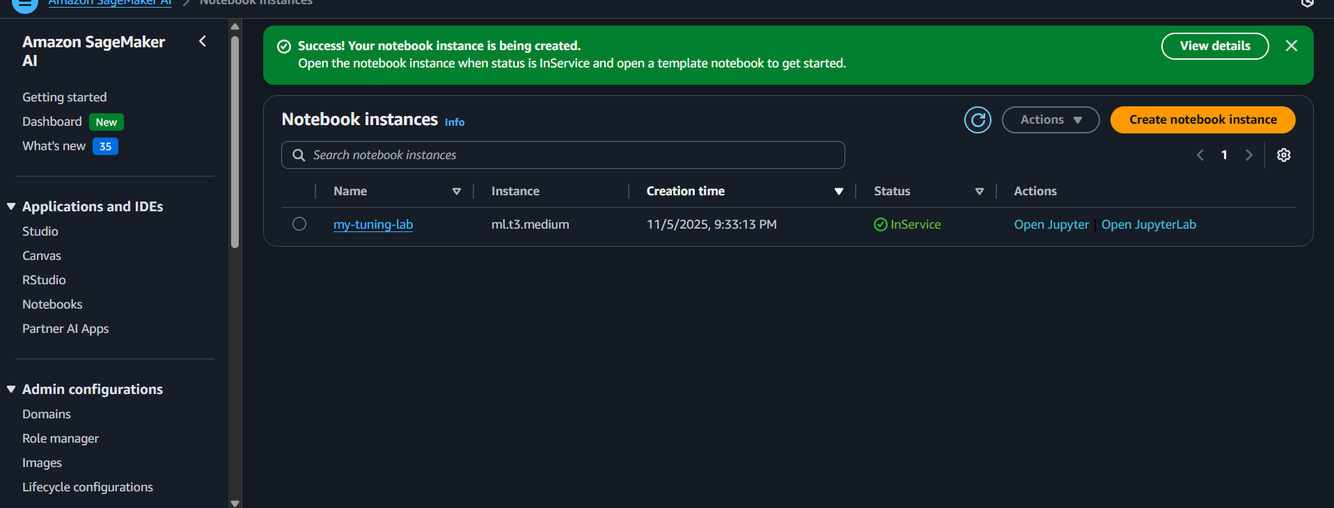

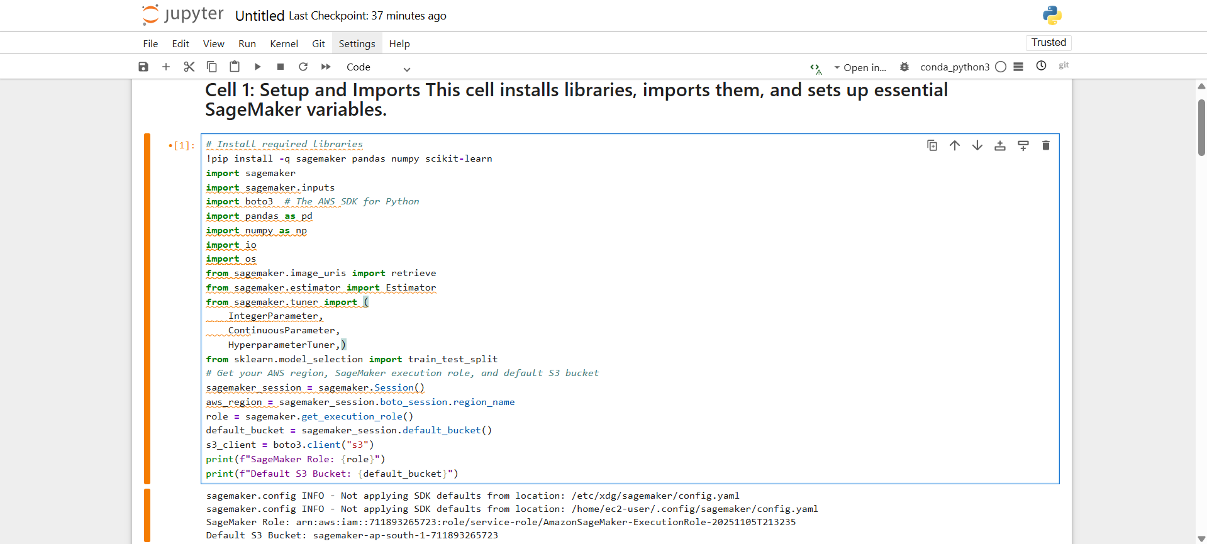

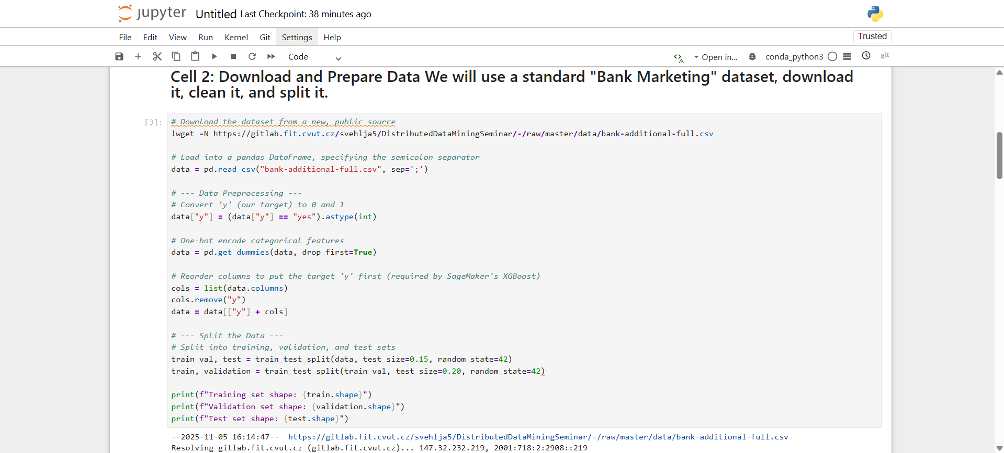

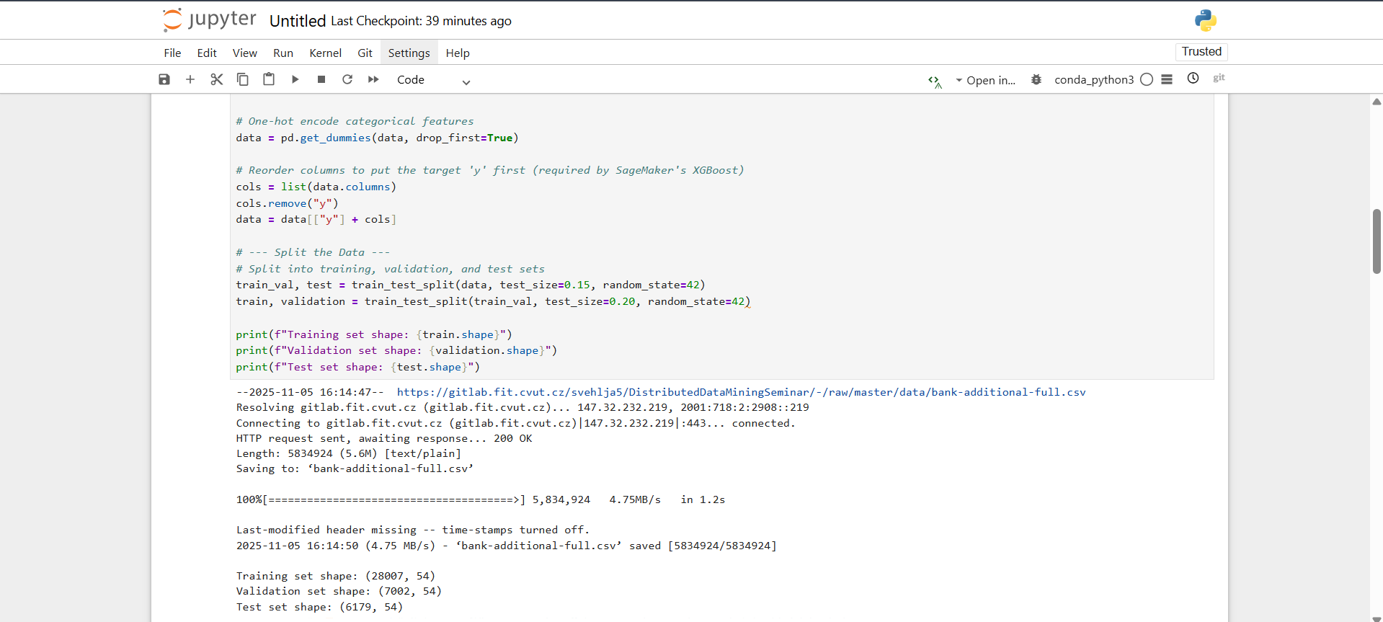

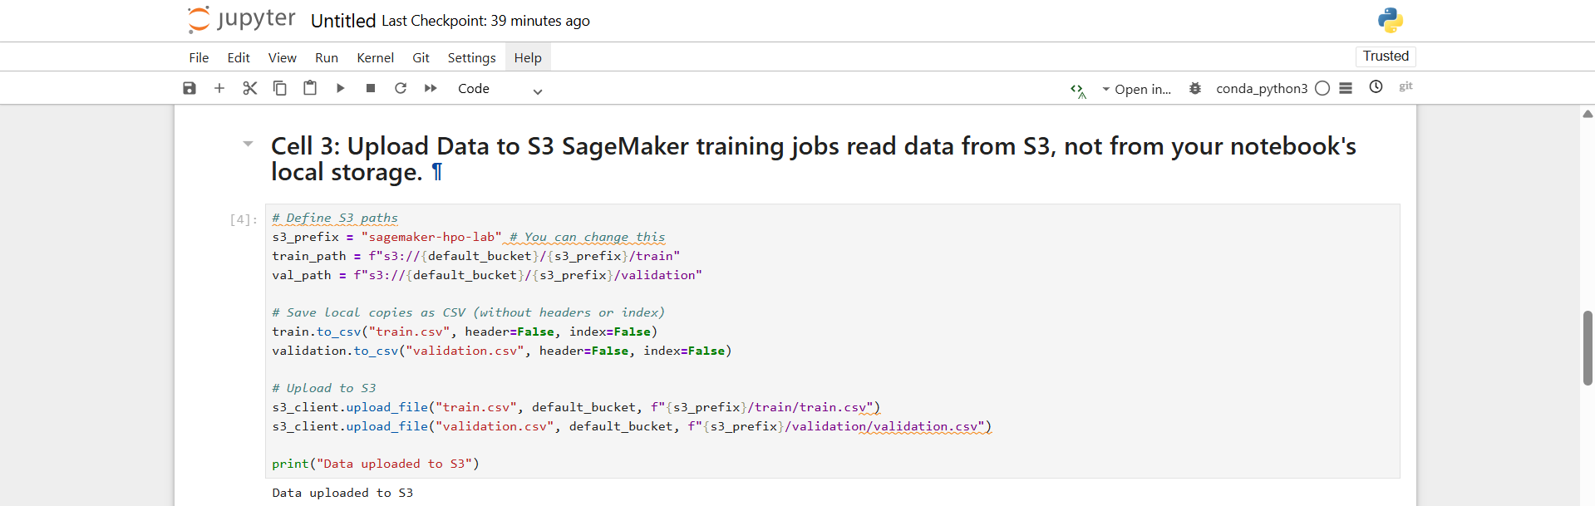

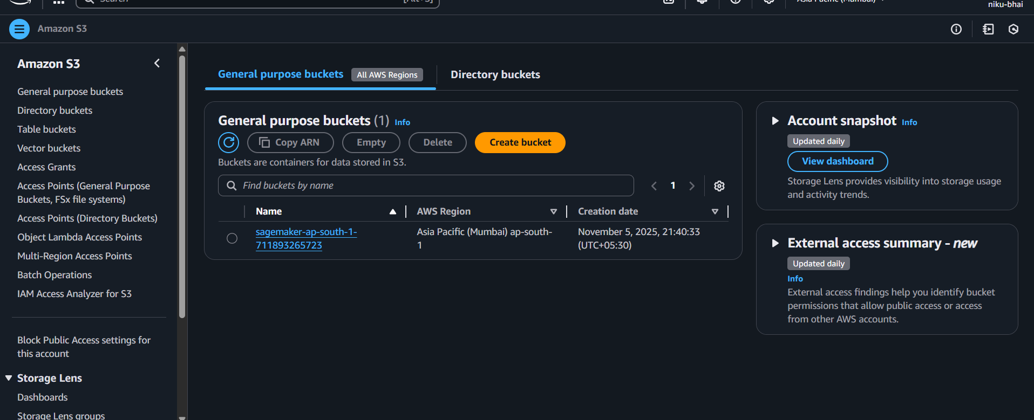

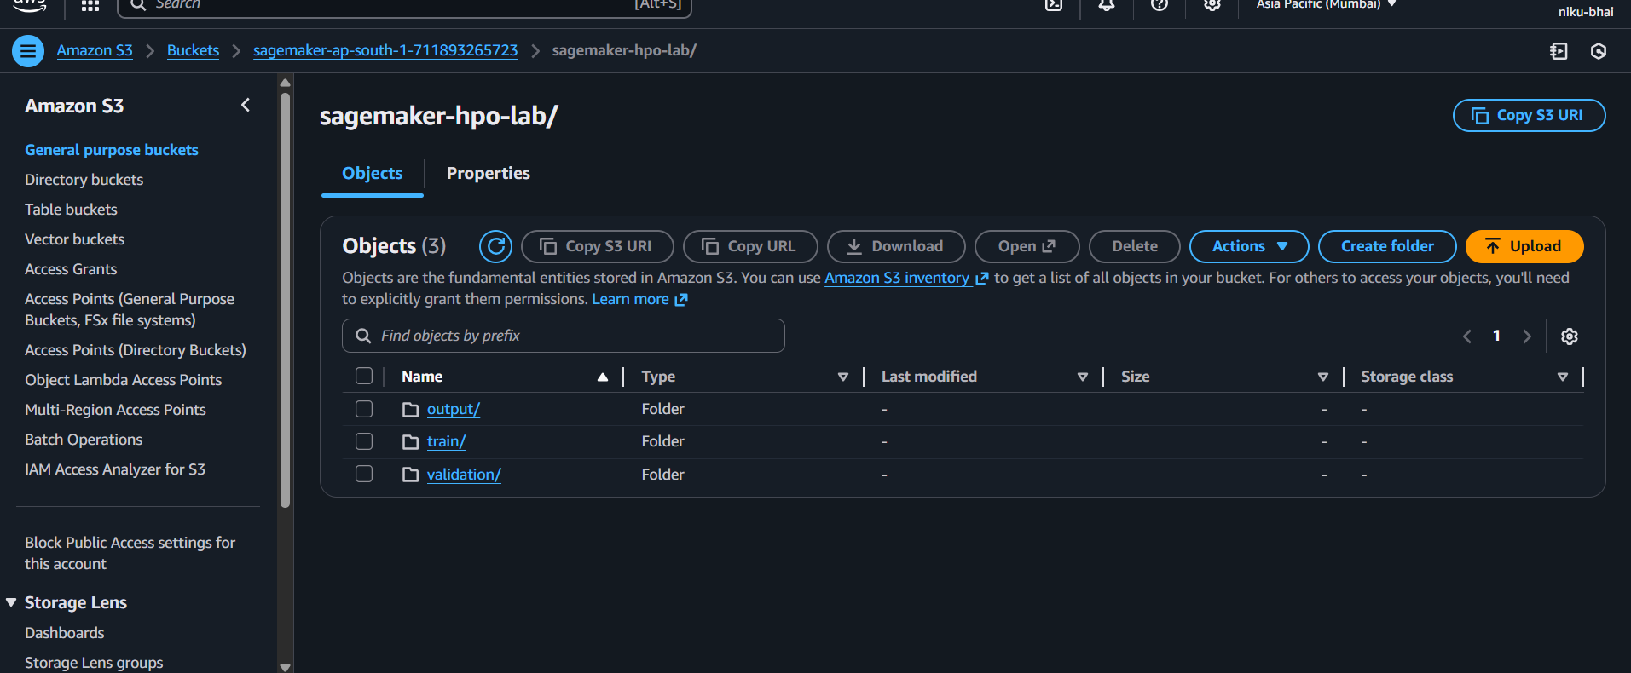

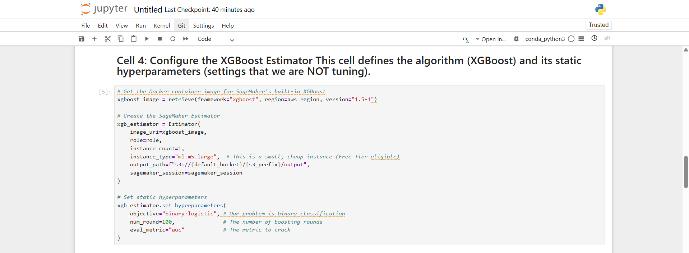

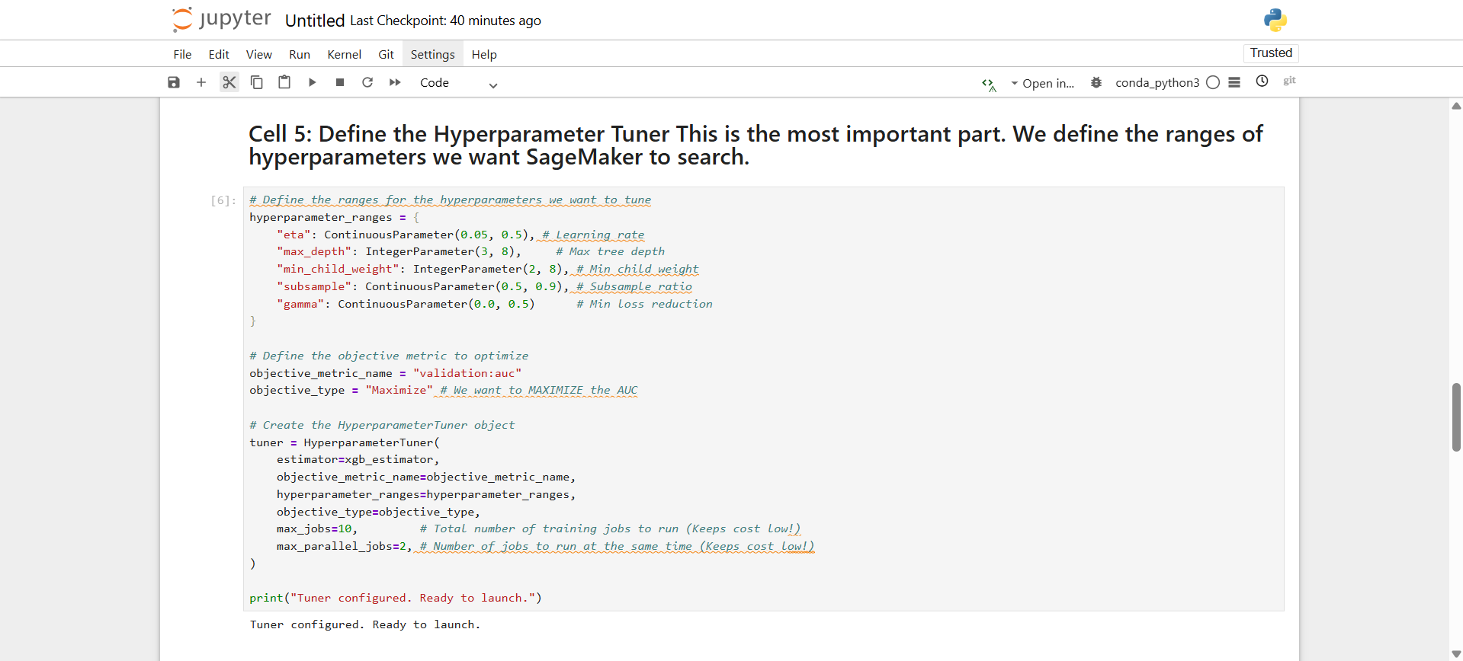

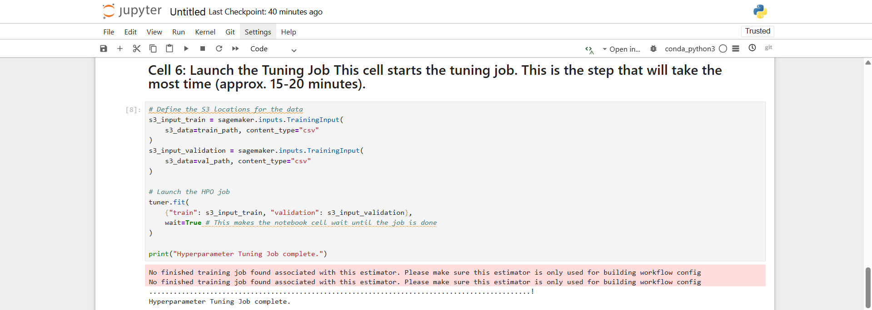

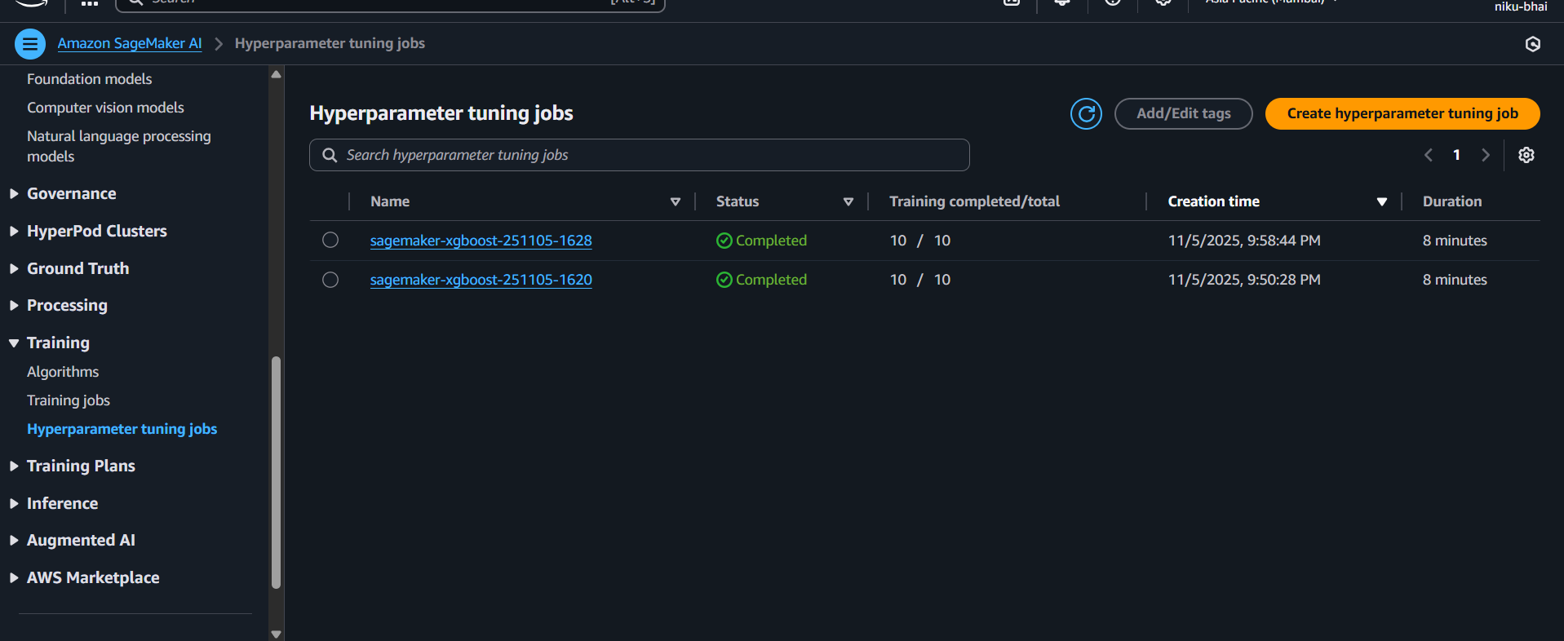  
  
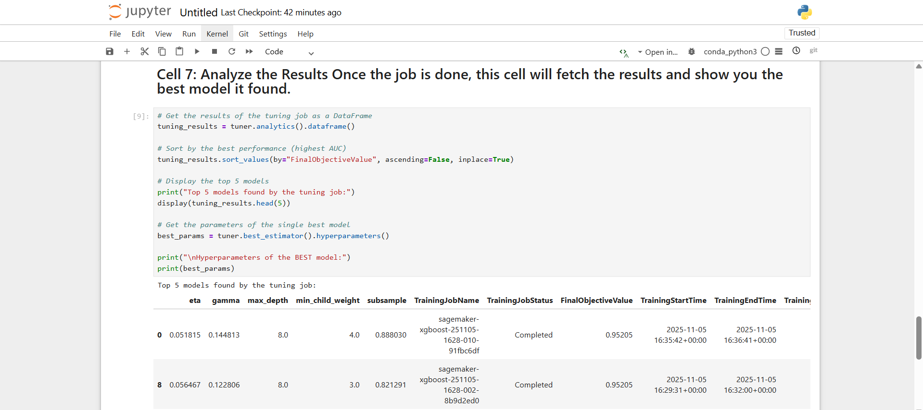

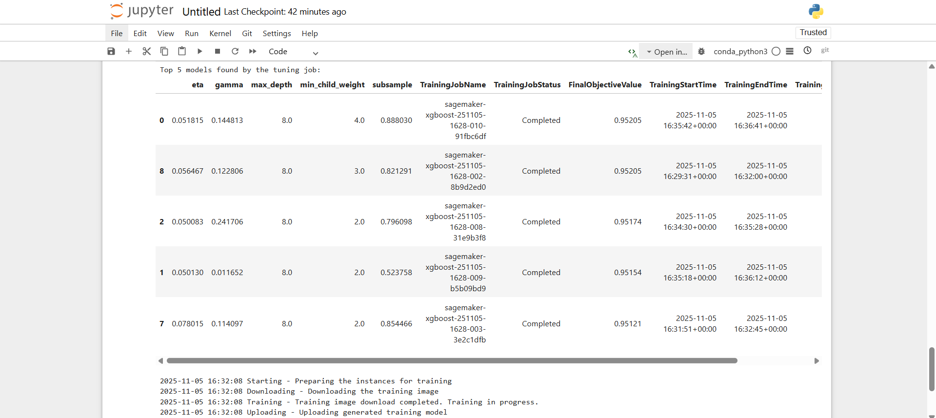

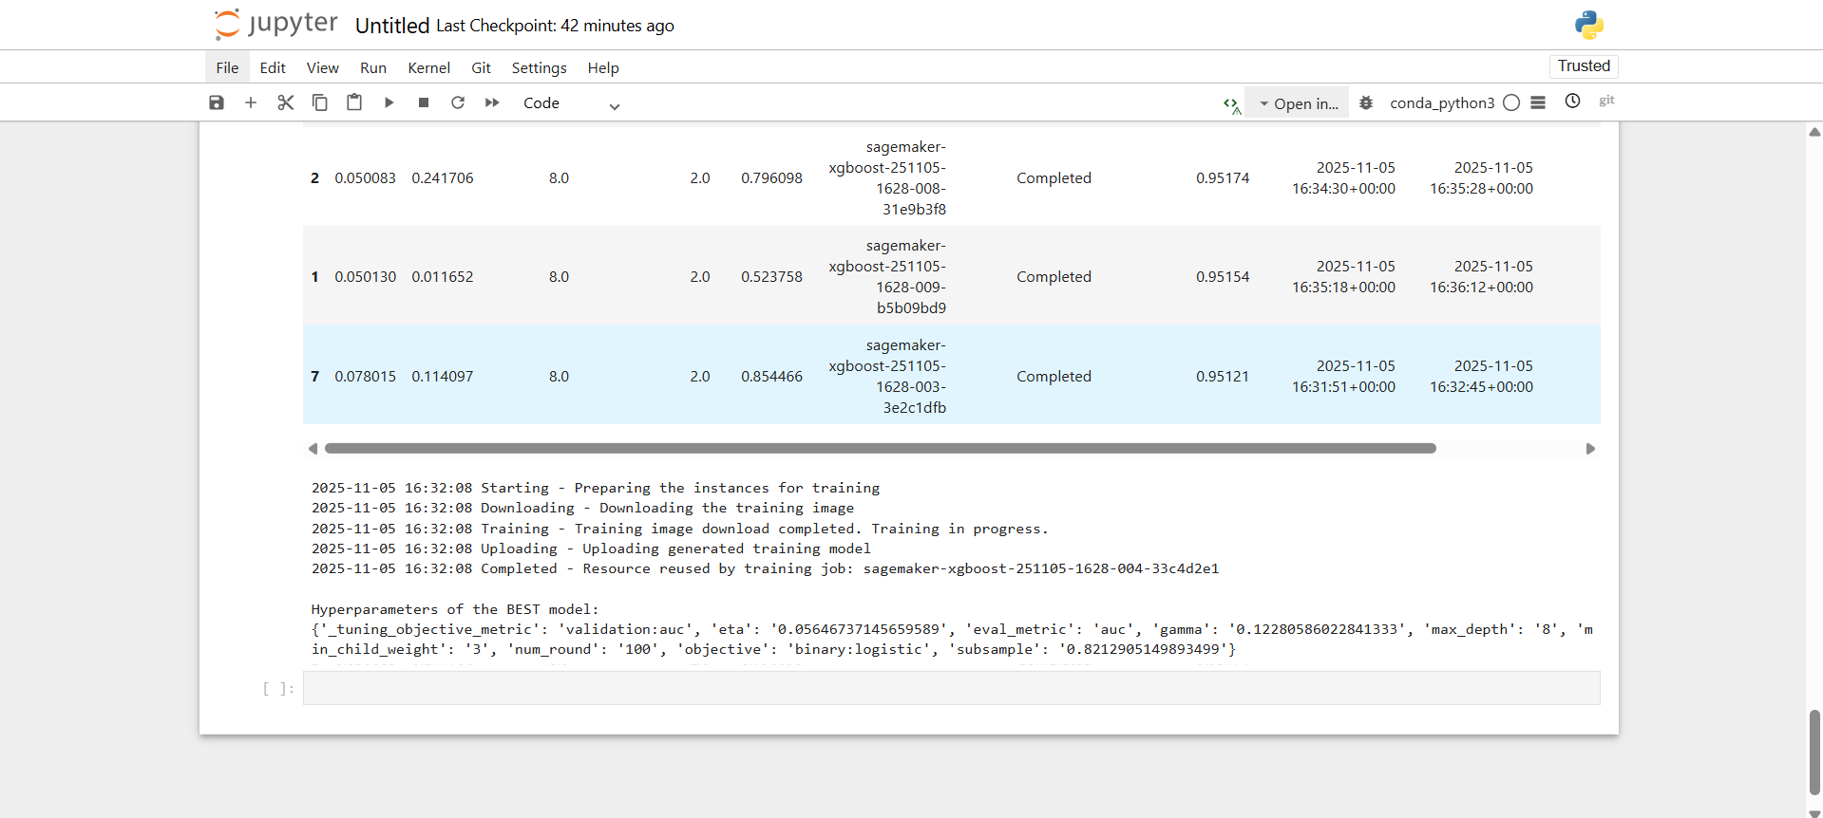

#### 

**7. Conclusion:**

In this practical, we successfully used **Amazon SageMaker** to perform automated hyperparameter tuning for an **XGBoost classification model**.

We began by preparing the Bank Marketing dataset, splitting it into training and validation sets, and uploading it to Amazon S3. We then configured a SageMaker Estimator using the built-in XGBoost algorithm.

Instead of training just one model, we defined a **HyperparameterTuner** to explore a range of values for key hyperparameters like eta, max_depth, and subsample. We set the objective to **maximize the validation:auc metric**, which is a standard measure of a classification model's quality.

The tuning job automatically launched 10 separate training jobs, intelligently searching the hyperparameter space using Bayesian optimization. After the job completed, we were able to analyze the results and identify the single **best combination of hyperparameters** (as shown in the final output table).

This process demonstrates how SageMaker can **significantly accelerate and improve the machine learning workflow**. It automates the tedious and time-consuming task of HPO, allowing data scientists to find highly performant models more efficiently and with less manual effort than traditional methods.

# Practical 06

| **Student Name: Roshan Samuel** |
| --- |
| **Date of Experiment: 06/10/2025** |
| **Date of Submission:** |
| **PRN No: 20220802088** |

**1. Title of lab:** **Sentiment Analysis using Amazon Comprehend:** To use Amazon Comprehend to perform sentiment analysis on text data.

**2. Objective:**

* To understand and apply sentiment analysis on text data using Amazon Comprehend.
* To identify whether a given text expresses **Positive, Negative, Neutral, or Mixed** sentiment.
* To learn how to use AWS AI/ML services with minimal cost.

**3. Tools:**

* AWS Management Console
* Web browser

**4. Software Used:**

* Web browser (Google Chrome, Firefox, etc.)
* AWS free-tier account

**5. Theory / Concept:**

**Amazon Comprehend** is a fully managed Natural Language Processing (NLP) service by AWS that analyzes text and extracts insights.

**Sentiment Analysis:**

* It classifies text into four categories:
  + **Positive** – Text expresses a positive feeling.
  + **Negative** – Text expresses a negative feeling.
  + **Neutral** – Text is informational or neutral.
  + **Mixed** – Text contains both positive and negative sentiment.

**Working Concept:**

1. Enter text into the Comprehend console.
2. Comprehend processes the text using pre-trained ML models.
3. The result is a sentiment label and confidence scores for each category.

**6. Output:**

**Step 1:** Search for Amazon Comprehend

1. Once logged in, at the top search bar, type **Comprehend**.
2. Click on **Amazon Comprehend** from the search results.

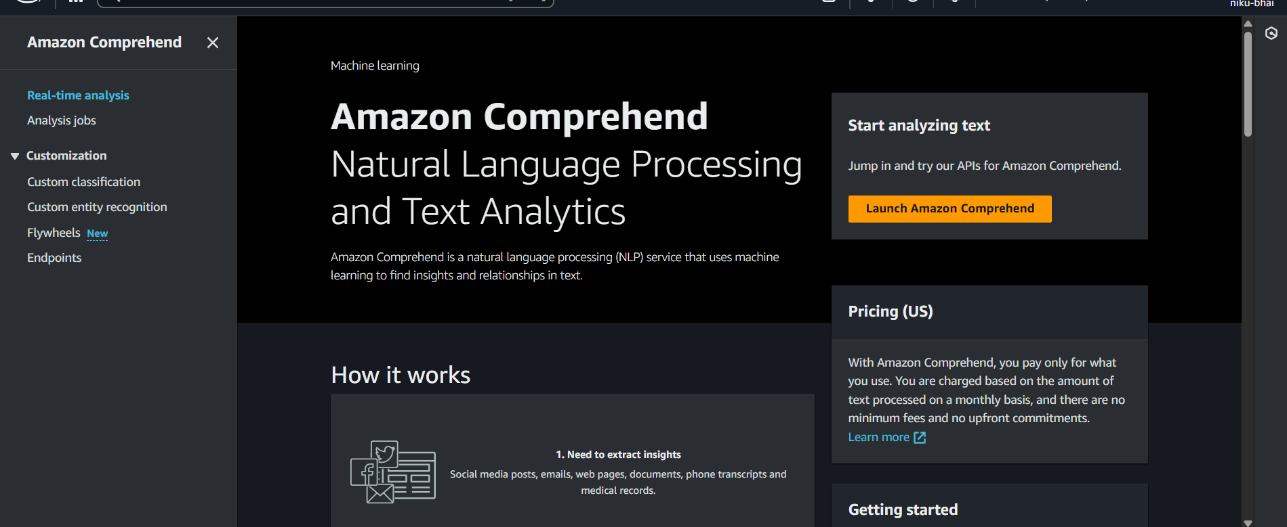

**Step 2:** Click on Real-time analysis

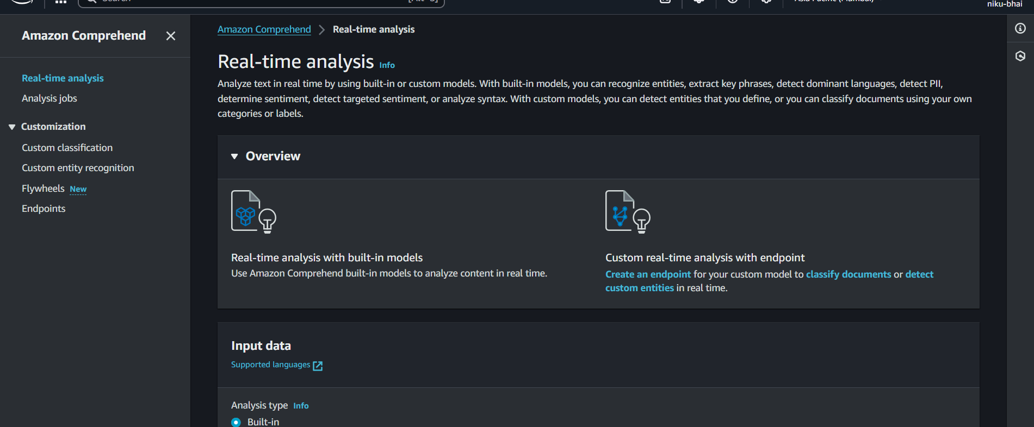  
  
**Step 3:** Give text in input text and then Analyze it.

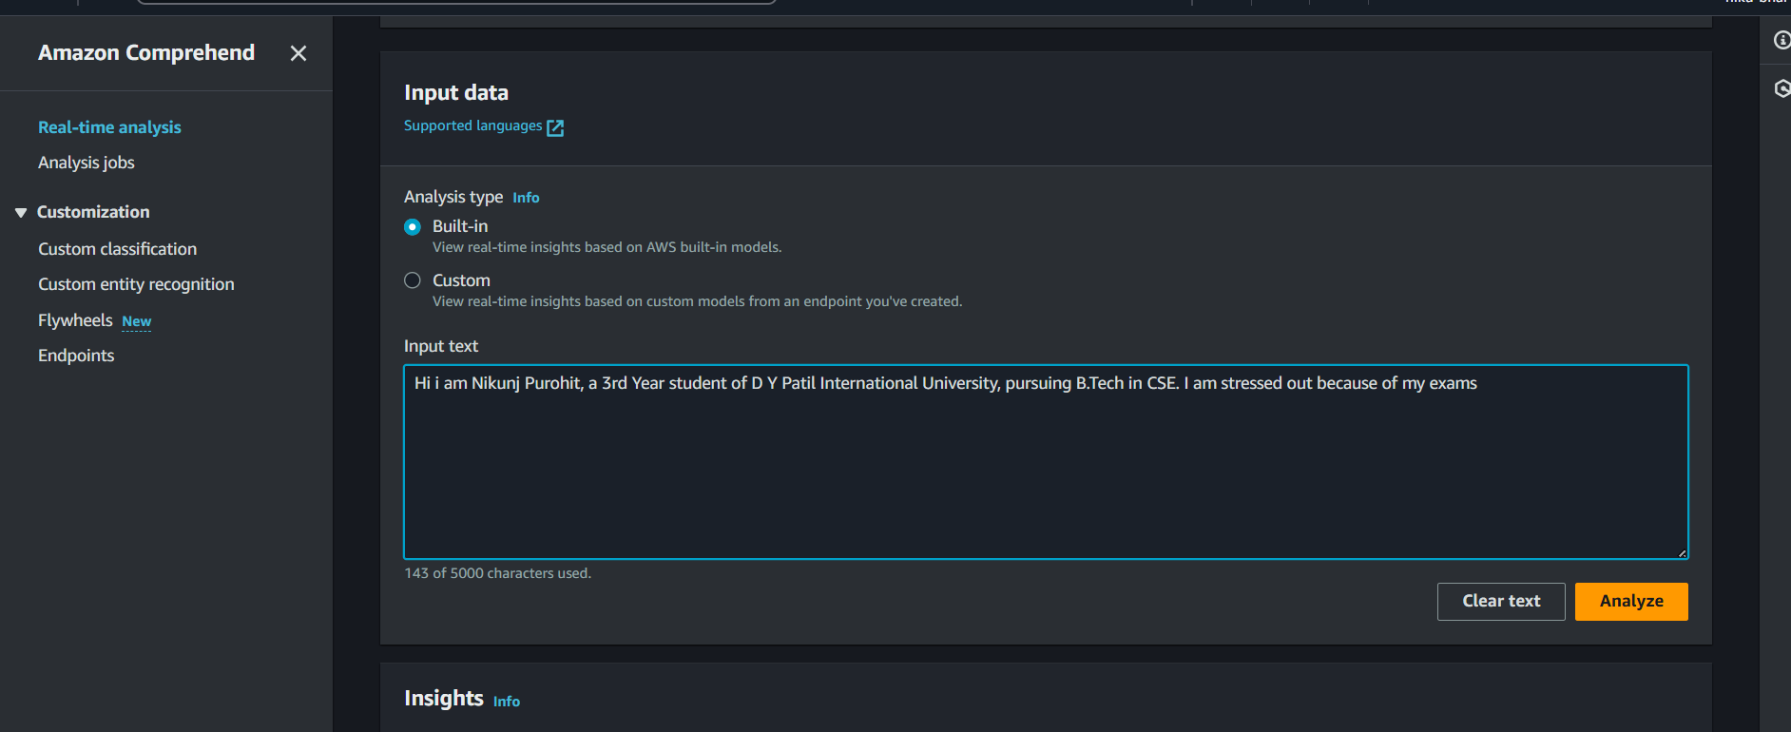

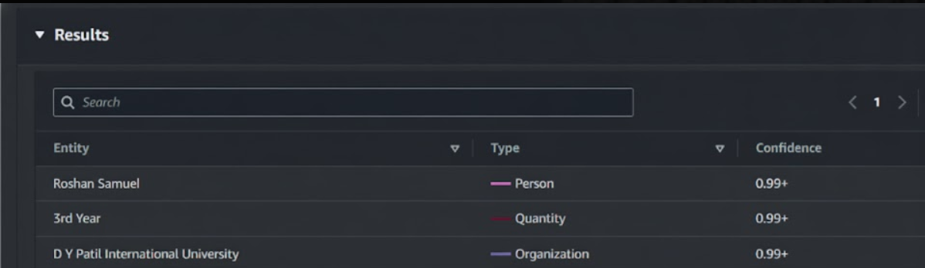Results:

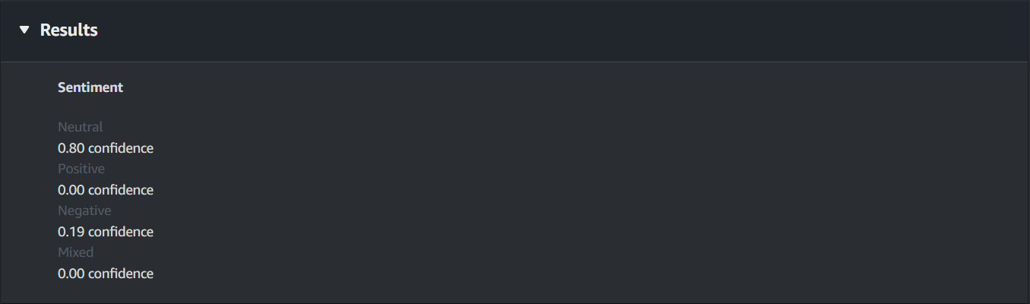

**7. Conclusion:**

Amazon Comprehend allows performing **sentiment analysis** on text data easily using the AWS Management Console, without any coding.

It accurately classifies text into **Positive, Negative, Neutral, or Mixed** sentiments and provides confidence scores for each category.

Using **Real-time analysis** with small text samples ensures minimal or no cost, making it suitable for learning and experimentation.

This practical demonstrates how **AWS NLP services** can help extract insights from text efficiently and effectively.

# Practical 07

| **Student Name: Roshan Samuel** |
| --- |
| **Date of Experiment: 13/10/2025** |
| **Date of Submission:** |
| **PRN No: 20220802088** |

**1. Title of lab:** Building a Simple Conversational Bot with Amazon Lex

**2. Objective:**

* To design and implement a simple conversational bot using Amazon Lex.
* To understand how natural language understanding (NLU) works for building chatbots.
* To interact with users and respond intelligently to basic queries.

**3. Tools:**

* Web browser (Chrome, Firefox, etc.)
* Internet connection

**4. Software Used:**

* **AWS Management Console** (No installation required)
* **Amazon Lex** service (for bot creation)
* Optional: **AWS Lambda** (for advanced responses, can be skipped for minimal cost)

**5. Theory / Concept:**

**Amazon Lex** is a service for creating conversational interfaces. For a **ticket booking bot**, we need:

1. **Intents:** Represents a goal or action the user wants to perform. For our practical, the intent will be **OrderFlowers**.
2. **Slots:** Information the bot needs from the user to fulfill the intent:
   * FlowerType
   * PickupDate
   * PickupTime
3. **Utterances:** Phrases that the user may say or type to trigger the intent:
   * “I want to order flowers”
   * “Can I buy roses?”
4. **Prompt:** The *question* the bot asks the user to get the information for a specific slot. For example, "What type of flowers would you like?"
5. **Fulfillment:** The action the bot takes after all necessary slots are filled. In a simple bot, this is often just a confirmation message (e.g., "Your order is confirmed"). In a complex bot, this could trigger an AWS Lambda function to process an order.

**Workflow:**

1. A user types or says an utterance.
2. Amazon Lex uses Natural Language Understanding (NLU) to match this utterance to the most likely **intent**.
3. The bot then checks the **slots** required for that intent.
4. If a slot is missing, the bot uses a **prompt** to ask the user for that information.
5. This continues until all required slots are filled.
6. Finally, the bot executes the **fulfillment** step.

**6. Output:**

#### **Step 1:** Create Your Bot

### You should see a "Get Started" screen or a "Create bot" button. Click it.

### On the "Create bot" page:

### Creation method: Select "Create a blank bot".

### Bot name: Enter OrderFlowers

### IAM permissions: Choose "Create a role with basic Amazon Lex permissions". This is the easiest option and lets AWS handle the permissions for you.

### Children's Online Privacy Protection Act (COPPA): Select "No".

### Idle session timeout: Leave this as 5 minutes.

### Click "Next".

### On the "Add language to bot" screen:

### Language: Choose English (US).

### Voice interaction: Leave this as "Standard" (we will test with text, but this is the default).

### Click "Done". You will be taken to your bot's dashboard.

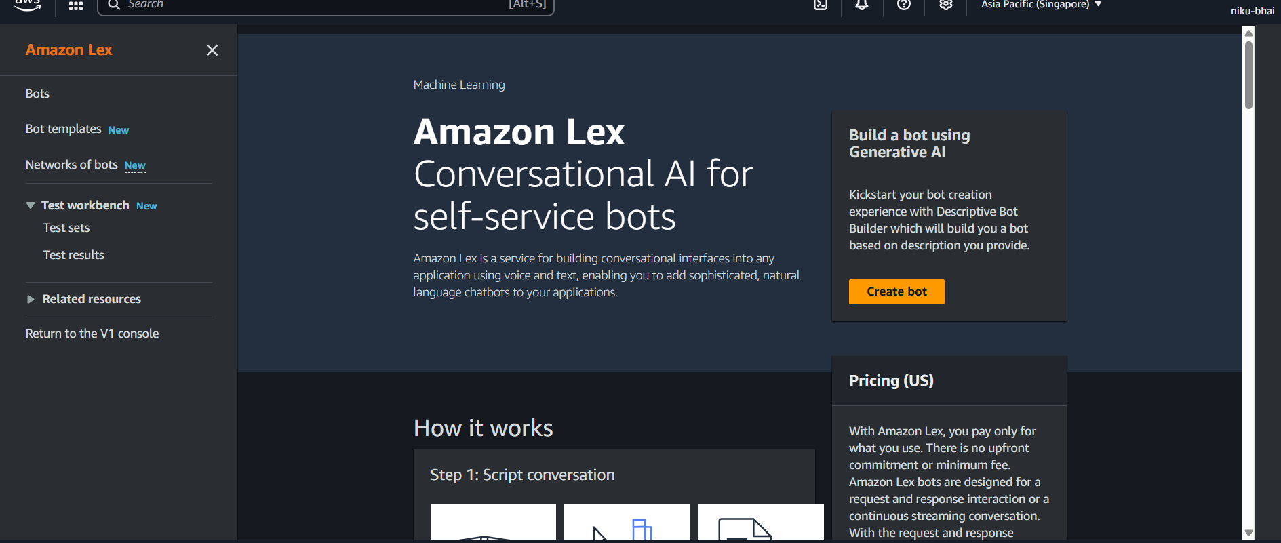

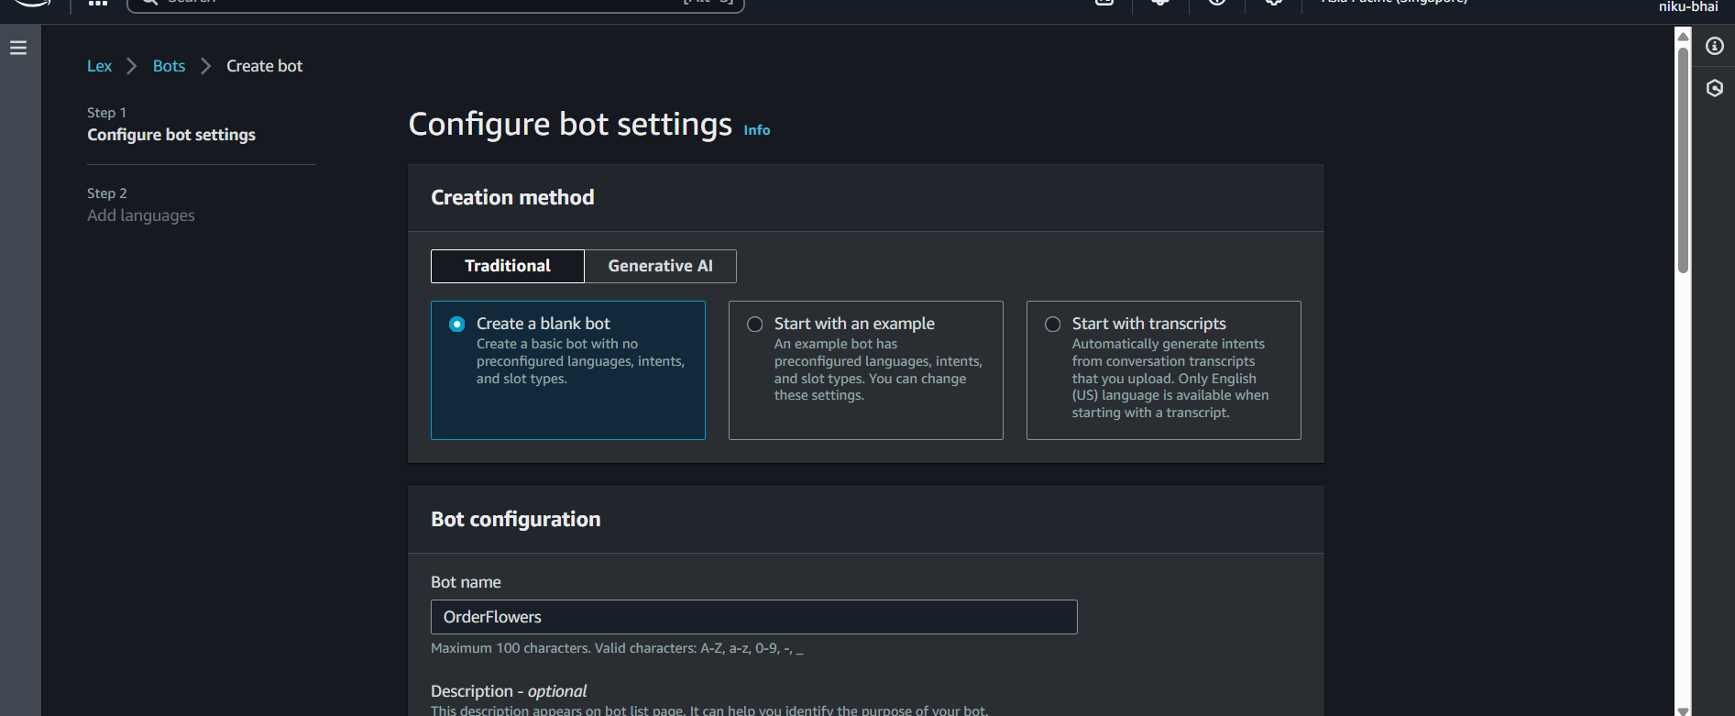

### 

### 

### 

### 

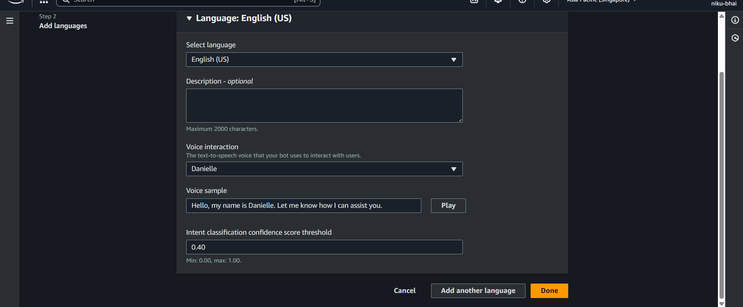

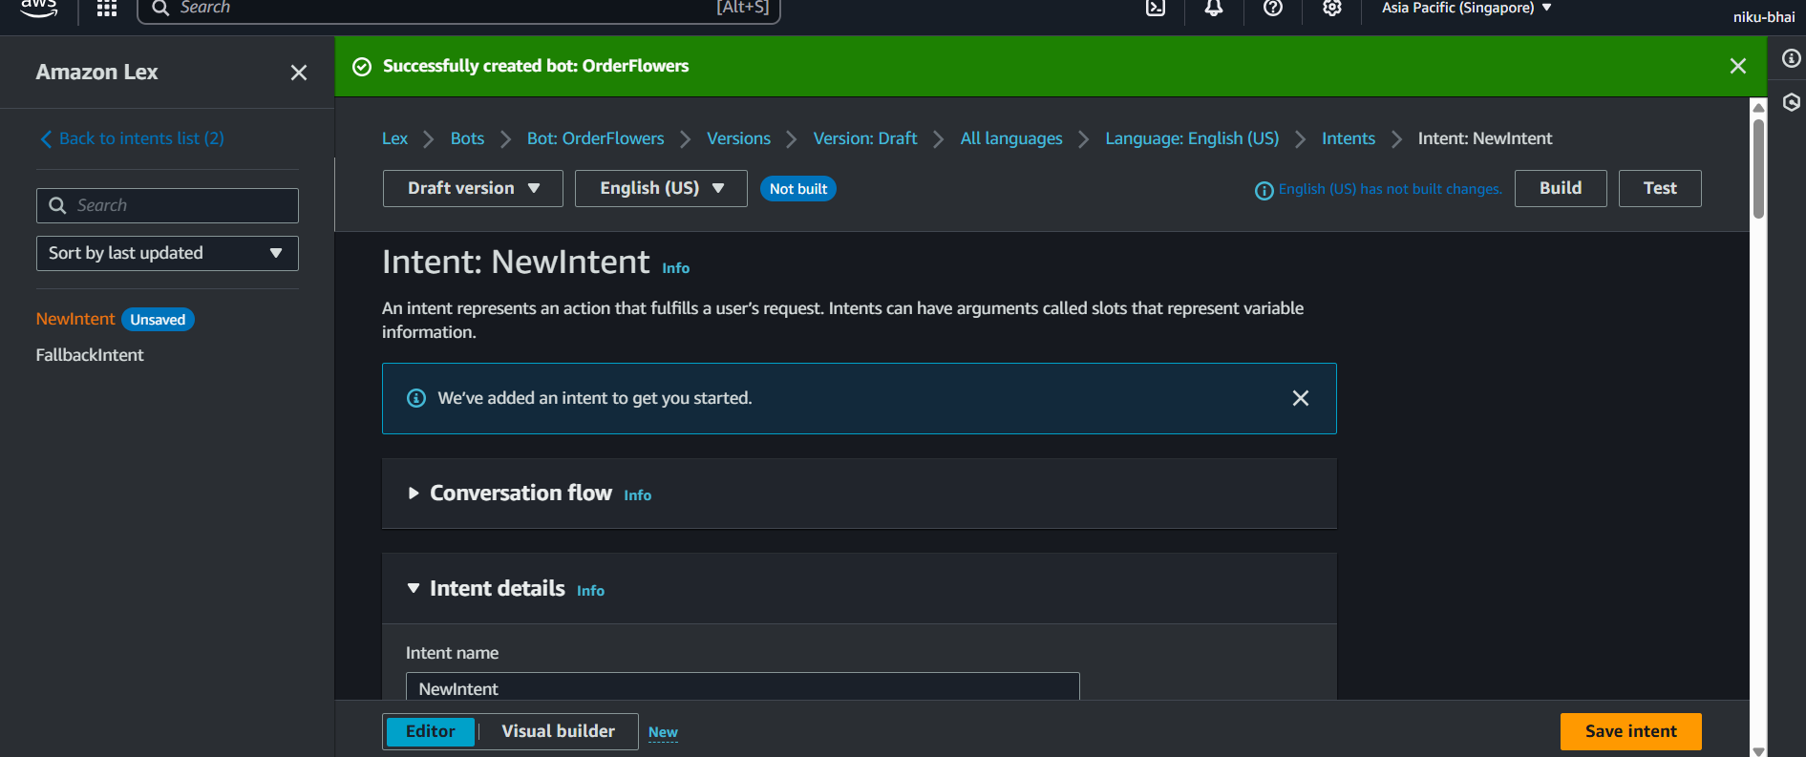

#### **Step 2:** Create Your Intent

The first thing your bot needs is a *purpose* (an intent).

1. In the "Intents" list on the left, click **"Add intent"** > **"Add empty intent"**.
2. **Intent name:** Type OrderFlowers and click **"Add"**.
3. Now you are inside the OrderFlowers intent configuration page.

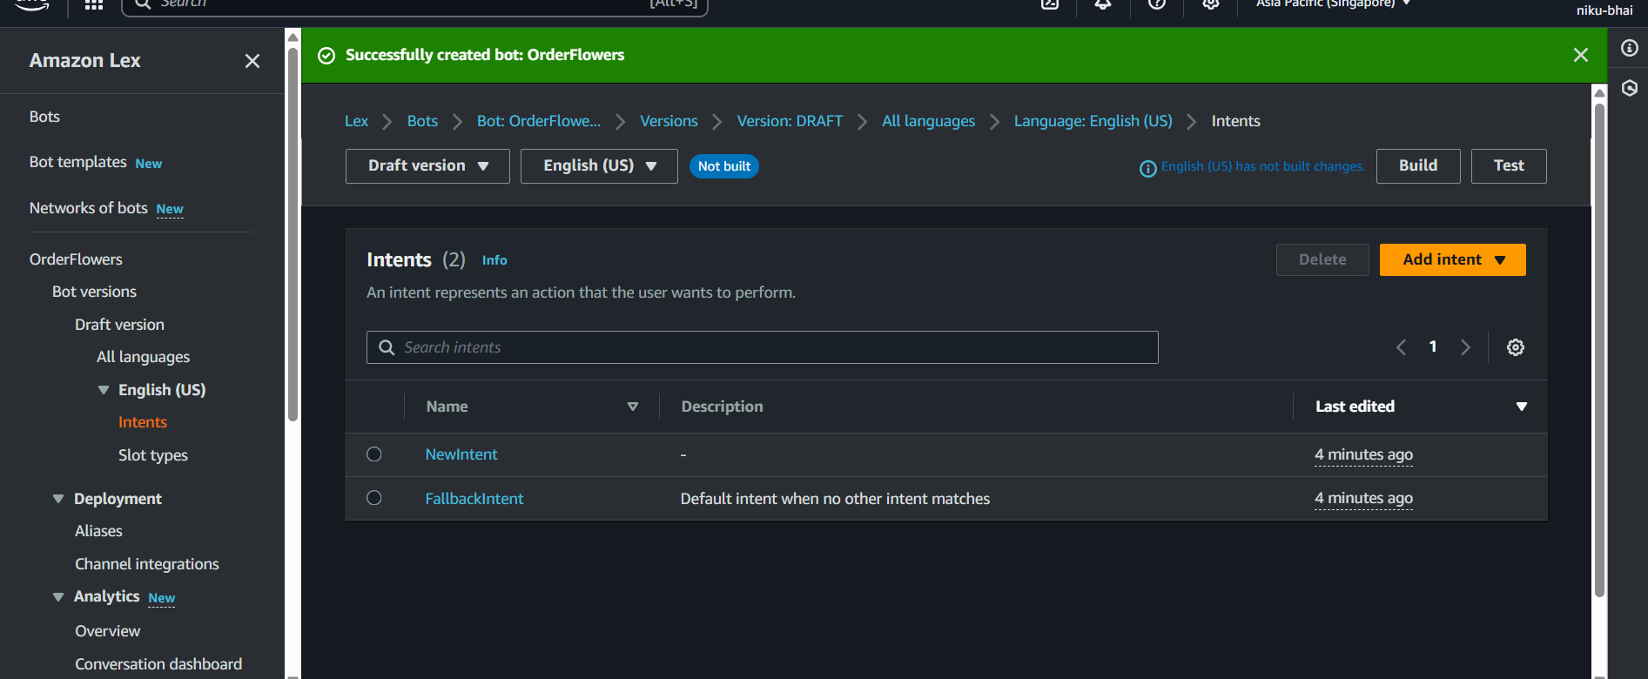

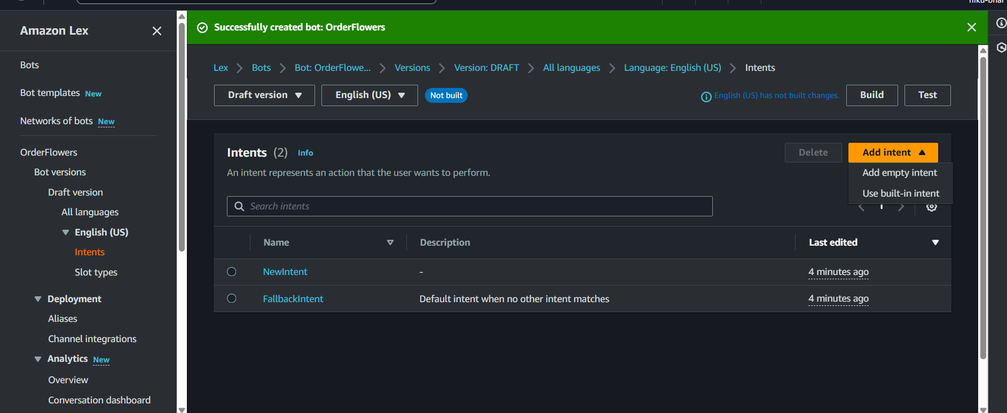

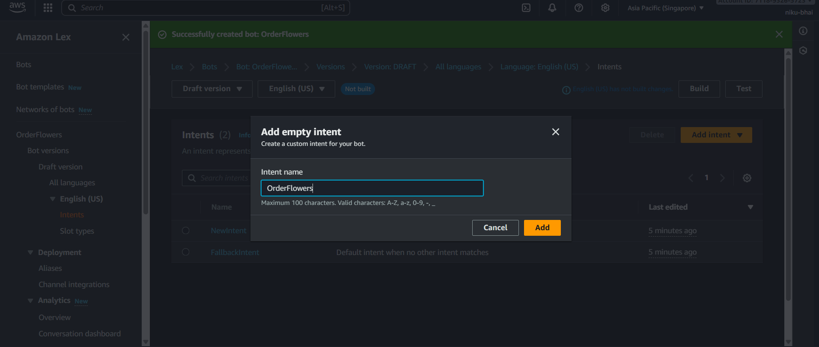

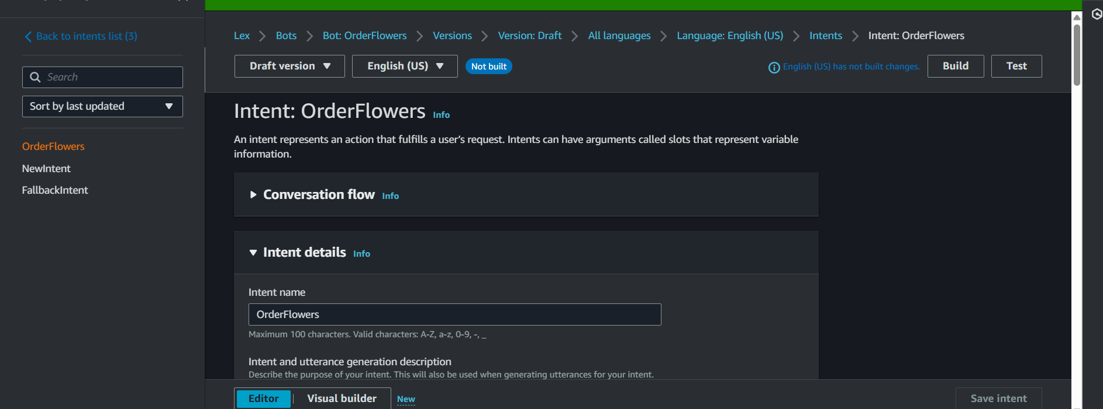

#### **Step 3:** Add Sample Utterances

Let's train the bot on what the user might say.

1. Find the **"Sample utterances"** box.
2. Type in the following phrases, pressing "Add" or Enter after each one:

* I want to order flowers
* I want to buy some flowers
* Send flowers
* Order flowers
* I need to get roses

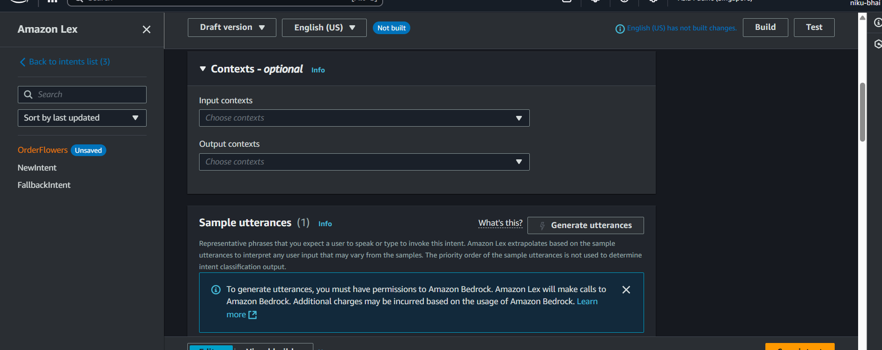

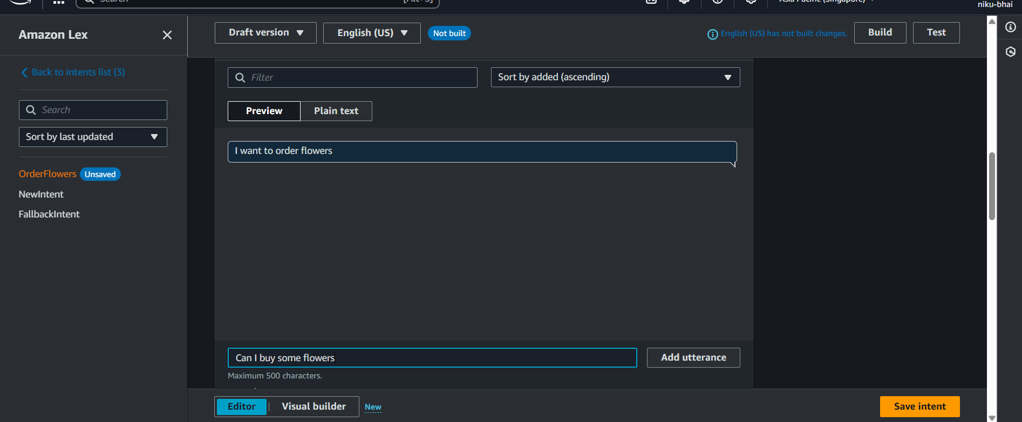

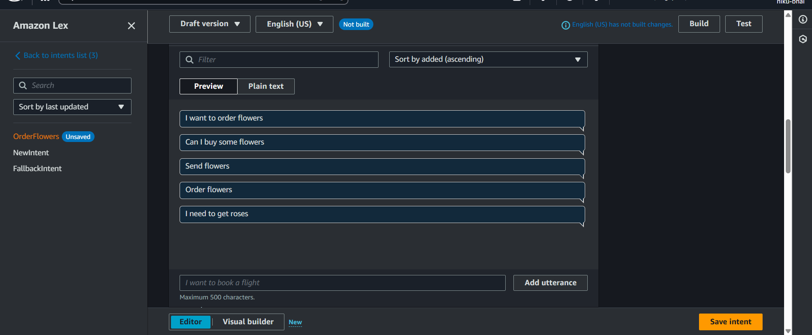

#### **Step 4:** Add Slots (The Information to Collect)

Come outside of the intent - By clicking on Back to intents list (3) (see above image)

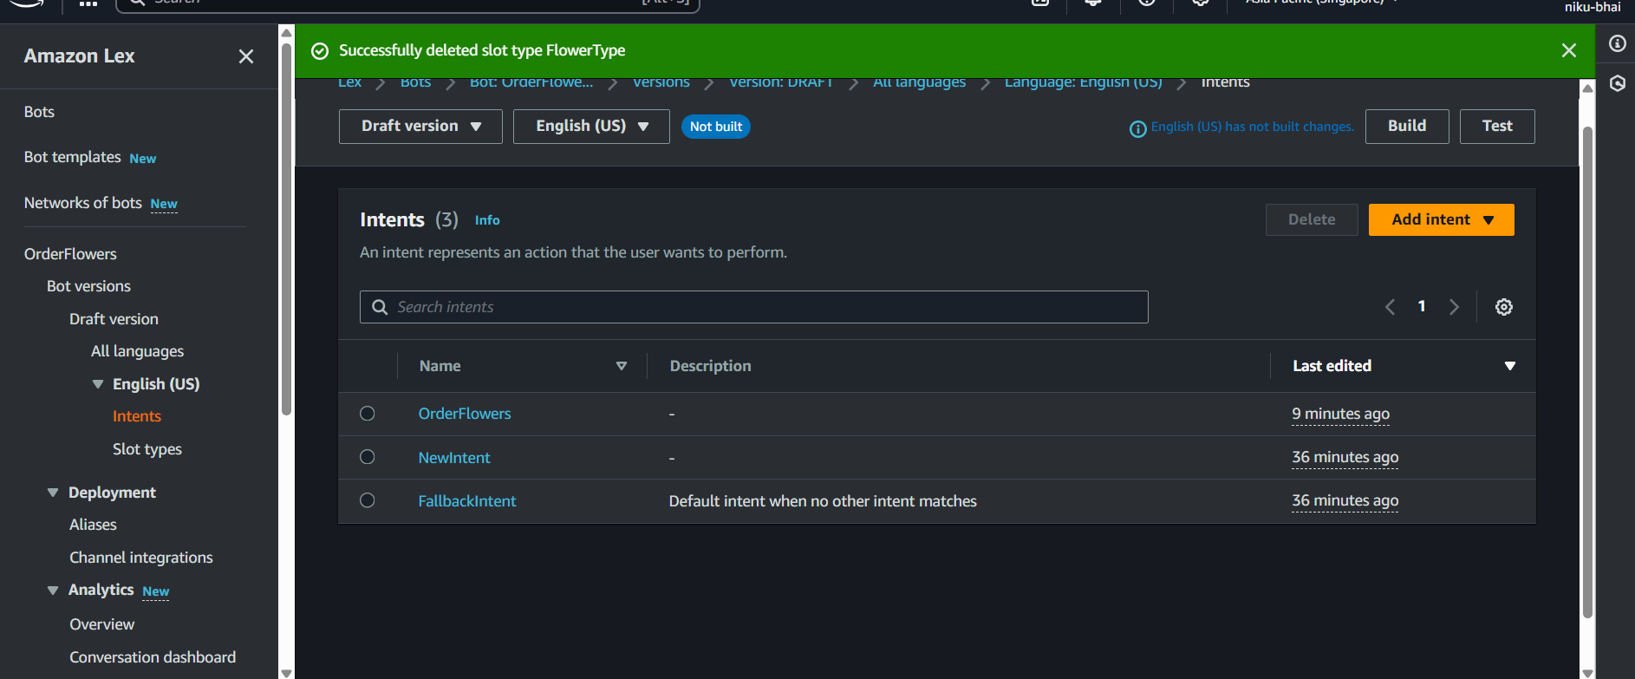

This is the most important part. We need to ask the user for details.

Click on **Slot types** (the one in your screenshot, under English (US)).

On the "Slot types" page, click the **"Add slot type"** button.

Choose **"Add blank slot type"**.

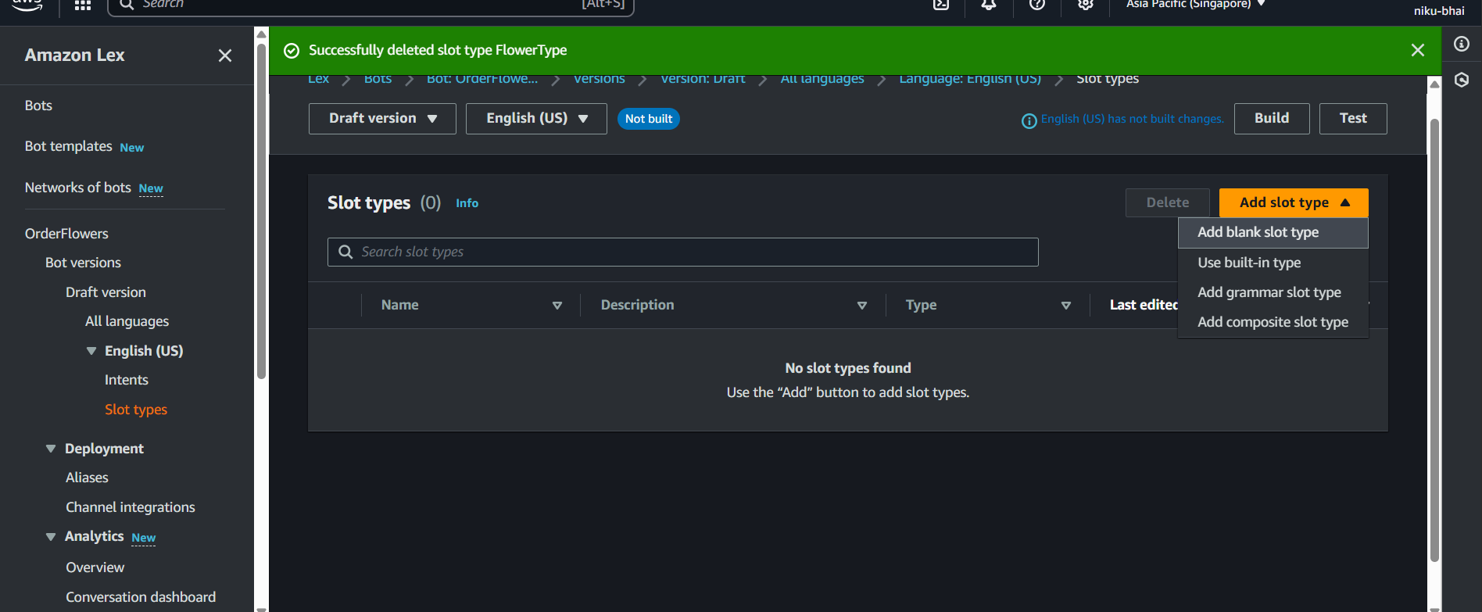

**Slot type name:** FlowerType

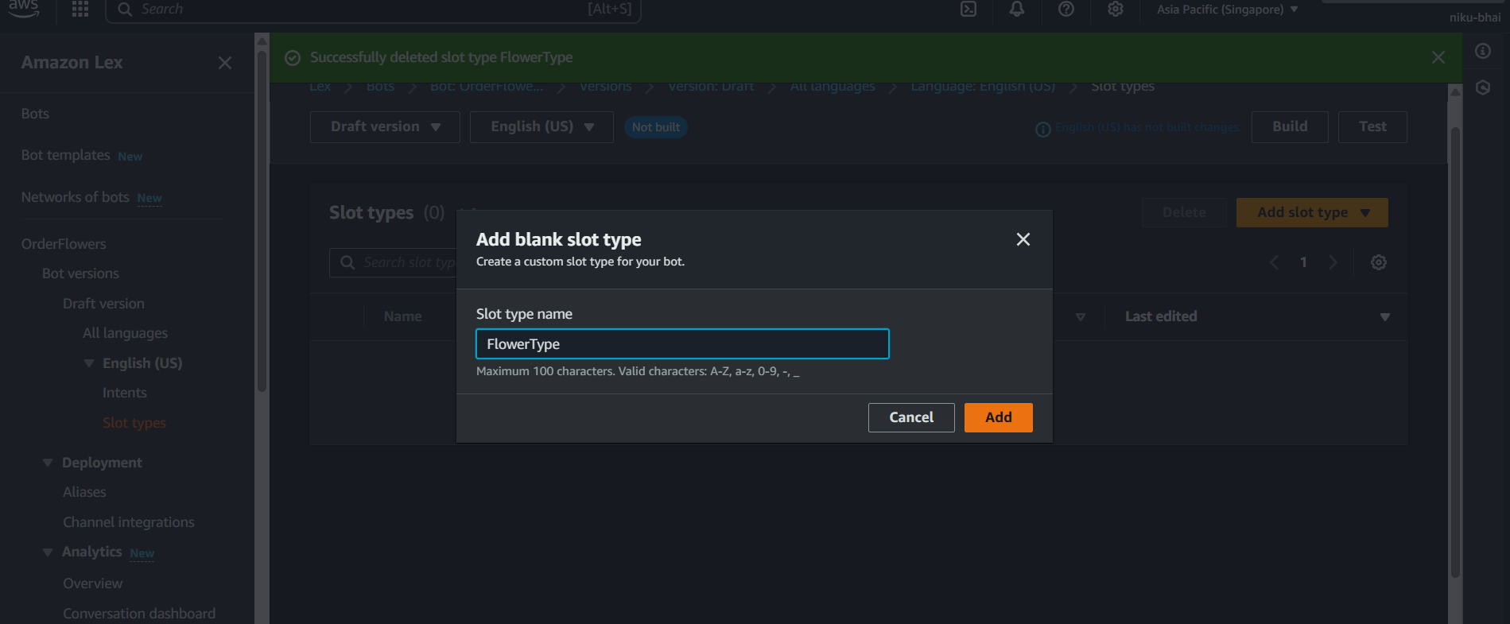

**Slot values:**

* In the "Slot values" box, type roses and click **"Add value"**.
* Type lilies and click **"Add value"**.
* Type tulips and click **"Add value"**.

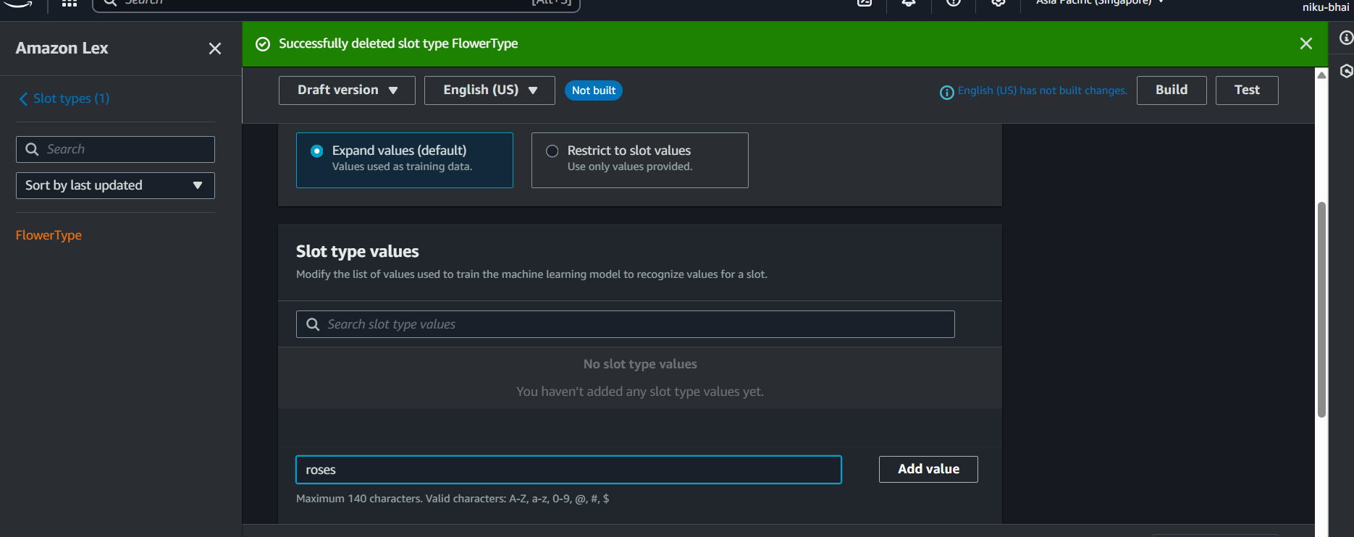

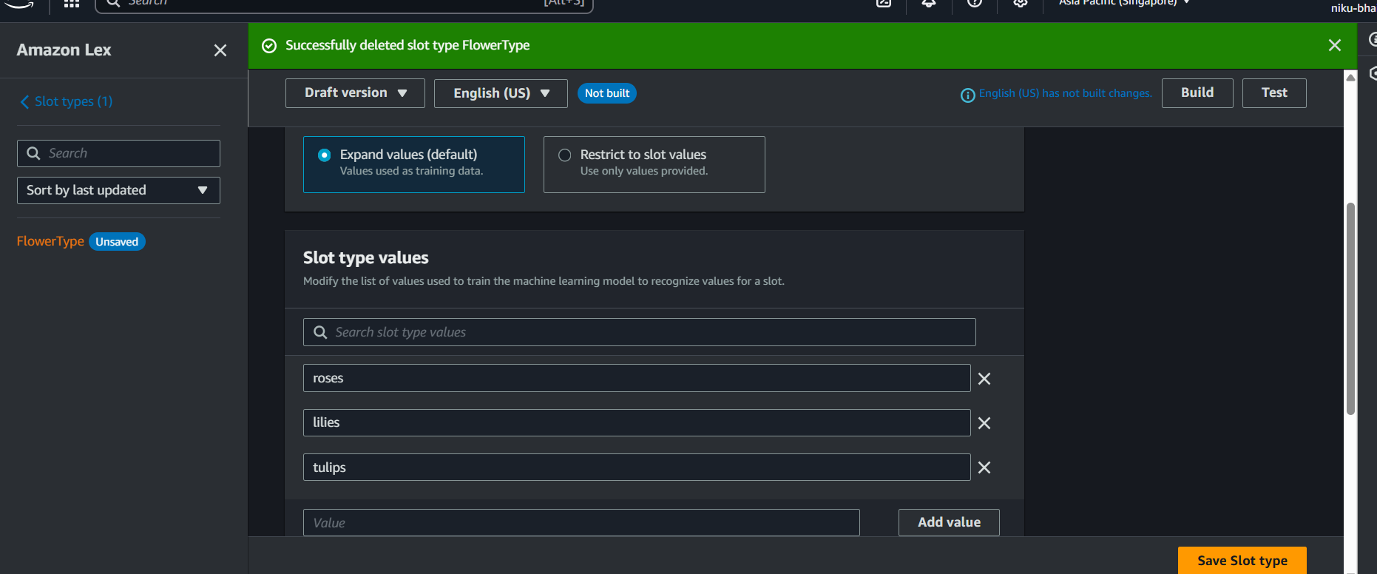

Click the **"Save slot type"** button at the bottom.

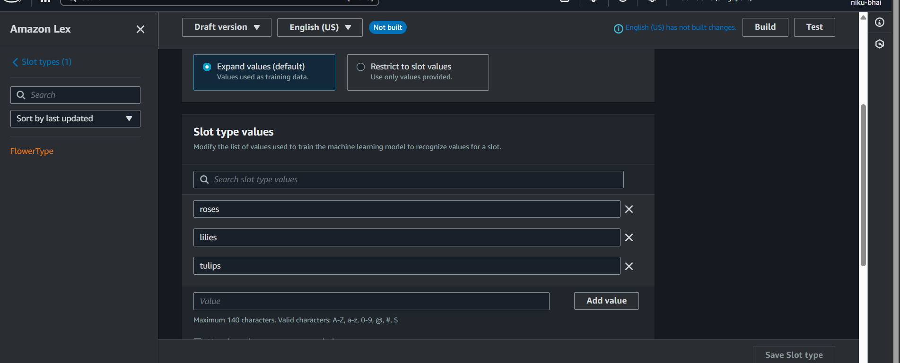

Now go back to the Intent by coming out of Slot types

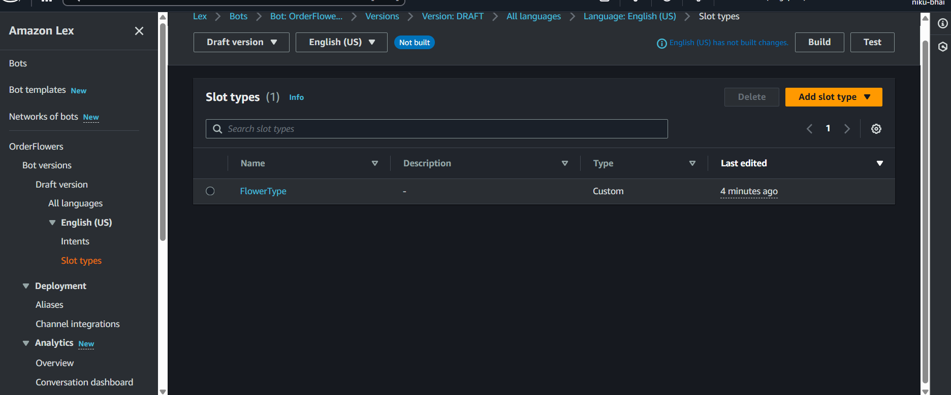

1. Scroll down to the **"Slots"** section and click **"Add slot"**.

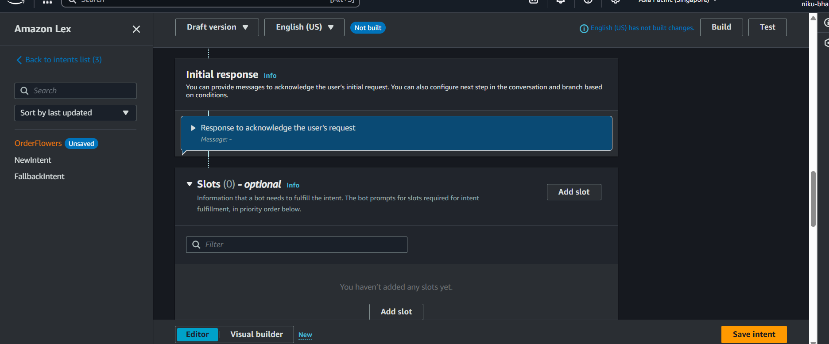

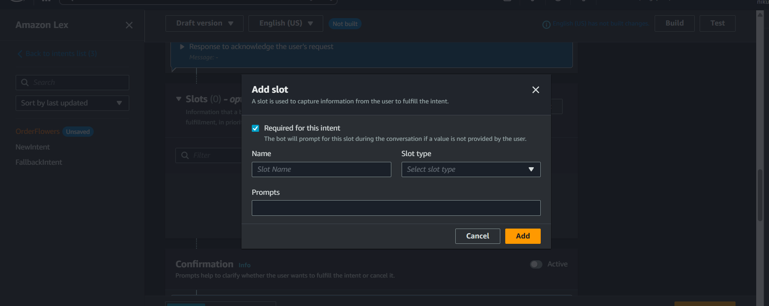

1. **Slot 1: FlowerType**
   * **Name:** FlowerType
   * **Slot type:** This is important. Instead of creating our own, let's use a built-in one. In the "Slot type" box, type AMAZON.FlowerType and select it.
   * **Prompts:** In the "Prompt" box, type: What type of flowers would you like to order?

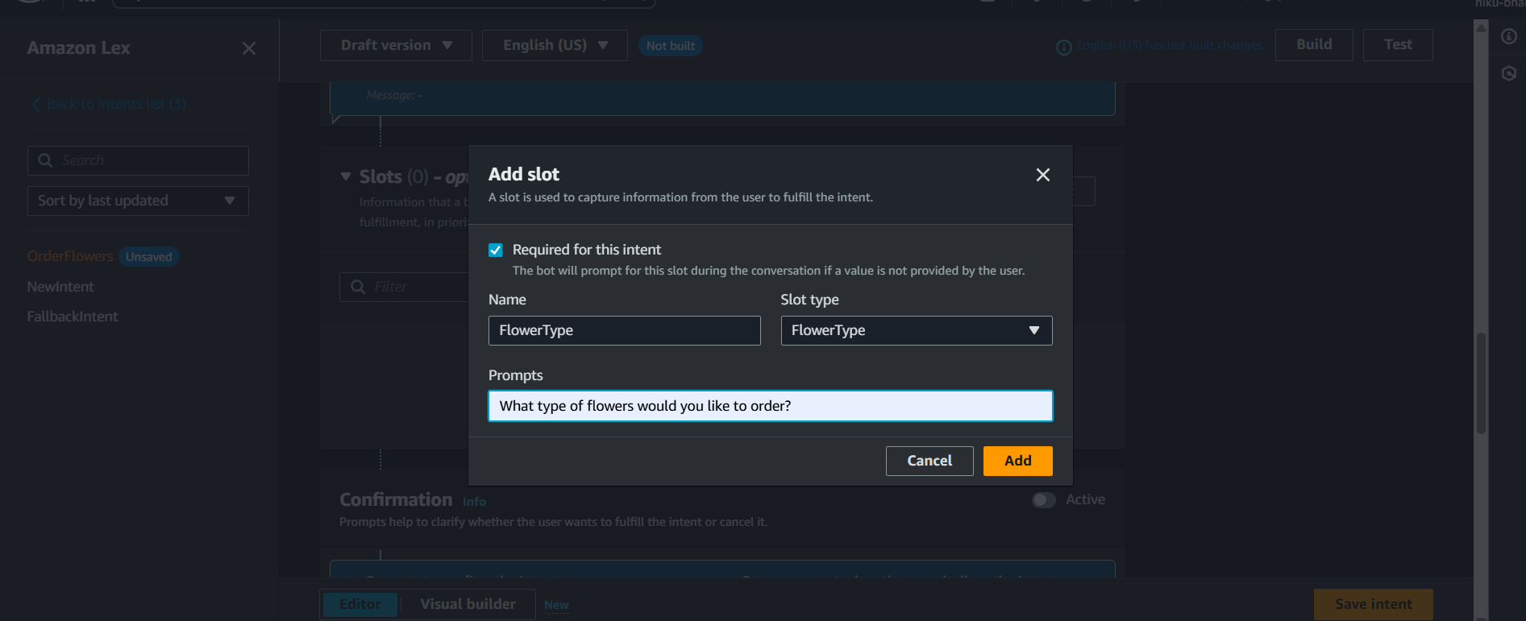

1. Click **"Add"**.

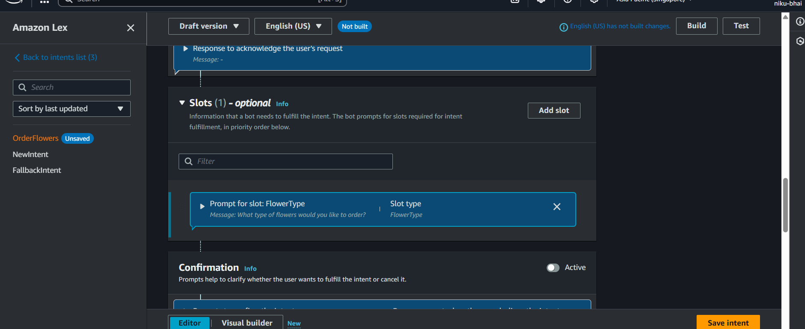

1. **Slot 2: PickupDate**
   * Click **"Add slot"** again.
   * **Name:** PickupDate
   * **Slot type:** Use the built-in AMAZON.Date.
   * **Prompts:** What day do you want to pick them up?
   * Click **"Add"**.
2. **Slot 3: PickupTime**
   * Click **"Add slot"** one last time.
   * **Name:** PickupTime
   * **Slot type:** Use the built-in AMAZON.Time.
   * **Prompts:** What time?
   * Click **"Add"**.

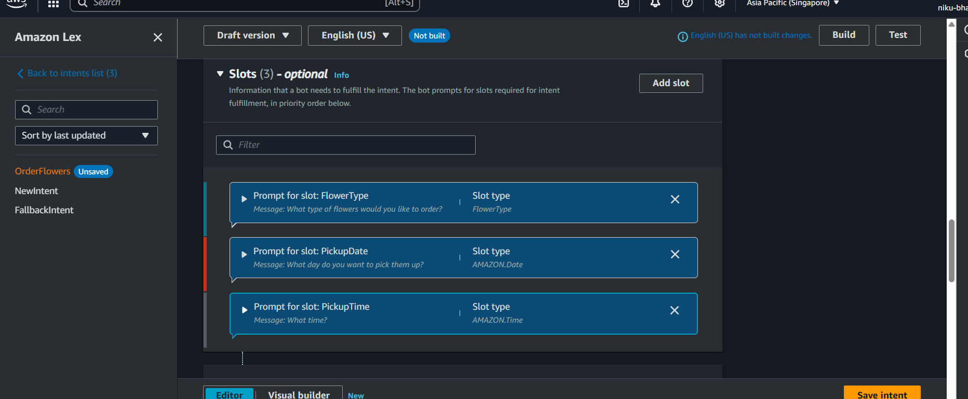

**Step 5:** **Add the Final Confirmation Message**

This is what the bot says when it has all the information.

1. Scroll down the page until you see the **"Fulfillment"** section. (It's below "Confirmation" and "Closing response").
2. 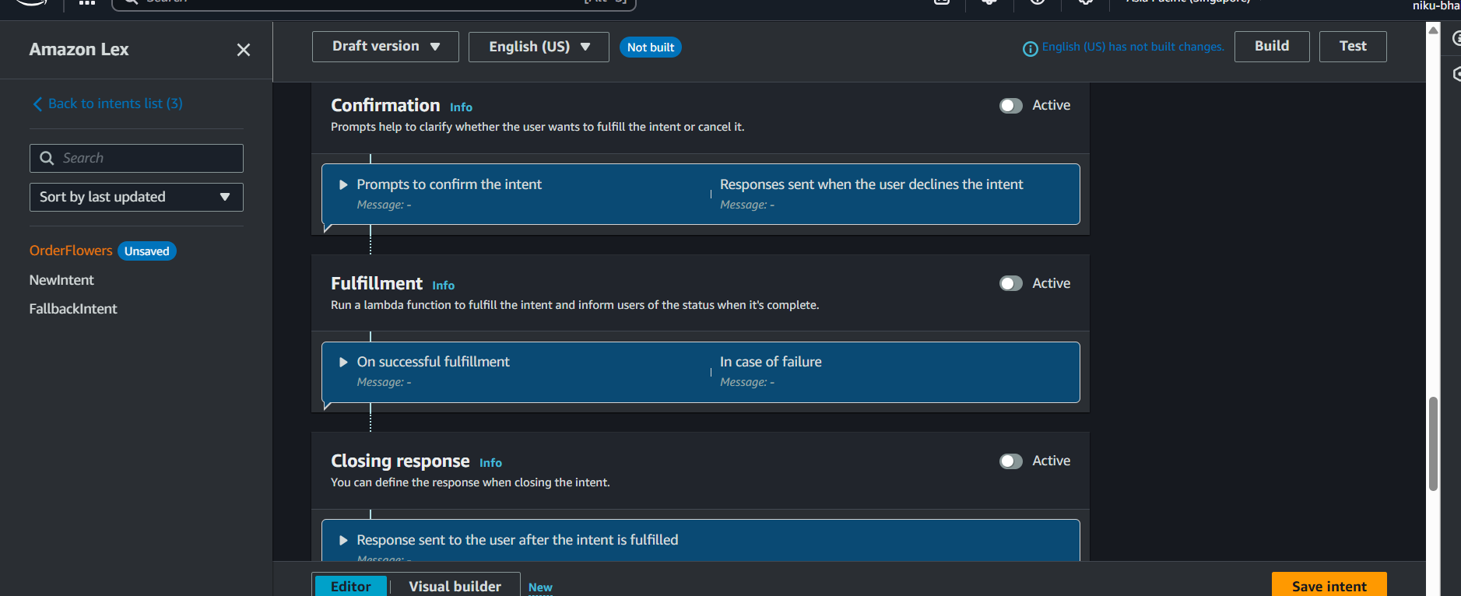
3. Click the switch to make it **"Active"**.

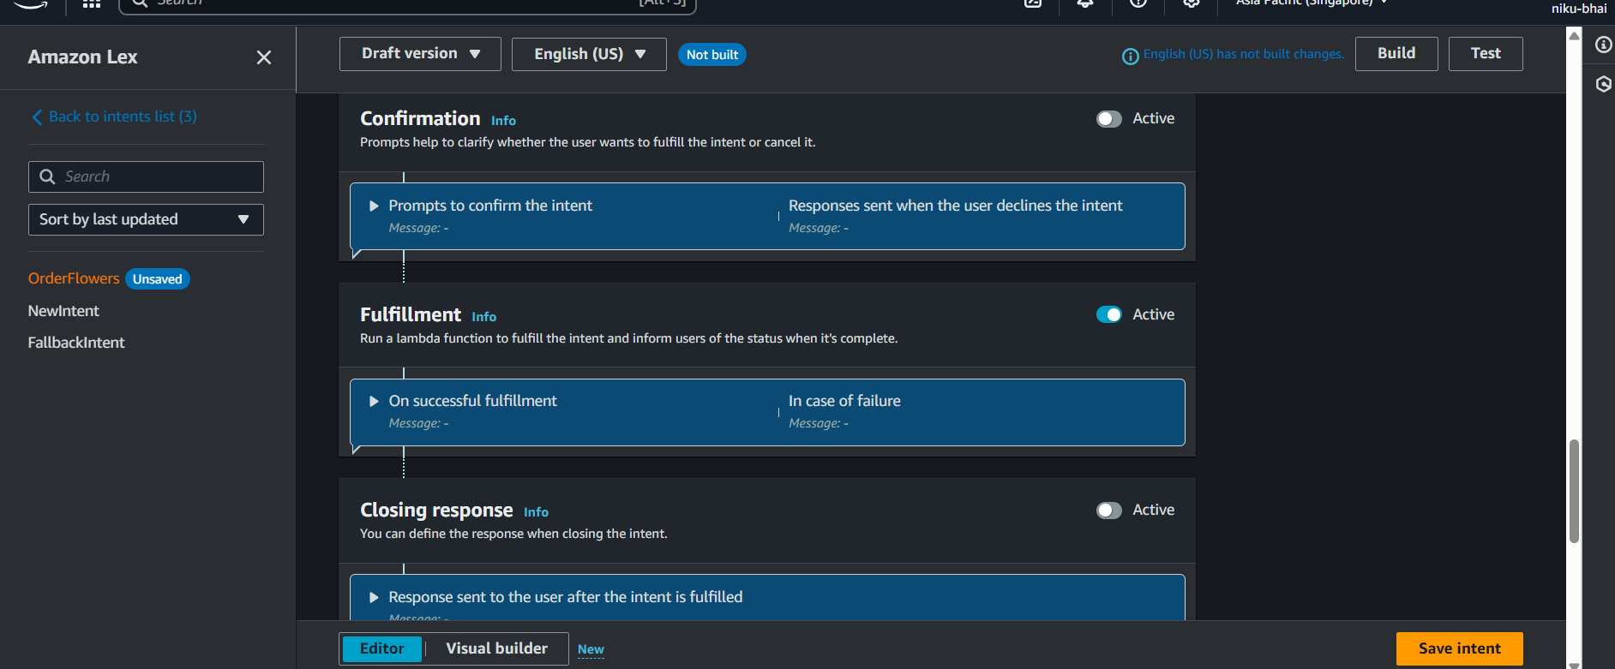

In the **"Fulfillment responses"** box that appears, copy and paste this *exact* message:  
Okay, I have your order for {FlowerType} ready for pickup on {PickupDate} at {PickupTime}. Thank you!

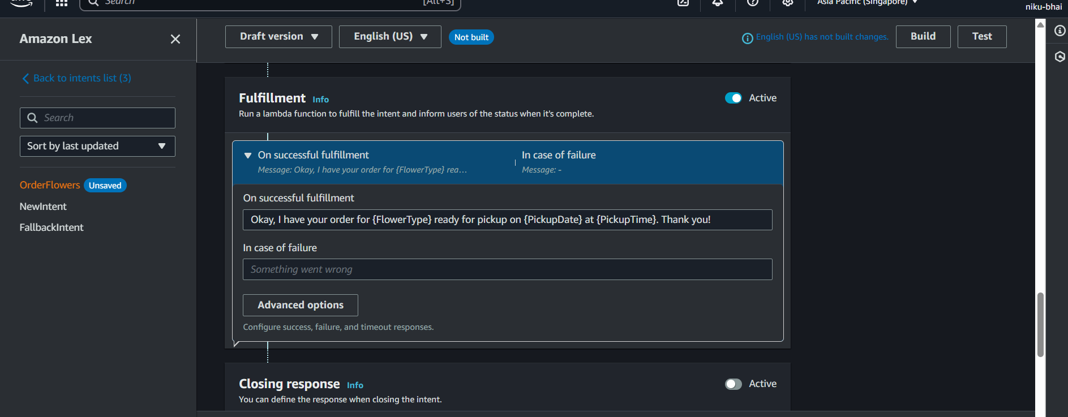

1. (The curly braces {} are very important, as they pull in the values the user gave you.)

### Step 6: Save Your Hard Work!

1. At the very bottom right of the page, click the **"Save intent"** button.

You have now fully configured your intent!

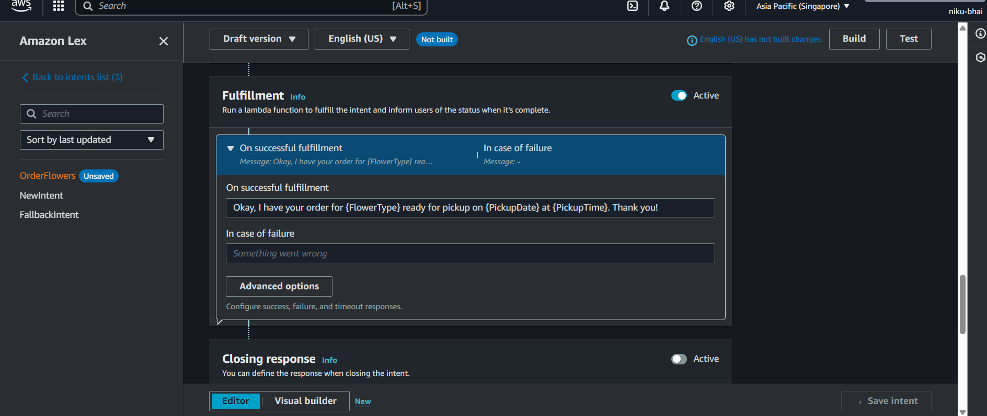

### Step 6: Build Your Bot

Now that you've saved the intent, you need to "compile" or **build** the entire bot so it learns all your new changes (the utterances, the slots, and the fulfillment message).

1. Look at the top right of your screen. You will see a **"Build"** button.
2. Click the **"Build"** button.

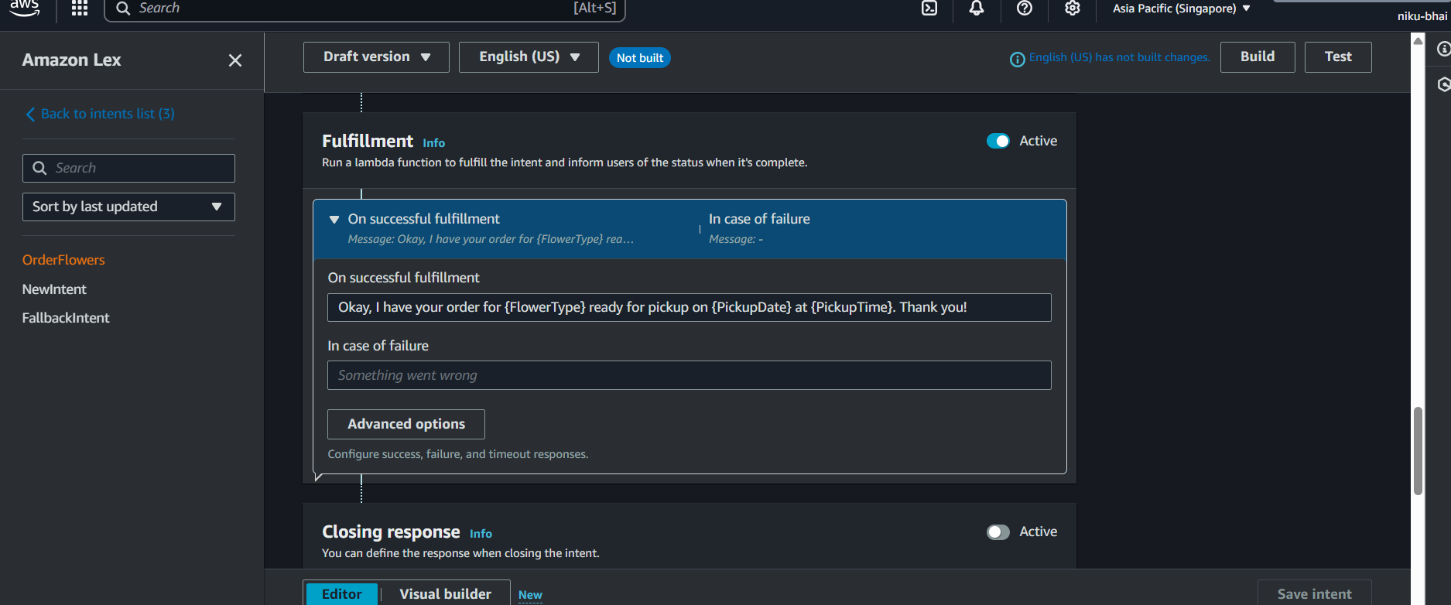

This process will take 1-2 minutes. You will see a notification in the console that says "Building..." and then "Build successful". **Do not proceed until you see it is successful.**

### Step 7: Test Your Bot

1. Once the build is successful, the **"Test"** button right next to "Build" will become active. Click **"Test"**.

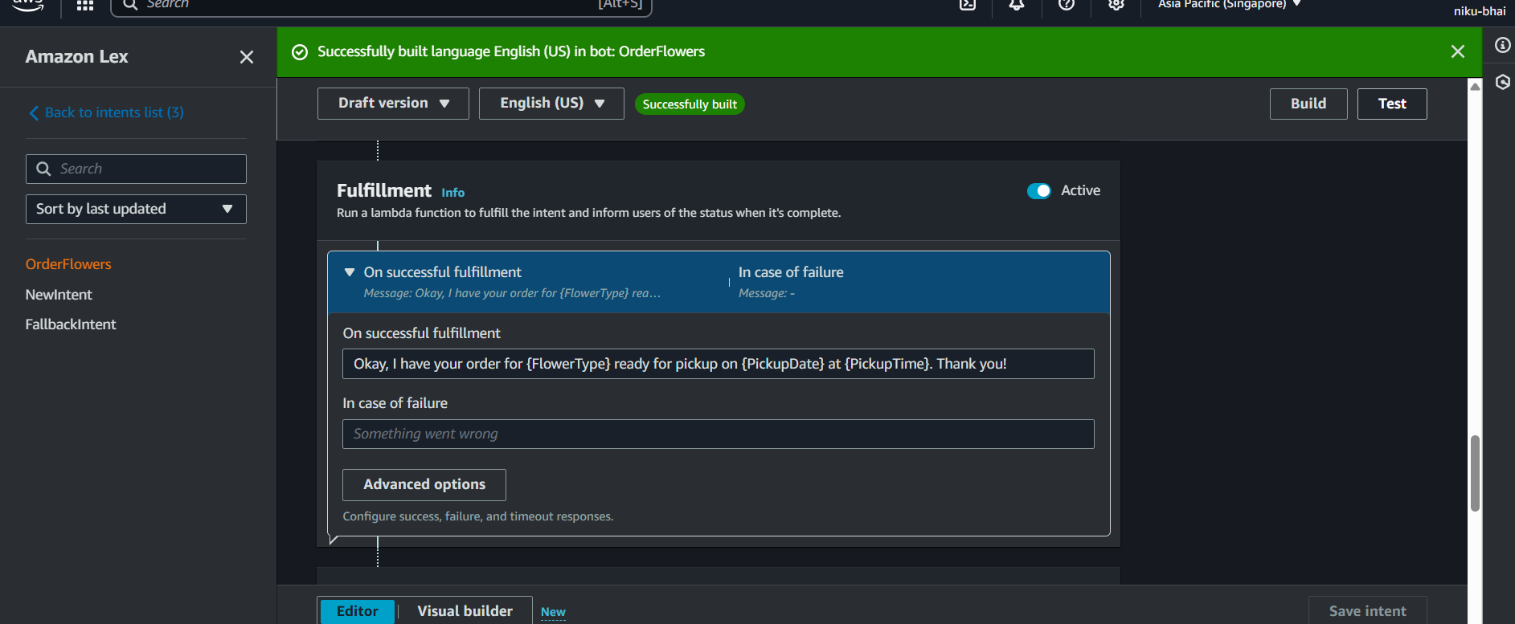

1. A new window will slide out from the side, labeled "Test your bot".

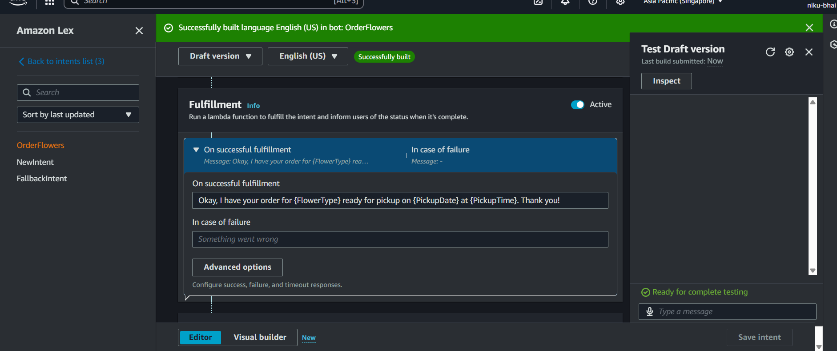

1. In the chat box at the bottom (where it says "Enter a message"), type one of your utterances and press Enter:
   * I want to order flowers

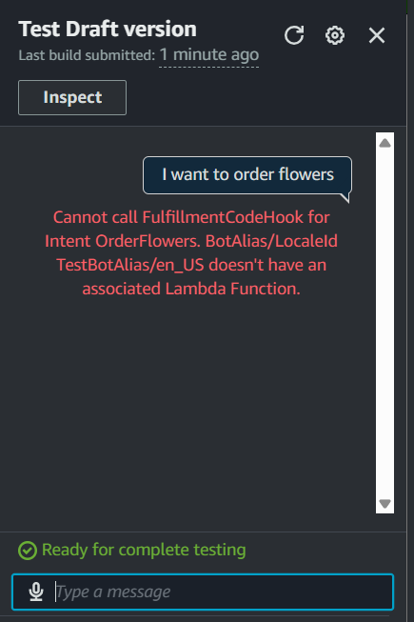

### How to Fix It (Step-by-Step)

**Go back to your OrderFlowers intent configuration page (where you added the slots and utterances).**

**Scroll down to the "Fulfillment" section (the one from your previous screenshot, image_3660de.png).**

**Click the blue "Active" toggle switch to turn it OFF. 4. Now, scroll down a little further on the page, past the "Fulfillment" section, until you see the "Closing response" section.**

**Click the "Active" toggle switch for "Closing response" to turn it ON.**

**A message box will appear. Delete any default text (like "Your request completed successfully").**

**In that "Closing response" message box, type our final confirmation message:  
Okay, I have your order for {FlowerType} ready for pickup on {PickupDate} at {PickupTime}. Thank you!**

1. The bot should respond by asking the first question: What type of flowers would you like to order?
2. **Answer its questions:**
   * **User:** roses (or lilies, tulips)
   * **Bot:** What day do you want to pick them up?
   * **User:** tomorrow
   * **Bot:** What time?
   * **User:** 10am
3. If everything worked, the bot will give you your final fulfillment message:
   * **Bot:** Okay, I have your order for roses ready for pickup on [Tomorrow's Date] at 10:00. Thank you!

### Step 8: Get Your Output

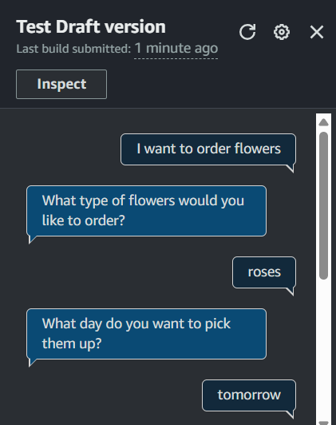

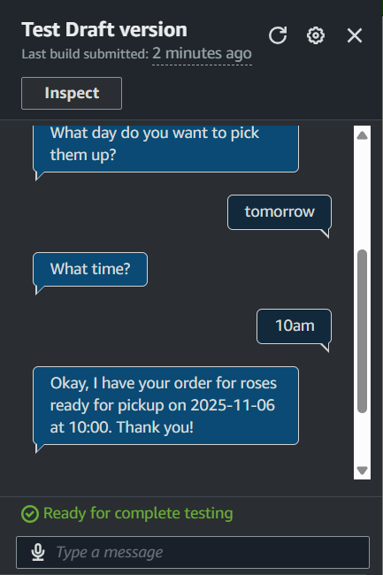

**This is the most important step for your lab report.**

* Have a full conversation with your bot from start to finish.

**7. Conclusion:**

In this practical, a simple conversational bot was successfully designed, implemented, and tested using the Amazon Lex service.

We learned how to configure the fundamental components of a Lex bot:

* An **Intent** (OrderFlowers) was created to represent the user's goal.
* **Sample Utterances** were provided to train the bot's Natural Language Understanding (NLU).
* A **Custom Slot Type** (FlowerType) was created to define our own data category, and built-in slot types (AMAZON.Date and AMAZON.Time) were used to capture common data.
* **Slots** were configured with **prompts** to enable the bot to ask questions and gather the required information.
* A dynamic **Closing Response** was set up to provide a final confirmation message using the data collected in the slots.

# Practical 08

| **Student Name: Roshan Samuel** |
| --- |
| **Date of Experiment: 27/10/2025** |
| **Date of Submission:** |
| **PRN No: 20220802088** |

**1. Title of lab**: Object Detection using Amazon Rekognition

**2. Objective:** To understand the concept and application of cloud-based computer vision services.

To practically use the Amazon Rekognition service to perform object and scene detection in an image.

To analyze the output (labels and confidence scores) provided by the service.

**3. Tools:** A personal computer with a stable internet connection.

An active AWS (Amazon Web Services) account with access to the AWS Free Tier.

**4. Software Used:** A modern web browser (e.g., Google Chrome, Mozilla Firefox).

The **Amazon Rekognition** service, accessed via the AWS Management Console.

**5. Theory / Concept:**

**Object Detection** is a computer vision technology that identifies and locates objects within an image or video. Unlike simple image classification (which might tell you "this image contains a car"), object detection will identify *all* the objects (e.g., "car," "person," "tree," "traffic light") and provide coordinates for their location, often by drawing a "bounding box" around them.

**Amazon Rekognition** is a fully managed, cloud-based service from AWS that makes it easy to add image and video analysis to applications. It uses powerful, pre-trained deep learning and machine learning models to perform its analysis.

Key concepts include:

* **Fully Managed:** As users, we do not need to build, train, or manage any machine learning models or servers. We simply send an image to the service, and it sends us back the results.
* **API-driven:** The service is accessed by making an API call (in our case, the web console does this for us). The DetectLabels API is used for object and scene detection.
* **Labels:** These are the objects, scenes, or concepts that Rekognition identifies (e.g., "Dog," "Park," "Outdoors," "Electronics").
* **Confidence Score:** A percentage (0-100%) that represents how "sure" the model is about its finding. A score of 98% for "Car" means the model is very confident it has found a car.

This practical uses the Amazon Rekognition console's demo tool to upload an image and visually analyze the results from the DetectLabels feature.

6. Output:

Click on Try Demo

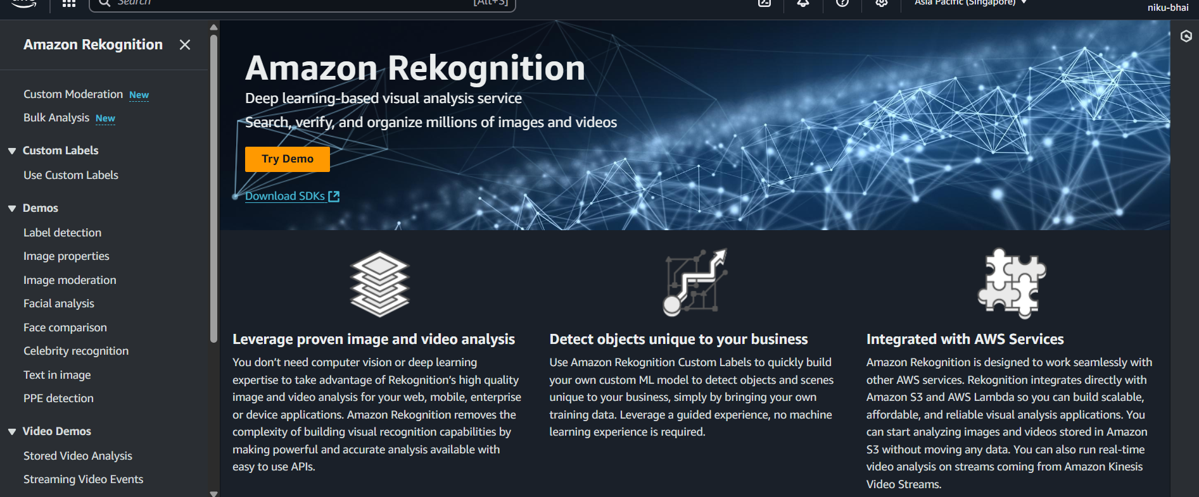

Go to Label Detection

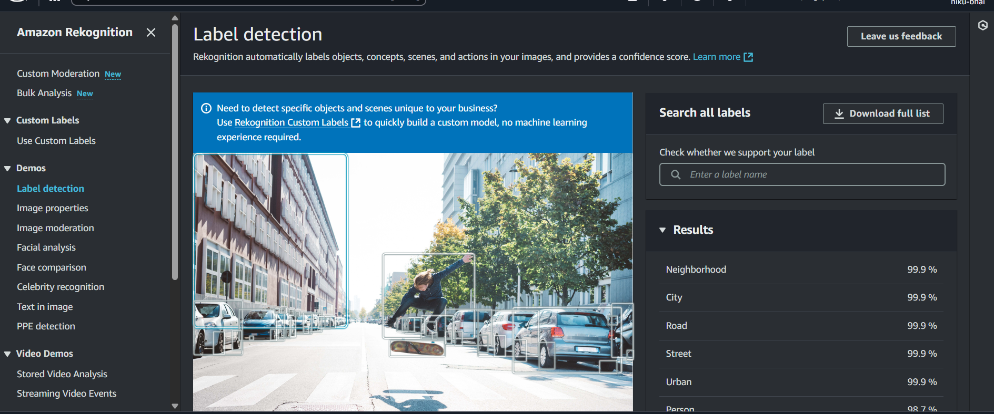

Upload your image and get the results

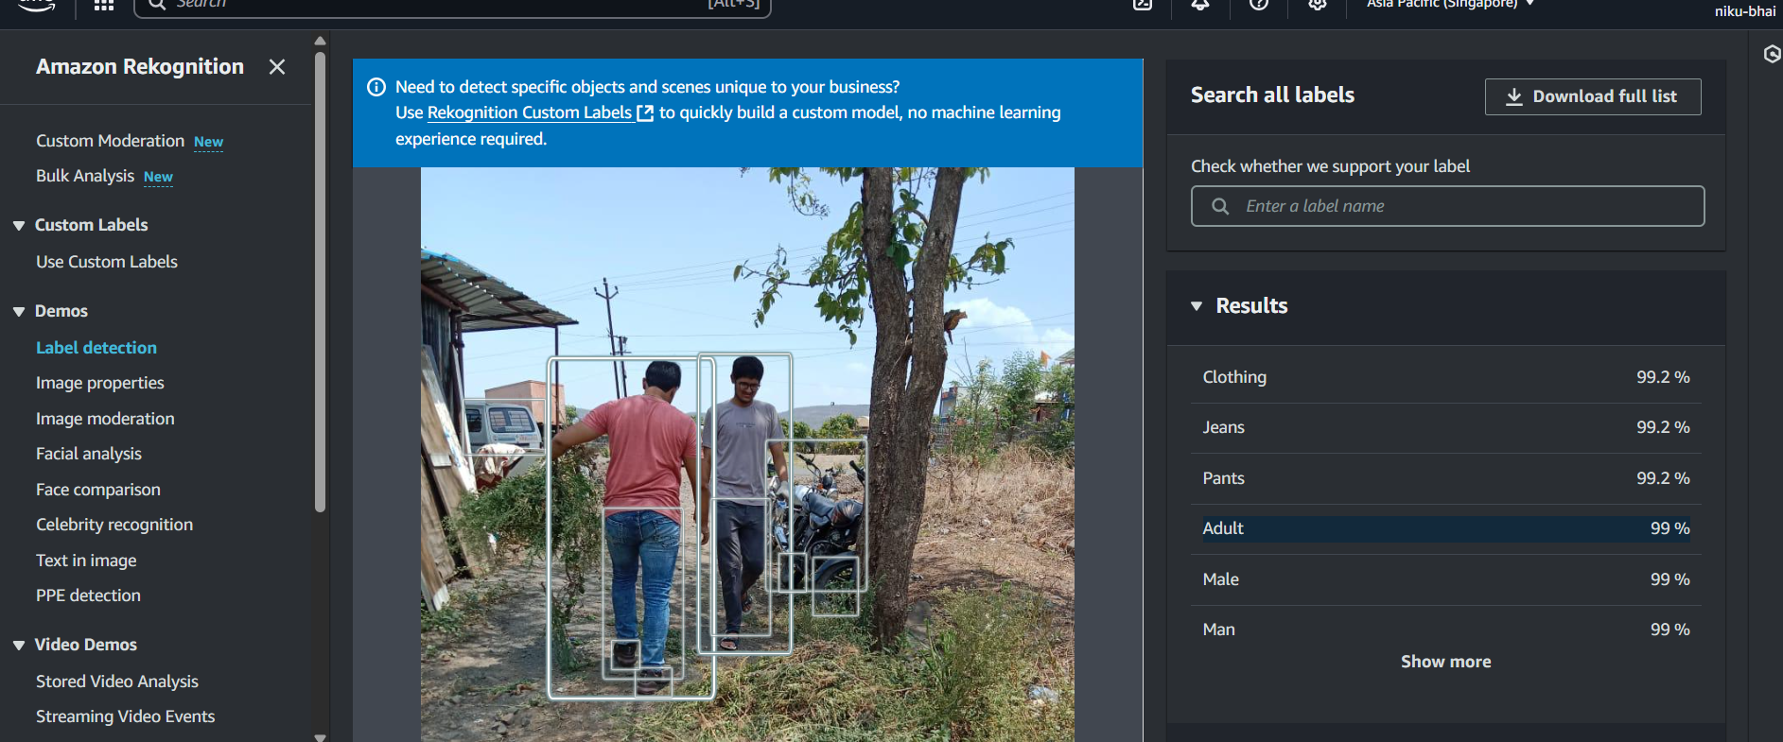

The "Results" panel shows a detailed analysis. The service didn't just identify "Man" (99% confidence) and "Adult" (99% confidence), but also detected attributes like "Clothing" (99.2%), "Jeans" (99.2%), and "Pants" (99.2%). This demonstrates the model's ability to identify not just general objects but also more specific details, all with very high confidence scores.

*(Note: If you clicked "Show more" in your test, you can also add other labels it found, such as "Motorcycle," "Tree," or "Outdoors".)*

**7. Conclusion:**

This practical successfully demonstrated the power and ease of use of Amazon Rekognition for object detection. By simply uploading an image through the AWS Console, the service provided a detailed list of labels, attributes, and confidence scores in seconds.

The experiment showed that the service is highly accurate, correctly identifying people and their clothing with high confidence. This was achieved without writing any code or managing any underlying machine learning infrastructure, highlighting how cloud AI services make complex computer vision tasks accessible to all developers.